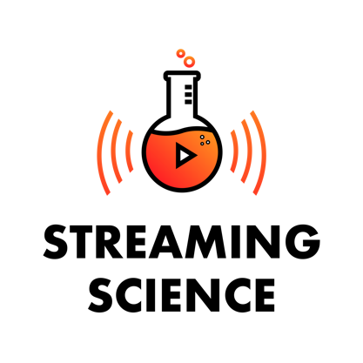

What do scientists do? Where do they work? What is scientific inquiry?

Scientists find solutions to problems that affect your everyday life.

Website: https://streamingscience.com/

Meet real-world scientists. Learn about STEM careers and research. Watch our online videos, listen to our podcasts, and engage in electronic field trips. All Streaming Science educational materials are produced by students majoring and minoring in Agricultural Education and Communication and Dr. Jamie Loizzo at the University of Florida. We invite you to use Streaming Science at home, in school, for clubs, and more!

Streaming Science is a college student-driven project-based learning science literacy program. The mission of Streaming Science is to introduce public audiences, especially middle and high school students and teachers, to real-world scientists and critical agricultural and environmental research through multiple interactive communication platforms. Through a series of courses and experiences students are developing videos, podcasts, and live interactive electronic field trips with iPad multimedia backpack communication kits. We invite you to watch our videos, listen to our podcasts, and engage with science topics that impact your everyday life!

Suggested activities include:

- Photo essays: https://streamingscience.com/category/photo-essay/
- Videos: https://streamingscience.com/category/video/
- Podcasts: https://streamingscience.com/category/podcast/
  - Select and read/watch/listen to photo essays, videos, and/or Streaming Science podcasts featuring agricultural and natural resource scientists
  - Do an online scavenger hunt to find out more about the science career featured in the photo essay
  - Write a story/record a video/or create a graphic about the science career, how the scientist uses scientific inquiry, and share why you are interested in science careers and research related to the topic you researched
  - Email your project to streamingscience1@gmail.com or -
  - Post your project social media and tag Streaming Science to share it with public audiences!

- Electronic Field Trips:
  - Go on an electronic field trip to learn about STEM research, scientific inquiry, and STEM careers in real-world settings
  - Watch past Streaming Science EFTs and write down key facts from each segment that you learned throughout the program
  - Recorded programs include:
    - Conservation Conversation

View the video recordings of a live electronic field trip to the 2,600 acre Austin Cary Forest and learn from scientists studying fire ecology, plants, and animals – including Diamondback Rattlesnakes.
    - Bats & Beyond!
Meet University of Florida wildlife and natural resource scientists to learn more about the exciting science, history, and future of bats.
    - Ranches, Rivers, and Rats
Learn more about a working ranch, water ecology, and kangaroo rat research in the Nebraska sandhills.
    - Sun Rays and Windy Days
See the inside of a wind turbine and learn how solar panels work, as well as about related Extension careers.

- Tools you can use to create your own science communication project to share with Streaming Science include:
  - Adobe Spark: https://spark.adobe.com/
  - Canva: https://www.canva.com/

