Plant science vocabulary
Agriscience foundations: 05.02 categorize plants based on specific characteristics according to industry and scientific standards.
Background:
For our next unit, we are going to be studying plant anatomy. The best way to build our understanding of plant anatomy is, to begin with, our vocab terms. The following terms are going to be very important for our plant lesson.

Instructions:
I expect you to fill in the following worksheet with the definitions, a real-world example, and a picture of what the term is referring to. This will help to build your understanding of the terms as we work through them.

Progress:
I expect you to be finished with stems by Monday. The whole worksheet should be completed on Tuesday, but it is not due until Friday at 11:59 pm.

Term | Definition | Example | Picture
Root
Taproot
Fibrous root
Adventitious root
Root cap
Root hair
Stem
Xylem
Phloem
Internode
Bulb
Corm
Tuber
Leaves
Simple leaf
Compound leaf
Leaf-blade
Petiole
Margin
Cuticle
Epidermis
Phototropism
flower
Petal
Sepal

Taxonomy:
Taxonomy is the science of naming, defining, and classifying groups of biological organisms based on shared characteristics. In the following taxonomy section, you will all need to research what the genus and species are of each of the following vegetables. The genus always comes before the species. It is marked by a capitalized Latin name. Species always follow the genus and begin with a lowercase letter.
For example:
The scientific name for humans is Homo sapiens.
Homo is the genus.
sapiens is the species.

Directions:
Give the genus and species of each of the following plants.

Danvers carrot
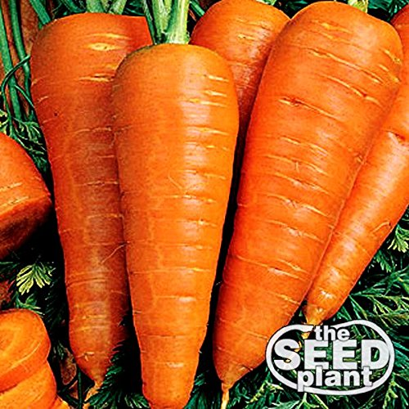
Genus: _____________________
species: ____________________

Romanesco Broccoli
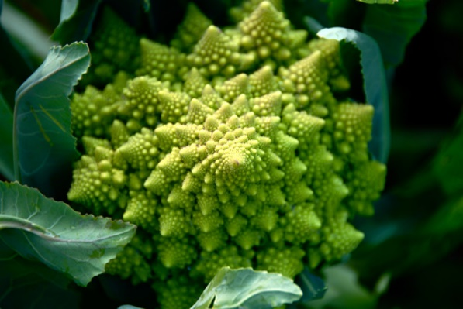
Genus: ______________________
species: _____________________

Yellow onion
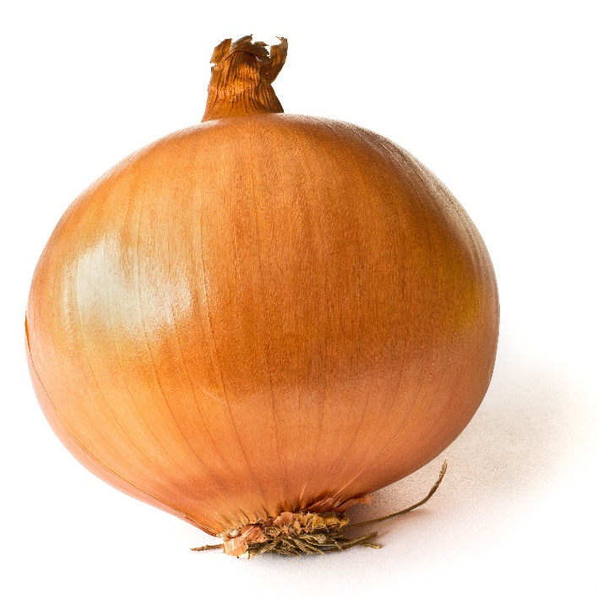
Genus: ______________________
species: _____________________

