USA FARM RESOURCE SCAVENGER HUNT

Overview: The USA is home to many resources. We grow and produce many different products all around the nation. Here in Florida we are lucky to be near a large commodity grouping. We produce large number of crops and products here, meaning they do not have far to travel to make it into our stores and kitchens.

Directions: You will use the USDA Farm Resource Region map to locate the different commodities around the nation. However, you will be using your kitchen to gather resources. You will need to pick 15 items from your fridge, pantry, freezer, etc. and map out where they came from.

Use the blank states map to color coordinate your product to the state produced. If the item does not say where it was grown, use the USDA link to figure it out.

The USDA regions link is here: https://www.ers.usda.gov/webdocs/publications/42298/32489_aib-760_002.pdf?v=42487

Try to fill in the map using colors or words. Please fill in the chart as well so we can track where everything has come from.

Hope you learn something new!

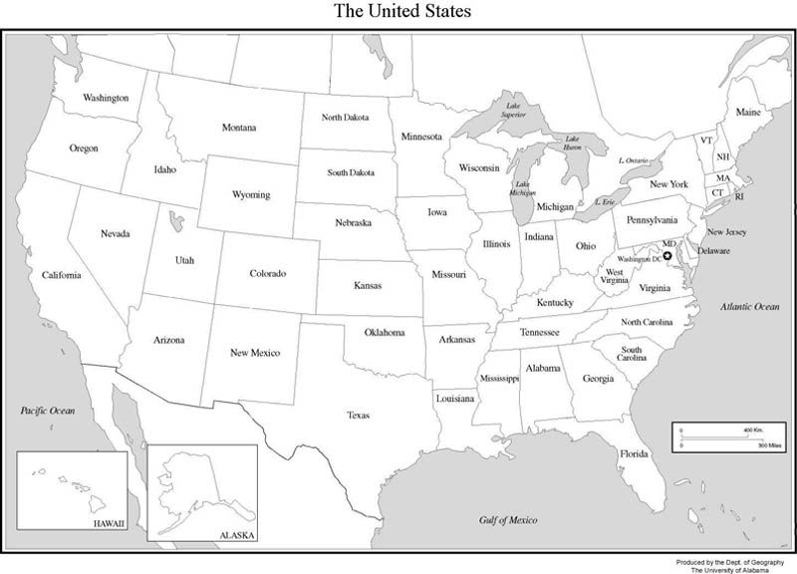
PRODUCT NAME | STATE IT CAME FROM

