Course: Land and Turf Science 4

Competency: 26.08 Identify appropriate pruning techniques to achieve plant size, form, and shape.

Read all of the following information and complete the activity below

For the FNGLA Landscape Maintenance Exam you will need to know the following five cuts

- Removal Cut
- Large Removal Cut
- Reduction Cut
- Heading Cut
- Selective Cut

Large Removal/ ABC Cut
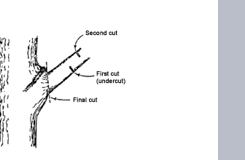

Reduction Cut:
used to reduce the length of a stem or a branch. A reduction cut removes a stem back to a lateral branch that is at least 1/3 the diameter of the cut stem.

Heading Cut:
a type of pruning cut that prunes a shoot no more than 2 years old back to a bud; cutting through an older stem back to a lateral branch less than 1/3 the diameter of the cut stem;

Selective Cut:
removing branches back to the point of attachment to another branch or the ground. This opens up the plant canopy, allowing for more light and air.

How to cut:

Begin the cut just outside the branch bark ridge and angle down away from the trunk of the tree. Make the cut as close as possible to the stem in the branch axil, but outside the branch bark ridge. With pruners or loppers position the blade against the trunk.

After Pruning be sure to:

- Wash and Sanitize your pruning tools using a weak alcohol solution of 1 part alcohol to 9 parts water
- Sharpen tools if they have become dull

Activity:

- On the following picture using the drawing tool to show how you would make the large removal cut.
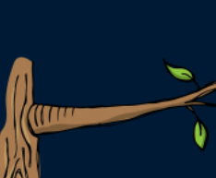

- What is it the importance of a large removal cut?

- What must you do with a pruning tool after using it?

- What do you think the goal of pruning is?

