Precision Agriculture Lab
Precision agriculture (PA), or site-specific farming, allows farmers to address field variability rather than treating the whole field the same. Using PA, growers can target management practices to particular areas within fields. PA focuses on managing land at a higher intensity in order to increase yield, increase efficiency, reduce costs, and reduce adverse environmental impacts. Because fields are rarely uniform, crops may require different inputs depending on where they grow. For example, fertilizer rates should be less on low-yielding eroded hilltops than in bottomland with high yield potential. Similarly, precision equipment allows farmers to treat patches of weeds and diseases, rather than having to spray the entire field.

The role of PA continues to expand with improved tools, ease of use, and reduced costs. Available machinery varies depending on the manufacturer, but common precision technologies incorporated into farming equipment include guidance systems, variable rate applicators, section controllers, and yield monitors.

Careful calibration of agricultural inputs not only reduces resource and economic losses that can lead to pollution and less profitable farms, but it can also help mitigate climate change. Precision management can play a central role in reducing agricultural greenhouse gas (GHG) emissions. For example, N₂O emissions can be decreased by reducing reactive soil nitrogen that is not used by the crop. Furthermore, when farmers reduce the amount of fertilizers or other inputs (e.g. pesticides or lime) they use, they also reduce consumption of natural gas and GHG emissions from manufacturing, transport and making multiple equipment passes over a field. Regardless of the economic and environmental incentives for using precision management on farms, high investment costs and a large learning curve for technologies and equipment has limited its adoption.

Standards: 04.0 Apply environmental Principles to the agricultural industry. 04.04 identify regulatory agencies that impact agricultural practices. 04.06 identify conservation practice related to natural resources.

Objectives:
In this lab you will:
- Explore the basic principles of precision agriculture.
- Determine how precision agriculture can reduce nitrogen fertilizer use.
- Calculate the dollar savings when precision agriculture tools are used.

Materials:
- White cardstock with grids
- Blue (or other dark colored) chalk or oil pastel

Pre lab Questions:
- Define and explain the roles of these PA tools: GIS, GPS , variable rate applicators, section controls
- How can farmers reduce input usage while maintaining yield and crop quality?
- Explain how the costs and benefits of PA impact grower adoption of these tools.
- How is the use of nitrogen-containing fertilizers related to climate change?

Lab Activity
Procedure:
- You will receive pieces of paper with gridded fields of various shapes and a piece of chalk (at least 1 in long), the shape represents your field and the chalk represents your tractor and fertilizer spreader.
- Lay the chalk on its side on the paper and drag it over the field as if it were a tractor applying fertilizer. As you move the chalk, consider how a tractor moves and turns corners (hint: do not lift the chalk up). Try to cover the paper with a uniform layer of chalk or “fertilizer”.
- Set a scale (for example 1 grid cell = 1 acre). Use the grid to determine a) the area of your entire field, b) the area of the field that received double the amount of fertilizer (the dark areas on the paper) and c) the area that received no fertilizer (the blank areas on the paper). Record in the table below under appropriate field shape.
- Calculate % of squares with overlap (count squares with at least ½ overlap)
- Calculate % of squares with no N applied
- Calculate the dollar value of wasted fertilizer
- Calculate the lost yield because of fertilizer “skips”
- Repeat for each shape so you have 3 total fields.

Field Shape: | Rectangle | Rounded Polygon | Trapezoid
Squares with overlap

Squares with gaps

Total number of squares in field

% overlap
(overlap/total) * 100
% gap
(gap/total) * 100
Wasted fertilizer
(# with overlap * 60 lbs N/ac * $0.50 /lb N)
Lost yield
(# with overlap * 40 bushel loss/acre * $8/bushel)
Total $ loss
(sum of wasted fert and lost yield)
Total $ loss per acre (total field area)
Questions:
- Which field shape was least efficient? Which was most efficient?

- What was more common, fertilizer gaps or overlaps?

- Which is more costly per acre, gaps or overlap? Based on this, would you recommend that a farmer over-fertilize to reduce gaps or under-fertilize to avoid waste?

Lab Activity 2
1. Study the yield map below. This data is from a site that receives approximately 25 inches of precipitation each year.

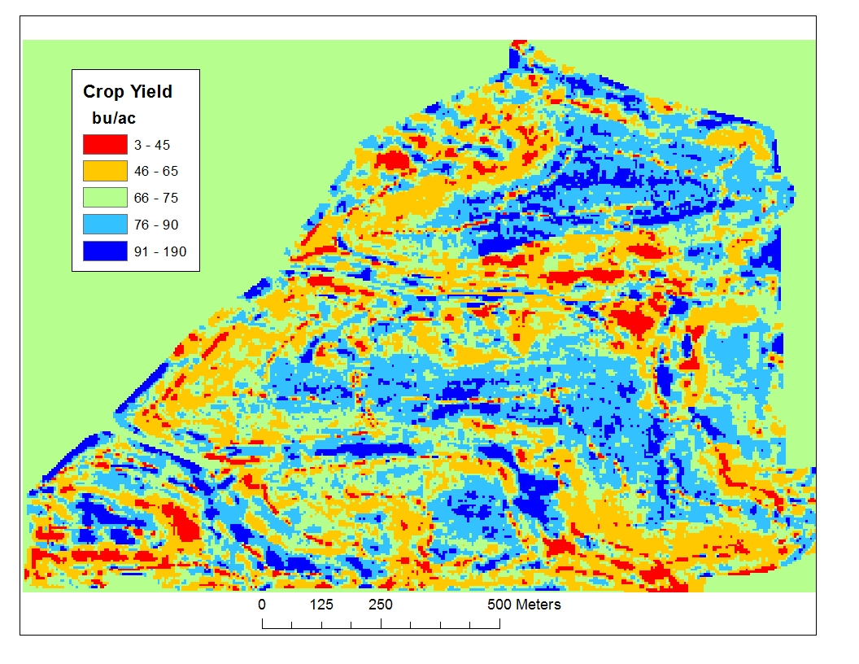
2. Observe how the yields of winter wheat change over the area. Can you suggest factors that may be causing the spatial variability in yield?
3. Assume that the average yield across the field is 90 bu/ac and estimate the area of the field using the scale bar. Use information from the University of Idaho winter wheat fertilizer guide (see table below) to estimate the required amount of fertilizer that would be applied to the entire field to achieve the potential yield of 90 bu/ac.
4. Draw lines on the yield map to delineate zones that you would manage the field by (Suggestion: typically growers use 2 to 5 zones).
5. Compare your zones with those actually used to fertilizer the field using PA technology (map at the end of the lab).
6. How did the use of N fertilizer differ when precision agriculture techniques were used instead of single application rates?
7. Compare the savings achieved using PA management.

Table 1. Estimated total N needed for winter wheat based on potential yield.
Annual precipitation (inches) | N needed (lb/ac)
21 or fewer | 2.5 x potential yield (bu/ac)
22 to 24 | 2.7 x potential yield (bu/ac)
More than 24 | 2.9 x potential yield (bu/ac)

Analysis:

1. What is precision agriculture? List at least 5 technologies precision equipment might include.
2. How may precision agriculture technologies be used to reduce GHG emissions from agricultural systems?
3. What are some factors limiting the adoption and use of precision agriculture tools?

Field shapes
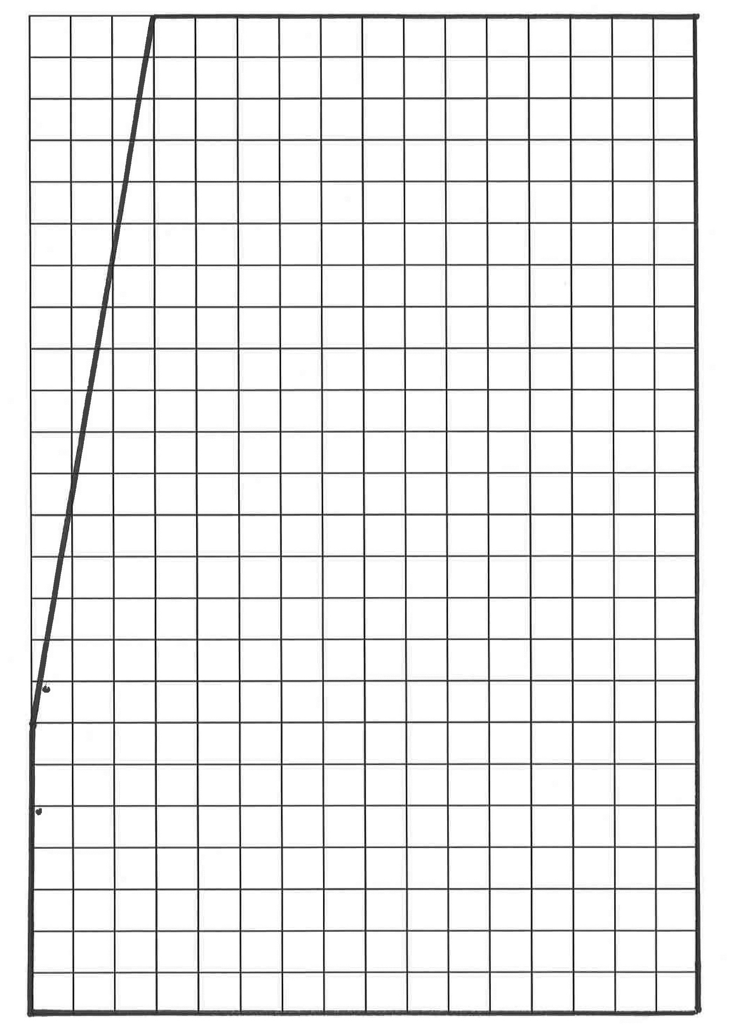
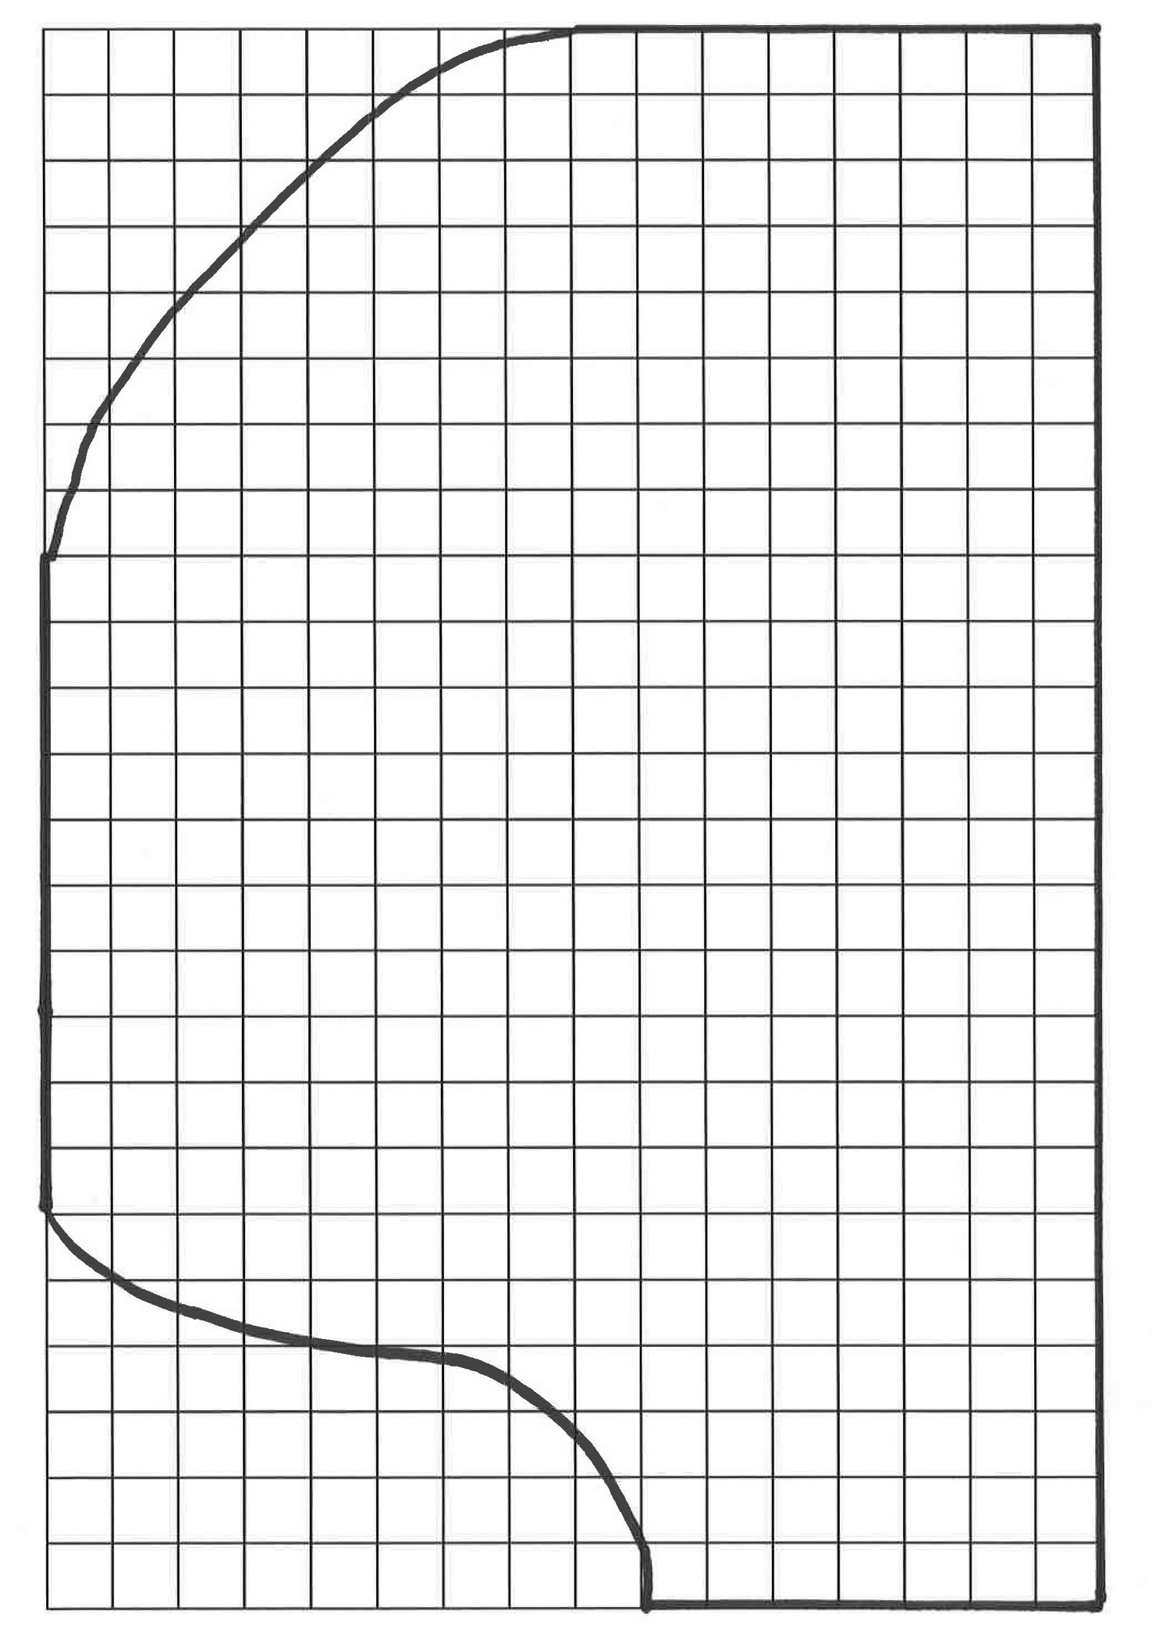
Map showing the rate of nitrogen fertilizer applied using PA technologies.
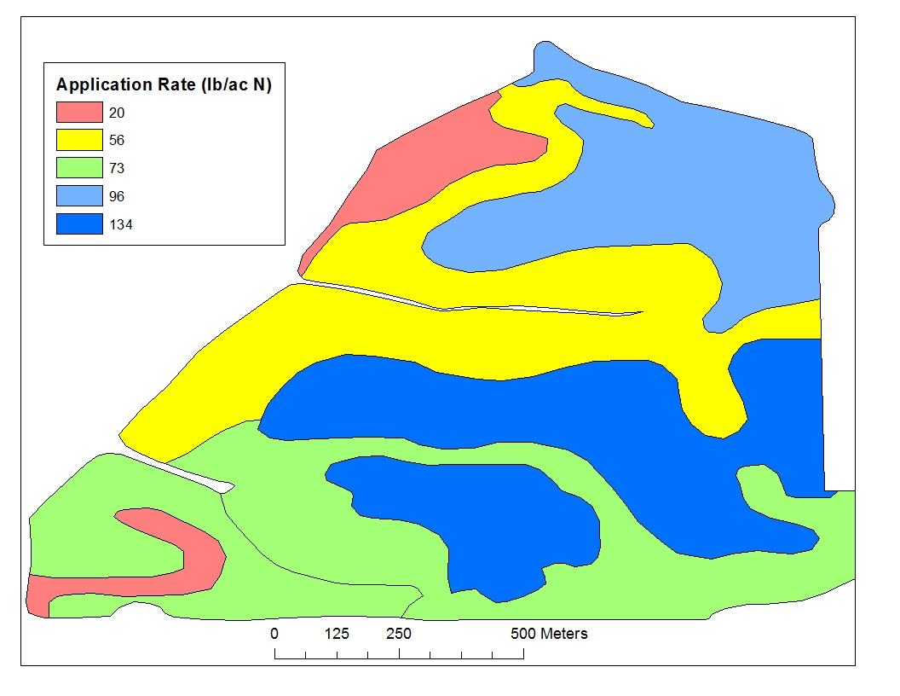

Additional Information for Teachers:

Factors leading to overlaps/gaps in seeding, spraying and fertilizing:
Example image of seeding overlap to avoid gaps caused by turning radius limitations:
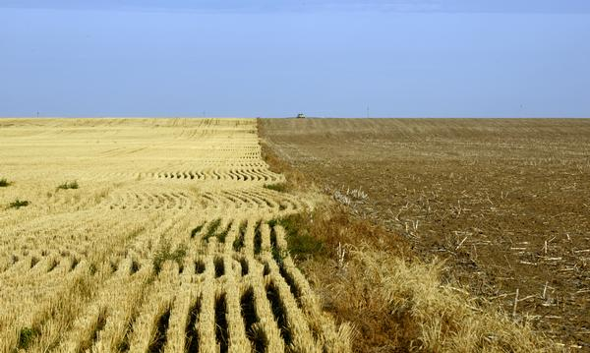
http://www.denverpost.com/news/ci_23803604/drought-leads-tighter-colorado-wheat-seed-supply

Set up:
- Print off grid sheets with field shapes on white paper. Cardstock works well. Generally a rougher textured paper seems to look better.
- Blue chalk shows overlap the best but other darker colors may work as well.

Attach demo pictures.
Attach pictures showing typical examples of gaps and overlaps.

1. Precision agriculture resources:

Understanding Technical Terms and Acronyms Used in Precision Agriculture. Pedro Andrade-Sanchez and John T. Heun. Arizona Cooperative Extension. AZ1534. Available at: http://extension.arizona.edu/sites/extension.arizona.edu/files/pubs/az1534.pdf Last accessed 7-11-2014.

Optional Extensions

How straight can you walk?
Procedure:
1. Using a GPS unit (or a smart phone/table with appropriate app) to mark points along your path, walk a straight line through a large field. For example diagonally through a football field.
2. Map your points and determine how successful you were in actually maintaining a straight line through the field.
3. Discuss how the line may have looked had you used your GPS to guide you instead of your own sense of direction.
4. Discuss how satellite GPS systems are used in tractors.

Available Technologies
Activity:
- Below is a 6 minute video demonstrating a high tech farming operation that seems very “futuristic”. This particular video was produced by John Deere FarmSightTM, although that does not need to be endorsed.
- Video: http://www.deere.com/wps/dcom/en_US/campaigns/ag_turf/farmsight/video_gallery_farmsight.page
- After viewing the video ask the students to list all of the technologies that are available now. The answer is all of them, in this video they were just presented comprehensively.
  - Heads-up display is used in jets and high end cars
  - Touch screens are used in smart phones, laptops, tablets etc.
  - Chlorophyll and soil monitors – already available
  - Others such as timers, communication outlets etc.

