Linda Jones (Sanchez)
Braden River High School
March 23-27, 2020
Veterinary Assisting 3: Reproductive Systems Unit

Standards: 21.0: Explain the reproductive system and breeding of common companion and livestock animals.
21.01: Explain the male and female reproductive systems of common companion and livestock animals.
21.03: Determine the appropriate age or weight for breeding.
21.05: Describe estrous cycle.

Objectives: Students will be able to..
- Properly identify the parts of the female reproductive system on the quiz.
- Describe the function of the hormones in the female reproductive system.
- Explain the estrus cycle and its stages through answering the questions correctly on the quiz.

Assignment: Female Reproductive System Quiz *** This is where this class left off before spring break and students are instructed to review the PowerPoints that are posted on Schoology that we have already gone over in class before attempting to take the quiz.***

Question 1 (11 points)
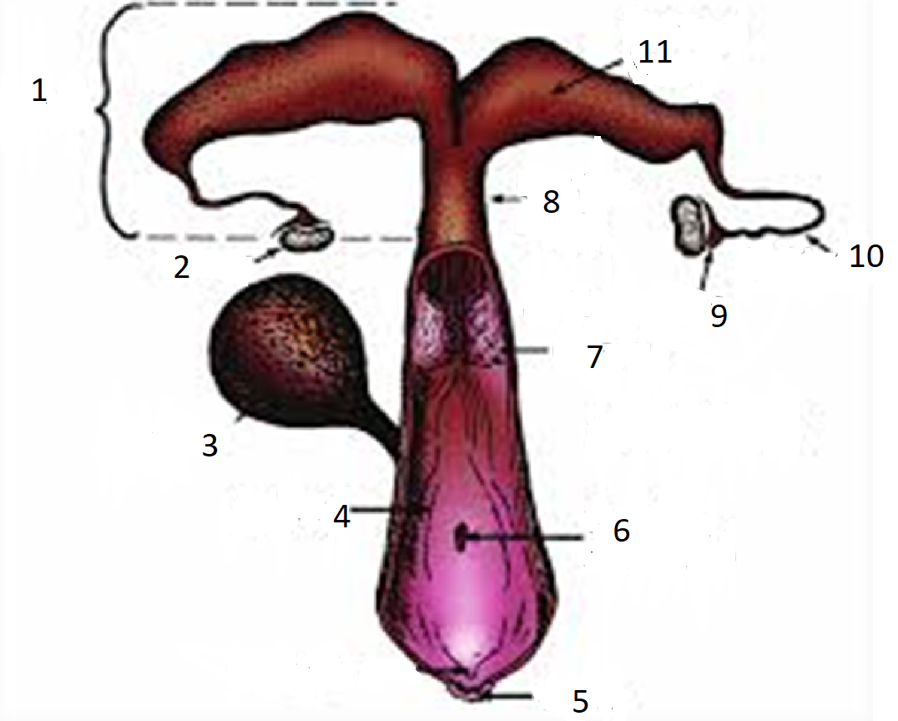
1.
2.
3.
4.
5.
6.
7.
8.
9.
10.
11.

Question 2 (7 points)
Match the correct parts of the reproductive system with its best definition/function.
Column A  1. External opening to the reproductive tract.: External opening to the reproductive tract.  2. Acts as a passageway to the uterus for sperm and keeps foreign materials out during pregnancy.: Acts as a passageway to the uterus for sperm and keeps foreign materials out during pregnancy.  3. Location of the development of the fertilized egg.: Location of the development of the fertilized egg.  4. Carries the egg from the ovary to the uterus and is the site of fertilization.: Carries the egg from the ovary to the uterus and is the site of fertilization.  5. The site through which male semen is deposited into the female reproductive system.: The site through which male semen is deposited into the female reproductive system.  6. Where the egg attaches and the fetus develops.: Where the egg attaches and the fetus develops.  7. Produces ova through meiosis during embryo devlopment.: Produces ova through meiosis during embryo devlopment. | Column B  a. Cervix  b. Ovary  c. Vagina  d. Oviduct  e. Cloaca  f. Uterus  g. Magnum  h. Vulva  i. Infundibulum  j. Isthmus  k. Uterine Horns

Question 3 (1 point)
Which hormone stimulates the devlopment and function of the follicle?
a | Estrogen
b | FSH
c | LH
d | Progesterone
Question 4 (1 point)
Which hormone devlops the corpus luteum, the yellow body?
a | Estrogen
b | FSH
c | LH
d | Progesterone

Question 5 (1 point)
Which hormone prevents FSH and LH production?
a | Estrogen
b | GnRH
c | Progesterone
d | Prostaglandin
Question 6 (1 point)
Which hormone develops the other sex organs?
a | Estrogen
b | FSH
c | LH
d | Progesterone

Question 7 (1 point)
What is the name of the stage in which the reproductive tract develops?
a | Estrus
b | Diestrus
c | Proestrus
d | Puberty
Question 8 (1 point)
What is the name of the stage in which the female is receptive to mating?
a | Diestrus
b | Estrus
c | Metestrus
d | Proestrus

Question 9 (1 point)
What species has an average estrous cycle of 17 days?
a | Cattle
b | Horses
c | Sheep
d | Swine
Question 10 (1 point)
What are the factors examined when deciding when a female should be bred for the first time?

