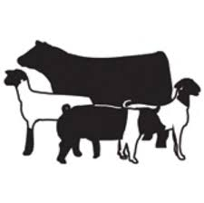
LIVESTOCK JUDGING 101

Overview: Now that you have become familiar with the different parts of livestock animals, we will begin going over how we judge these animals. The reason we judge livestock is to determine which animals are better for certain reasons. For example, we can judge animals for breeding. This means the judge would determine the soundness (overall structural quality) of the animal in terms of how it is set up for breeding. You would be looking for the animal that fits your desired qualities the most.

Directions: You will first need to research livestock evaluation. You will determine the basic or key points to look at, based on the animal species and type. After this, you will go to livestockjudging.com and place 2 classes of your choice.
Steps:
- Go to livestockjudging.com
- At the top of the page, select Videos.
- From the drop-down bar, select All Free Classes.
- Select 2 classes to place and fill in the information on the chart below.

This should all go on the attached chart. Please fill that in and submit it.

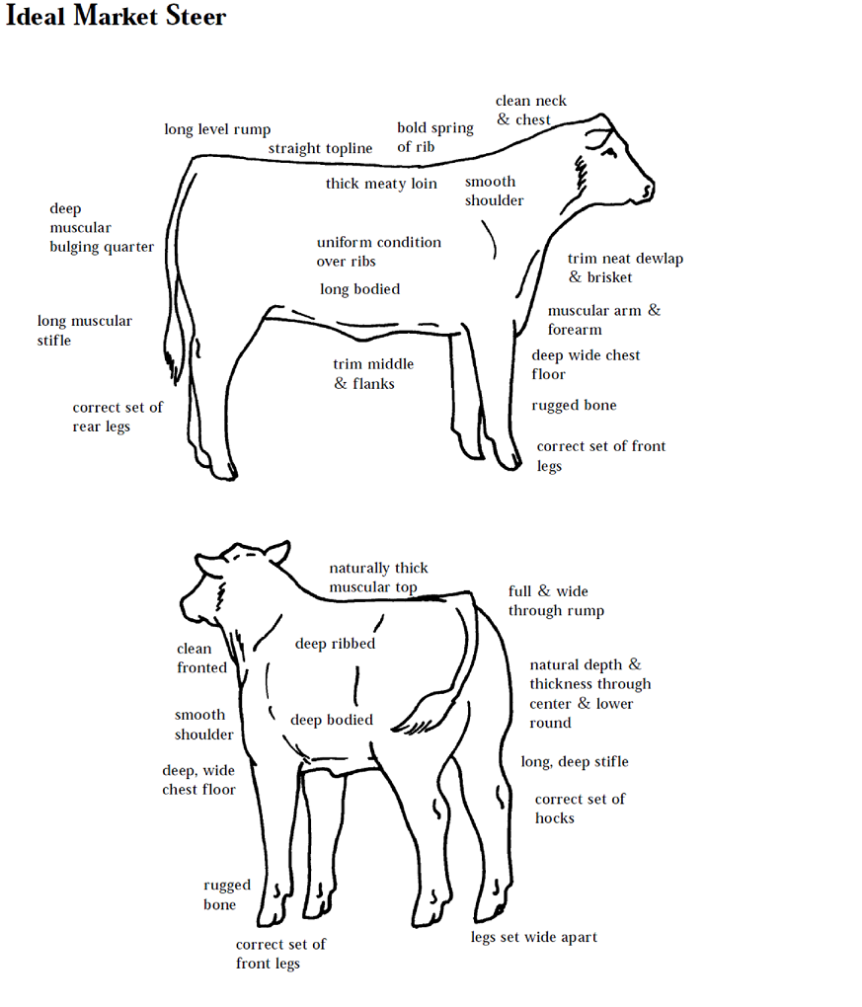

Class Type | Qualities to look for | Key Points of Evaluation
Market Steers
Feeder Cattle
Market Lambs
Market Swine
Breeding Heifers
Livestockjudging.com | Your Placement | Official Placings
- Name of class here
- Name of class here

