Overview: Since we cannot be in the classroom or go visit farms, we are going to do it online! Today, you will be taking a virtual tour of different agricultural facilities around the United States. Some of these places include crop farms, dairies, and livestock facilities.

Directions: You may use your phone or your computer to complete the videos.

- Go to https://www.agclassroom.org/student/tours.cfm to find the videos.

- Choose one subject, such as Pig Farms and select the title. This will bring you to YouTube, where you will be given the option to watch multiple videos on the topic. Watch two of the videos and take some notes.

- Next, you are to make a flyer or poster on the importance of this agriculture area.

For example, “Why Pig Farms are Important.” This should include what they do and why we have them.

Please upload your finished product! You may email it to me if needed.

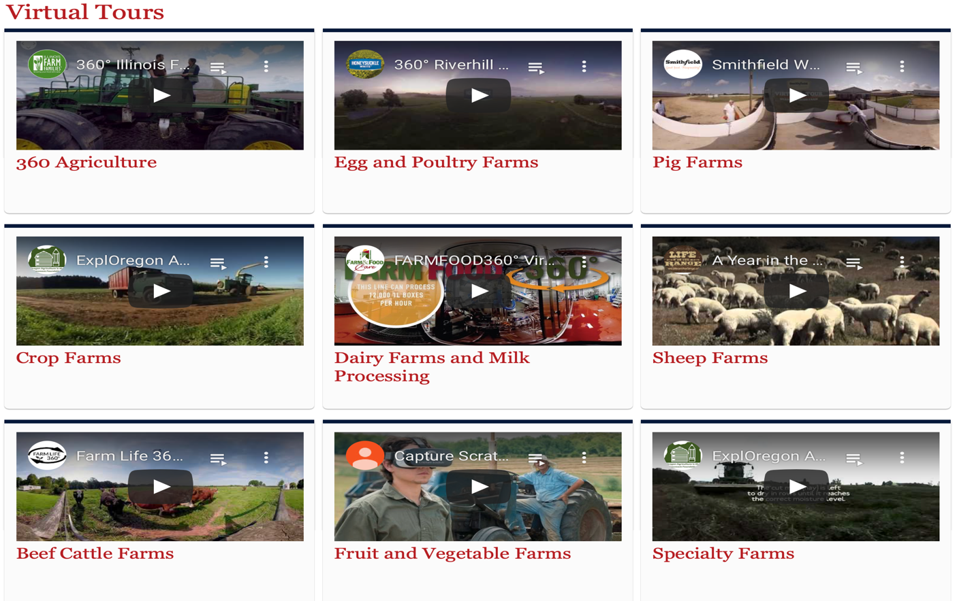
I look forward to seeing what you come up with!

