Dairy Industry – Breeds

Competency: FL DOE 06.02 – Analyze commercially important livestock breeds in Florida.

Directions: The pictures below showcase six of the most common dairy breeds. Using the website provided, http://www.carlisle.k12.ky.us/userfiles/937/Classes/630/E%20Unit%202-%20Breeds.pdf, identify the breed and the characteristics associated with each.

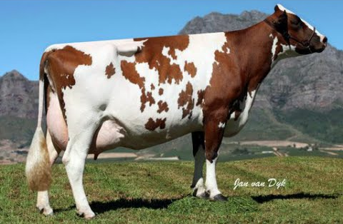
Breed:
Characteristics:

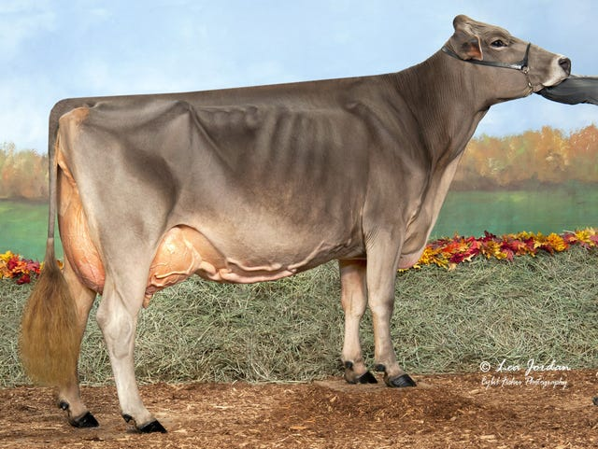
Breed:
Characteristics:

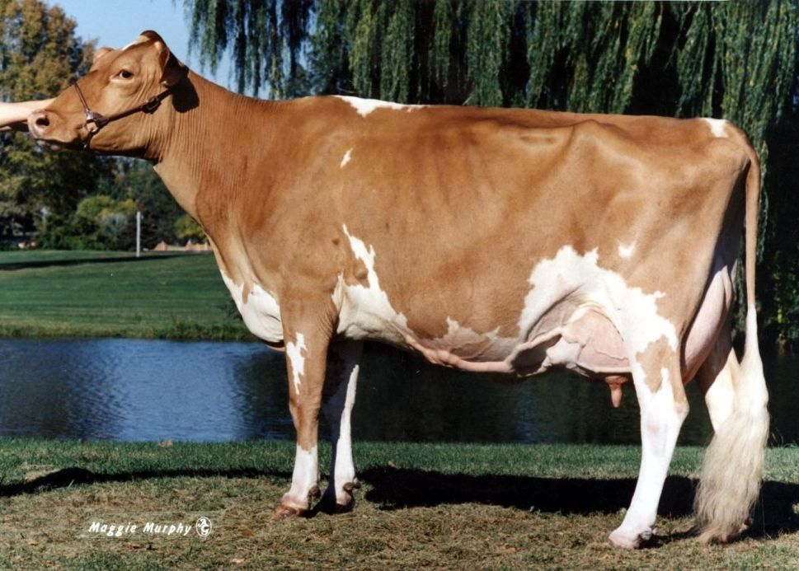
Breed:
Characteristics:

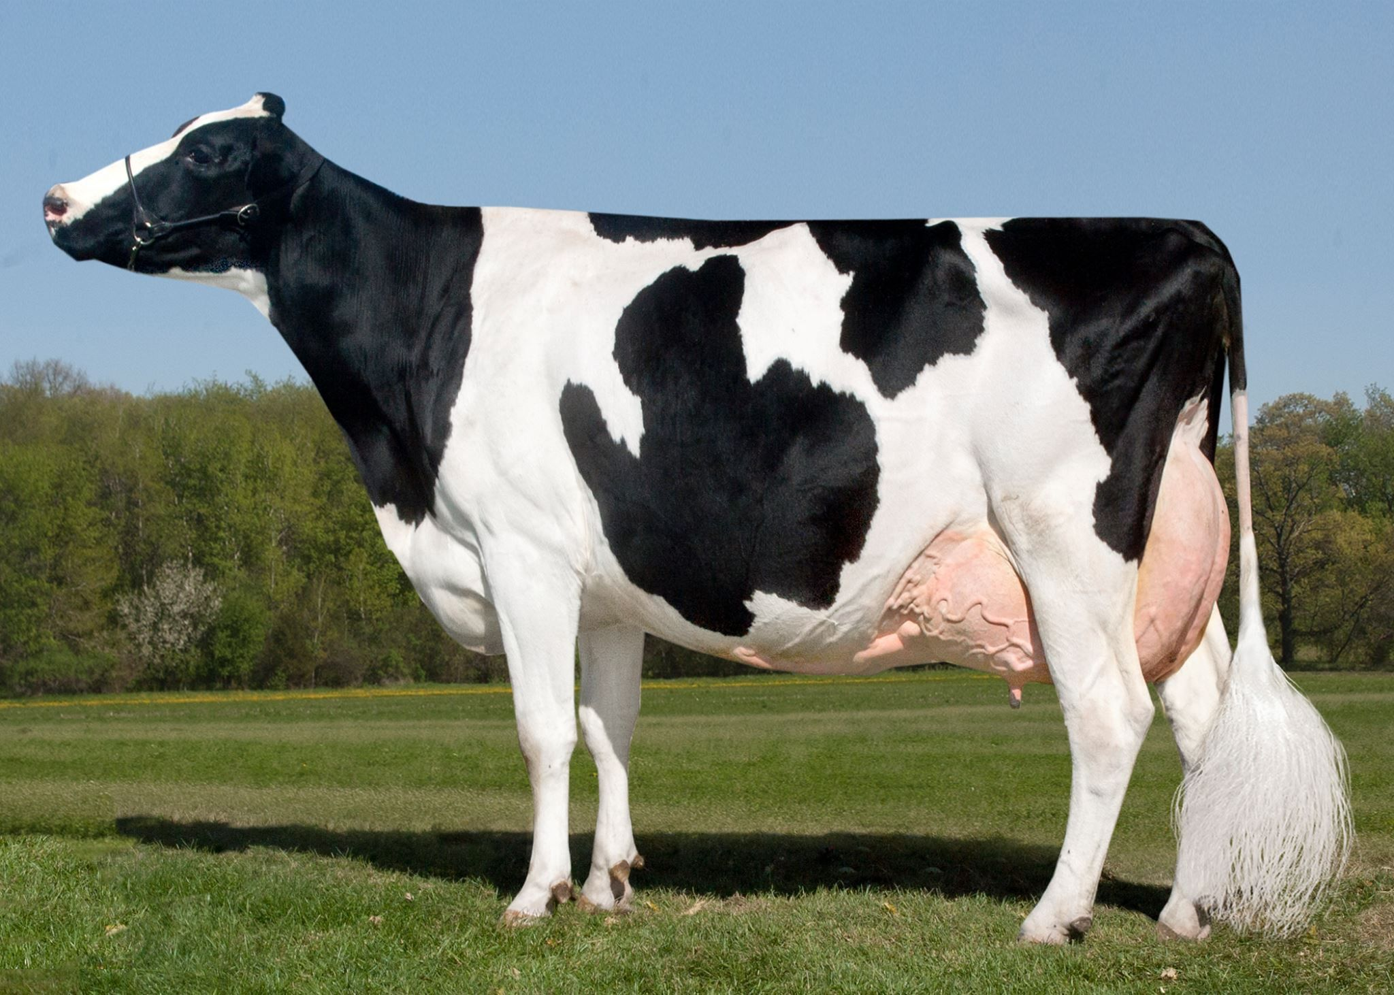
Breed:
Characteristics:

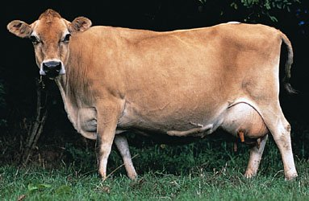
Breed:
Characteristics:

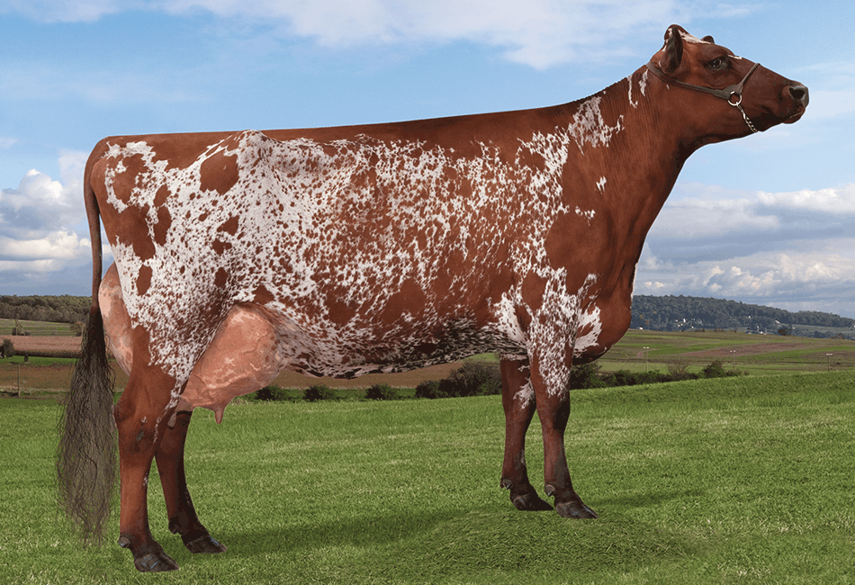
Breed:
Characteristics:

Dairy Industry – Anatomy

Competency: FL DOE 28.02 – Compare and contrast desirable anatomical and physiological characteristics of animals within and between species.

Directions: The figure below showcases the main body parts of dairy cattle. Using this figure and the word bank provided, match the terms to the numbers located on the cow. Once you have identified the term for a specific number, place that number with the term in the word bank. Use the example as a reference.

9.
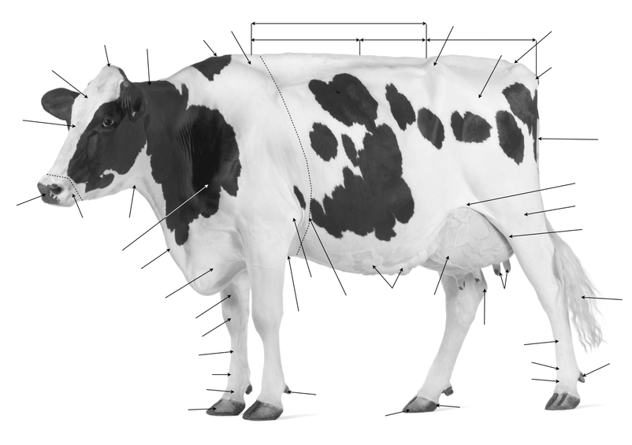
43.
42.
41.
40.
39.
38.
37.
36.
35.
34.
33.
32.
31.
30.
29.
28.
27.
26.
25.
24.
23.
22.
21.
20.
19.
18.
17.
16.
15.
14.
13.
12.
11.
10.
8.
7.
6.
5.
4.
3.
2.
1.
Chest Floor  #____ | Fore Udder  #____ | Elbow  #____ | Milk Veins  #____ | Heart Girth  #____ | Muzzle  #____ | Hoof  #____ | Throat  #____ | Pastern  #____
Shoulder  #____ | Fetlock  #____ | Dewlap  #____ | Cannon  #____ | Brisket  #____ | Knee  #____ | Forearm  #____ | Declaw  #____ | Toes  #____
Heel  #____ | Teats  #____ | Hock  #____ | Switch  #____ | Tailhead  #____ | Stifle  #____ | Pin  #____ | Thigh  #____ | Tail  #____
Flank  #____ | Neck  #____ | Nose  #____ | Poll  #____ | Face  #____ | Forehead  #____ | Withers  #____ | Back  #____ | Crops  #____
Rump  #____ | Chine  #____ | Hook  #____ | Loin  #____ | Example  Thurl  #12

Word Bank
**Three terms will have two numbers.

