Beef Industry – Terminology

Competency: FL DOE 12.01 – Analyze the visual characteristics of an animal or animal product and select correct classification terminology when referring to companion and production animals.

Directions: Correctly match the terminology in the word bank to the pictures provided below. Each term will be used once.

Word Bank: Bull, Heifer, Calf, Steer, and Cow

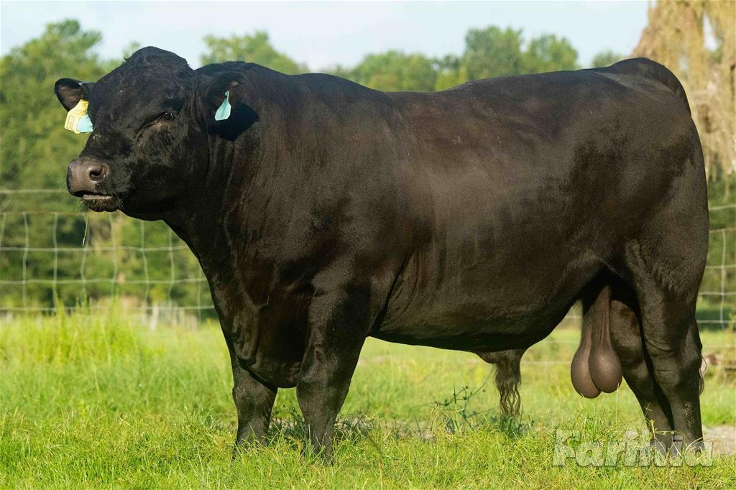 Answer Choice: _______________

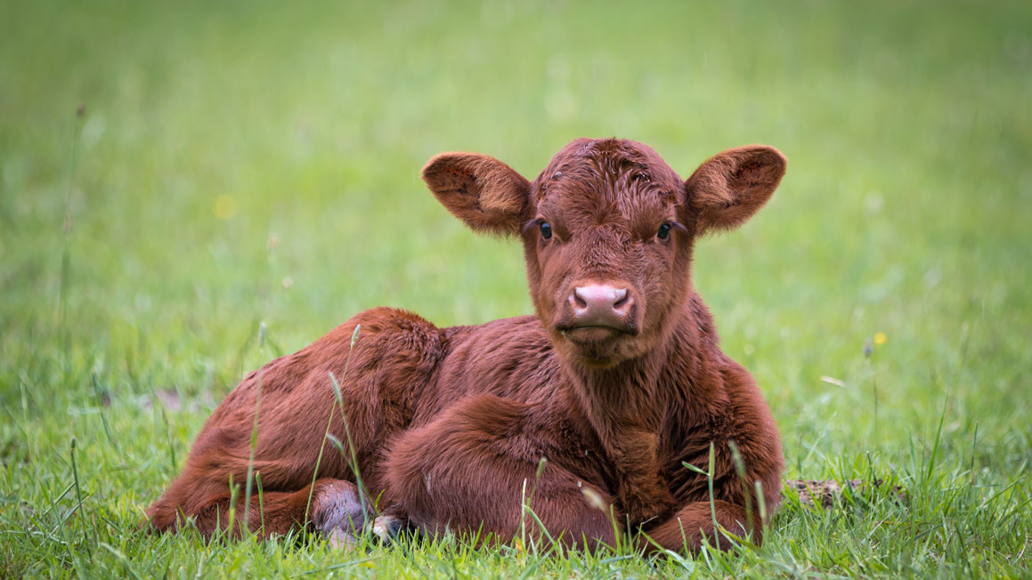 Answer Choice: _______________

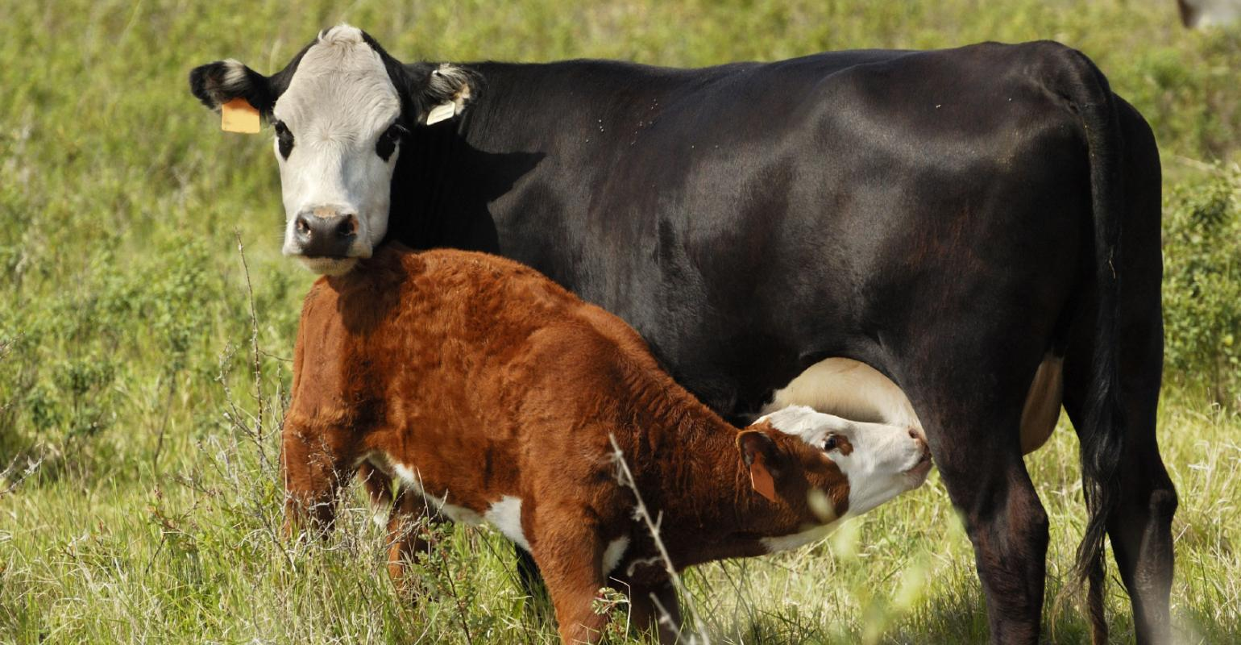 Answer Choice: _______________

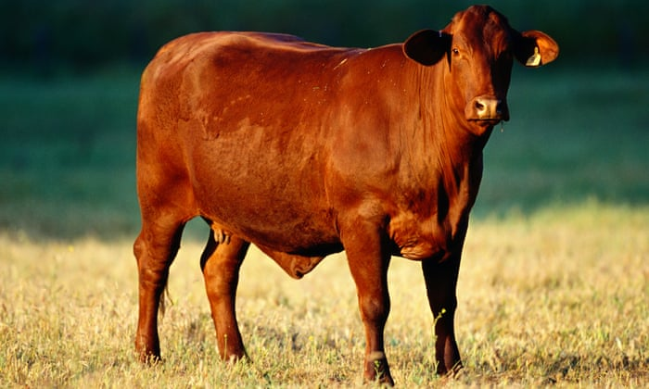 Answer Choice: _______________

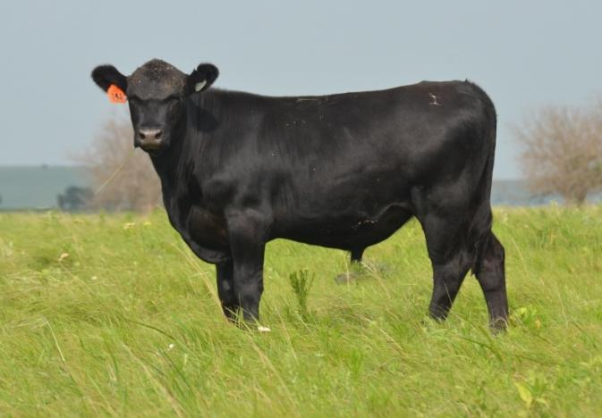 Answer Choice: _______________

Directions: Answer the questions below in complete sentences. These terms are commonly utilized in the beef cattle industry, so understanding their meaning is essential.

- What is the difference between a heifer and a cow?

- What must occur to transform a bull into a steer?

Bonus – Extra Credit Opportunity

- How many steers are born annually in the United States?

Beef Industry – Anatomy

Competency: FL DOE 28.02 – Compare and contrast desirable anatomical and physiological characteristics of animals within and between species.

Directions: The figure below showcases the main body parts of beef cattle. Using this figure and the word bank provided, match the terms to the numbers located on the steer. Once you have identified the term for a specific number, place that number with the term in the word bank. Use the example as a reference.
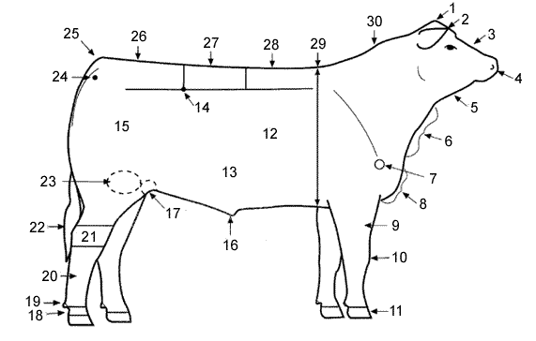
16
Word Bank
Back #____ | Belly #____ | Brisket #____
Cannon Bone #____ | Crest #____ | Dew Claw#____
Dewlap #____ | Ear #____ | Face #____
Forearm #____ | Heart Girth #____ | Hook #____
Hock #____ | Hoof #____ | Knee #____
Loin #____ | Muzzle #____ | Pastern #____
Pin #____ | Point of Shoulder #____ | Poll #____
Quarter #____ | Rear Flank #____ | Rib #____
Rump #____ | Example Sheath #16 | Stifle Joint #____
Switch #____ | Tail Head #____ | Throat #____

