Beef Industry – Wholesale and Retail Cuts

Competency: FL DOE 06.05 – Investigate the nature and properties of food, fiber, and by-products from animals.

Directions: The figure below showcases the wholesale and retail cuts of beef. Using this figure and the word bank provided, match the terms to the letters located on the carcass. Once you have identified the term for a specific letter, place that letter with the term in the word bank. The highlighted words have been provided to aid in identifying the position of the carcass.

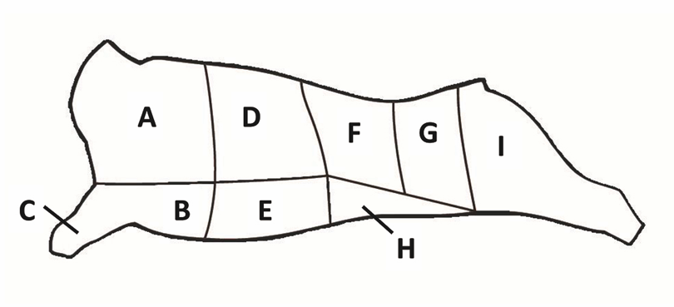
Tail
Back Legs
Front Legs
Neck
Word Bank

Plate  Letter: ____ | Flank  Letter: ____ | Round  Letter: ____
Sirloin  Letter: ____ | Fore Shank  Letter: ____ | Brisket  Letter: ____
Rib  Letter: ____ | Chuck  Letter: ____ | Short Loin  Letter: ____
Beef Industry – By-Products

Directions: The figure below showcases an array of by-products that are produced from beef cattle. Surprisingly, cows produce more products than beef! For this portion of the assignment, please take a walk throughout your house to see how many beef by-products are within your home. If you were able to locate the item in your home, simply place an X next to the term in the word banks provided.
From Fat
Chewing Gum
Candles
Detergents
Deodorant
Shaving Cream
Perfume
Pet Food
Cosmetics
Cream and Lotions
Crayons
Paint
Oil
Biodiesel
Plastics
Waterproofing Agents
Cement
Ceramics
Chalk
Fertilizer
Antifreeze
Insulation
Rubber
Medicines
From Skin
Gelatin
Flavorings
Emery Boards
Sheet Rock
Wallpaper
Adhesives
Medicines
Candies and Confectionary
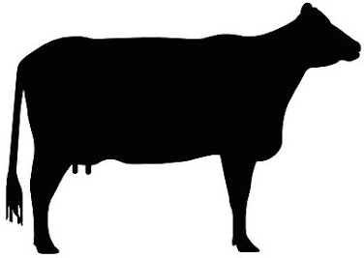
From Hair
Air Filters
Brushes
Felt
Insulation
Plaster
From Hooves and Horns
Adhesives
Plastics
Pet Food
Plant Food
Photo Film
Shampoo and Conditioner
Emery Boards
Lamination
Wallpaper
Plywood
By-Product List from Farm Credit Knowledge Center: www.farmcreditknowledgecenter.com

From Milk
Adhesives
Plastics
Cosmetics
Medicines
From Blood
Pasta
Cake Mixes
Dyes and Inks
Adhesives
Minerals
Medicines

From Bones
Refined Sugar
Charcoal
Fertilizer
Glass
From Manure
Fertilizer
Nitrogen
Phosphorus
From Brain
Anti-Aging Cream
Medicines
From Internal Organs
Instrument Strings
Tennis Racquet Strings
Enzymes
Vitamins
Medical Materials

