Beef Industry – Breeds

Competency: FL DOE 06.02 – Analyze commercially important livestock breeds in Florida.

Directions: The pictures below portray nine common breeds found throughout the beef industry. Using the list of breed choices and the website provided, http://afs.okstate.edu/breeds/cattle/, please identify the breed of cattle and the characteristics associated with each.

Breed Choices: Hereford, Brahman, Santa Gertrudis, Angus, Brangus, Simmental, Texas Longhorn, Charolais, and Chianina
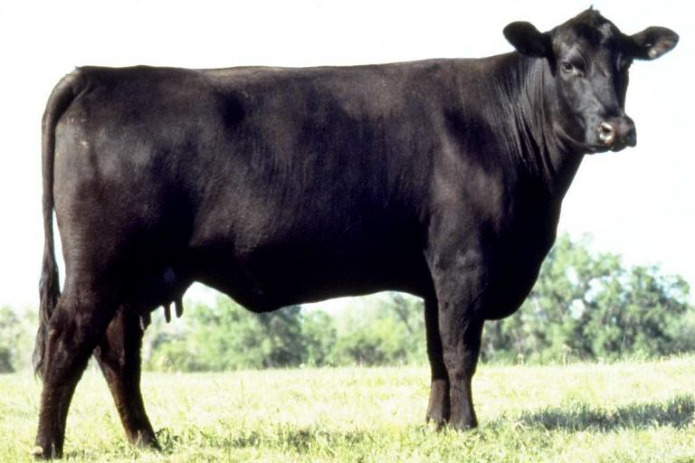
Breed:
Characteristics:

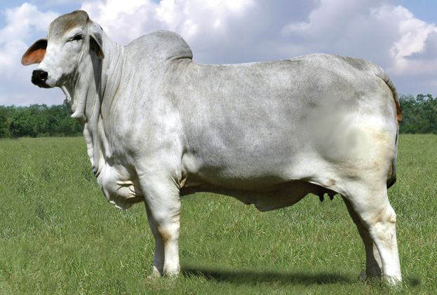
Breed:
Characteristics:

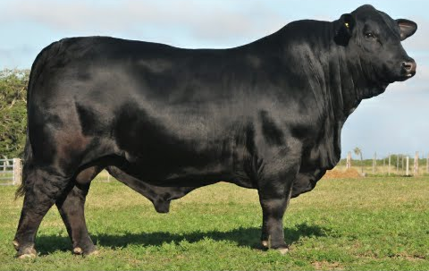
Breed:
Characteristics:

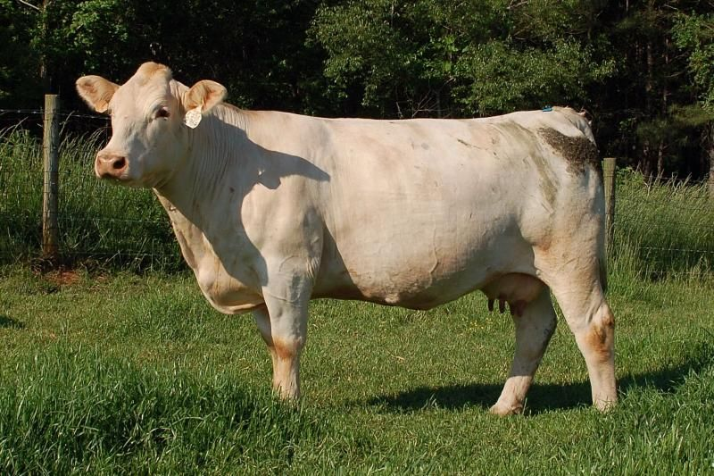
Breed:
Characteristics:

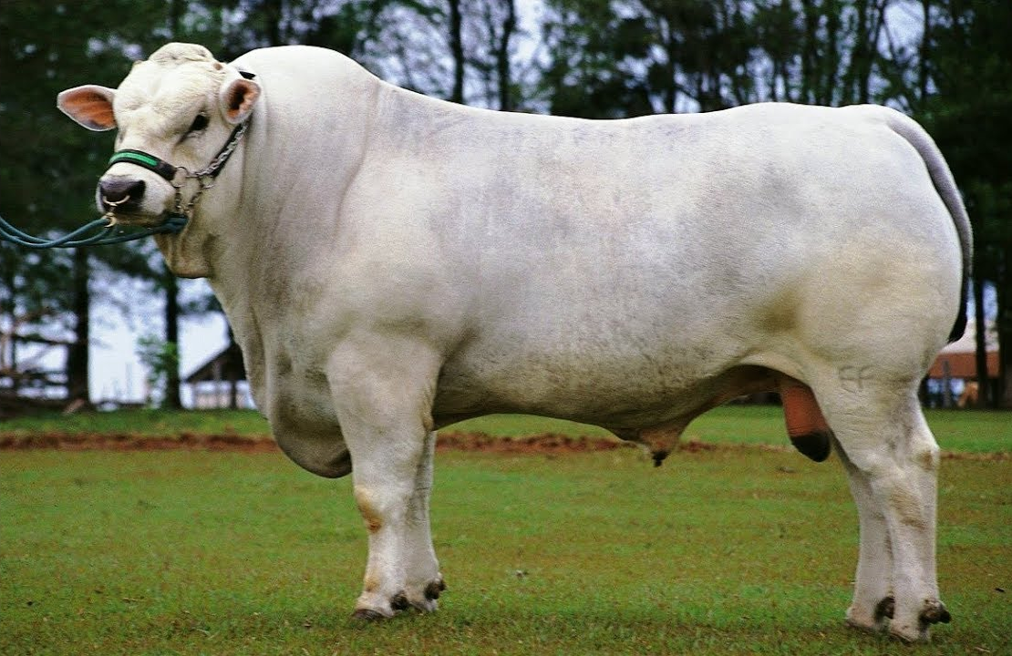
Breed:
Characteristics:

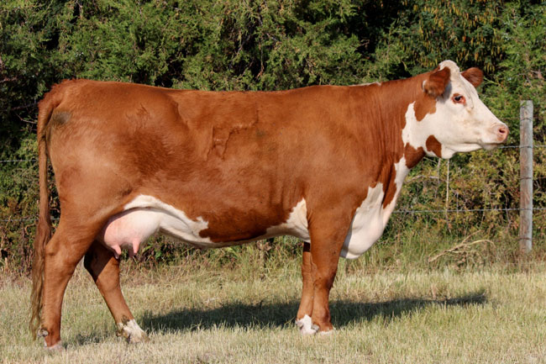
Breed:
Characteristics:

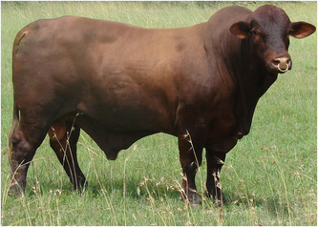
Breed:
Characteristics:

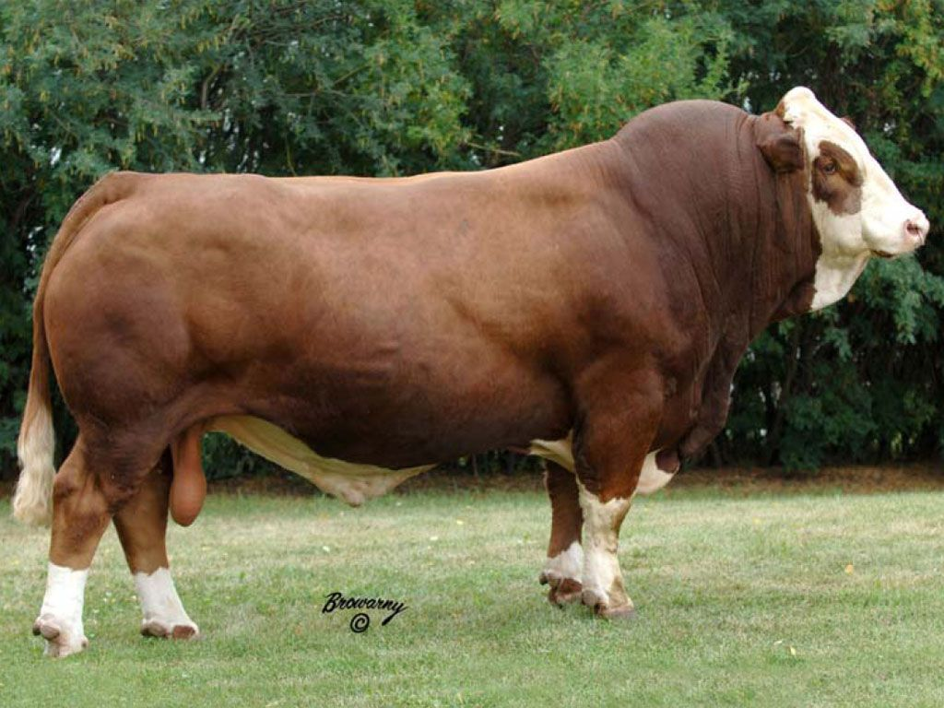
Breed:
Characteristics:

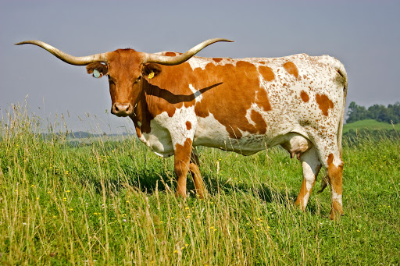
Breed:
Characteristics:

Directions: You have been chosen to establish a ranch in Florida that specializes in producing beef cattle. Based off of the information you’ve collected above pertaining to the different breeds, answer the questions below.

- What breeds of cattle would you select?

- Why did you select these specific breeds?

- What characteristics would be ideal for a ranch located in Florida?

- Do Texas Longhorns pose any safety concerns? If so, what are they?

