Poultry Industry Web Quest
Competency: FL DOE 06.02- Analyze commercially important livestock breeds in Florida.
Directions: As scientists, it is our job to conduct research and make ourselves knowledgeable consumers, which we can do easily with access to the internet! Using credible websites, please answer the following questions regarding the poultry industry. All questions should be answered in complete sentences.
Websites to reference:
- https://www.incredibleegg.org/
- https://www.ers.usda.gov/topics/animal-products/poultry-eggs/
- http://www.poultryhub.org/
- https://www.nationalchickencouncil.org/
- http://www.vicvet.com/index.php

Define the following vocabulary terms:
Poultry-
Broiler-
Layer-
Hatchery-
Candling-
Web Research Questions
- What are two health benefits derived from eating eggs?

- What kinds of feed do chickens eat?

- In comparison to pork and beef consumption, where does poultry consumption stand?

- What are the three different types of poultry operations?

- What 4 production types of eggs can be found in the layer industry?
- Since the beginning of poultry production, birds have continuously gotten bigger and produced more resources. How is this possible?

- In general, approximately how many eggs can a commercial hen produce in a year?

- In general, approximately how much does a broiler chicken weigh at harvest?

- Why are eggs cleaned and given a coating of mineral oil?

- Why are layer hens smaller in comparison to broiler chickens?

- What are the different grades of eggs?

- Why do we grade eggs differently?

- What is the purpose of a nesting box?

- List the three common identification methods used in poultry.

- Name and describe two cuts of poultry (chicken you would buy at the store).

Bonus question: What is the nutritional difference between a white and brown egg? Are brown eggs only laid by brown chickens?

Chicken External Anatomy
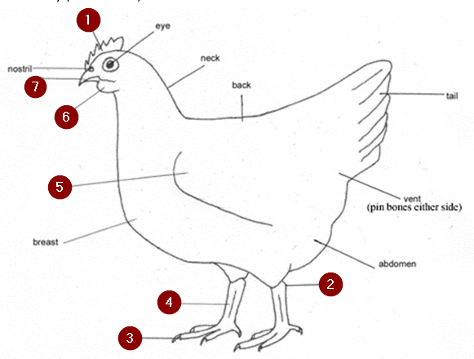
Beak | Comb | Claw | Chin | Hock
Breast | Spur | Toe | Wing | Wattles

Using the diagram and word bank above, please label the remaining pieces of the diagram. Not all answers will be used.

