Monogastric Digestion
Competency: FL DOE 06.02- Analyze commercially important livestock breeds in Florida.
Directions: Using the article on swine digestion found at http://www.swineweb.com/the-digestive-tract-of-the-pig1/ you will define the components of swine digestion, as well as answer the following questions pertaining to monogastric digestion. Please read the entire article and answer all questions with complete sentences.

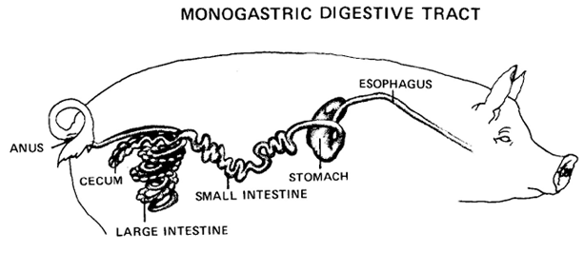
Vocabulary to know- define each and give the functions of each digestive organ.
Monogastric-
Ruminant-
Esophogus-
Stomach-
Small intestine-
Large intestine-
Cecum-
Anus-

Research Questions- Please answer each question in complete sentences.
- What is the difference between ruminant digestion and monogastric?
- Give 3 examples of living things with monogastric digestive systems.
- What role does the mouth play in digestion?
- What is the difference between the anus and the rectum?
- What are some examples of grains that pigs commonly eat?
- Where and how does the chemical break down of food occur?
- What is the cecum and how is it utilized?
- What are the three parts of the small intestine and their functions?
- How does food move through the large intestine?
- What is the purpose of villi in the small intestine?

Bonus question- Please answer in 3-5 complete sentences.
Why is it important to understand the digestive system of an animal we raise or consume?

