Swine Sort Through
Competency: FL DOE 06.02- Analyze commercially important livestock breeds in Florida.
Directions: Using online resources such as pork.org (the Pork checkoff website), research each of the following breeds of pig. Once you have conducted your research, you will give a short description of each breed with a minimum of 3 full sentences. Breed descriptions should include the origin of the breed and its purpose- are they good pork producers or breeders? You will also illustrate each breed and include a sketch of their ears which will be either erect or droopy depending on the breed.

Vocabulary to know before beginning:
Farrowing: the act of giving birth in swine.
Artificial Insemination: The process of collecting sperm from a male to manually deposit the semen into the reproductive tract of the female.
Natural Breeding: Allowing a male and female pig to mate without human intervention.
Boar: Intact male pig used for breeding.
Gilt: Mature female pig who has had piglets.

Berkshire:
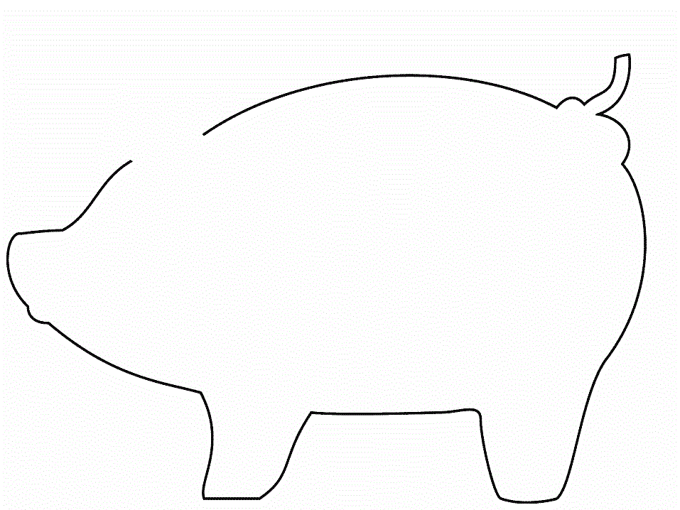
Description:____________________________________________________________________________________________________________________________________________________________________________________________

Chester White:

Description:______________________________________________________________________________________________________________________________________________________________________________________________________________________________________________________________

Duroc:

Description:______________________________________________________________________________________________________________________________________________________________________________________________________________________________________________________________

Hampshire:

Description:______________________________________________________________________________________________________________________________________________________________________________________________________________________________________________________________

Landrace:

Description:______________________________________________________________________________________________________________________________________________________________________________________________________________________________________________________________
Poland China:

Description:______________________________________________________________________________________________________________________________________________________________________________________________________________________________________________________________

Yorkshire:

Description:______________________________________________________________________________________________________________________________________________________________________________________________________________________________________________________________

Review, Refresh
Please answer each of the following questions in 1-2 complete sentences.
- Why might artificial insemination be used on large swine operations rather than natural breeding?
__________________________________________________________________________________________________________________________

- In your opinion, which breed seems to be the most well rounded? Who can do it all? __________________________________________________________________________________________________________________________

- If you were going to crossbreed two swine breeds to bring into your heard, which two would you cross? Why?
__________________________________________________________________________________________________________________________

- Which breeds have erect ears?
__________________________________________________________________________________________________________________________

- Which breeds tend to have a higher maternal instinct?
__________________________________________________________________________________________________________________________

