Hutton Onboarding Tutorial
AEC Master’s Project
Dolores (Dolly) Cummings
Fall 2019

Table of Contents

Instructional Program Plan 2
Cornerstone Tasks and Grading 3
Lesson 1- Orientation- First Things First 5
Lesson 2- Seed Sowing 9
Lesson 3- Field Planting 11
Lesson 4- Pruning in the Breeding Bench 13
Lesson 5- Tomato Diseases in the Greenhouse 16
Lesson 6- Emasculating tomato flowers 19
Lesson 7- Pollinating in the Breeding Bench 22
Lesson 8- Fruit Harvest from Breeding Bench 24
Lesson 9- Fruit Harvest from Field 26
Lesson 10- Harvest for Yield 28
Program Evaluation Model 30
Survey- Qualtrics 32
References 34

Instructional Program Plan
Program Mission
The mission of University of Florida/IFAS Gulf Coast Research Center (GCREC) is to develop and share new science-based information and technology that will help Florida's agricultural industry compete in a global marketplace. To that end, skills for supporting the research in the Tomato Breeding Lab will reflect the best practices in this sector.

Program Values
The Hutton Onboarding Tutorial values…
- Excellence - We perform at the highest level, always learning and looking for ways to improve.
- Mutual Respect - We embrace diversity and treat one another with dignity and respect.

Program Learning Principles
- Students’ prior knowledge can help or hinder learning.
- Goal-directed practice coupled with targeted feedback enhances the quality of students’ learning.
Program Transfer Goals
- Communicate effectively based on purpose, task, and audience using appropriate vocabulary.
- Demonstrate professionalism through exhibiting attentiveness, following best practices, growing from feedback, and adhering to Lab standards

Instructor
Dolly Cummings
Biological Scientist II
Hutton Lab
813-363-5438
dollyc@ufl.edu
Office Hours: by appointment

Time and Location
Begin within one week of hire
Location: Hutton Lab

Course/Workshop Description
Students will train in the proper Knowledge, Skills and Attitudes necessary to work in the Hutton Tomato Breeding Lab.
Course/Workshop Understanding
Learners will understand that:
- Best practices ensure proper preparation and execution of protocols that produce desired results.
- Careless practices will result in deficiencies, disease and lower outputs.
The Program consists of 10 lesson modules, comprised of a presentation or video, optional reading material, knowledge assessment and/or skills checklist for mastery and a survey to help inform future revisions.

Course Cornerstone Tasks and Grading

Orientation (OR)
Students will complete all the entry requirements of HR. Navigate to the locations for all Tomato Lab work areas. Review the history of the Gulf Coast Research and Education Center’s Tomato Lab.

Seed Sowing (SS)
Students will learn the proper protocols for sowing seeds, as well as filling/thinning, inventory for adequate germination and re-sowing as needed. Understanding the use of different growing mediums and preparations that are required for different trials is important. An understanding of the color coding system is essential to plant culture and maintenance parameters.

Field Planting (FP)
Students will understand how to select plants according to the specific genetic requirements and the proposed field map, ensuring that controls are included. An understanding of the field markings is required to ensure proper placement and map coordination.

Breeding Bench (BB)
Students will learn the proper protocols necessary to manage the parent plants and perform successful hybrid crossings. Accuracy and attention to detail is required to ensure that the correct parent pedigrees are reflected in the subsequent seed produced.

Fruit Harvest (FH)
Students will learn the proper protocols necessary to harvest appropriate fruit and label for seed extraction. Accuracy and attention to detail is required to ensure the correct seed is available for future experimental trials and observations.

Grading / Assessment
All tasks must be completed with 100% accurately.

Refresher
A repeat of any lesson will be required if tasks are not completed with 100% accuracy. A refresher lesson/assessment is also required at the beginning of each season (Spring and Fall) to ensure that protocols will be conducted accurately and efficiently in subsequent seasons.

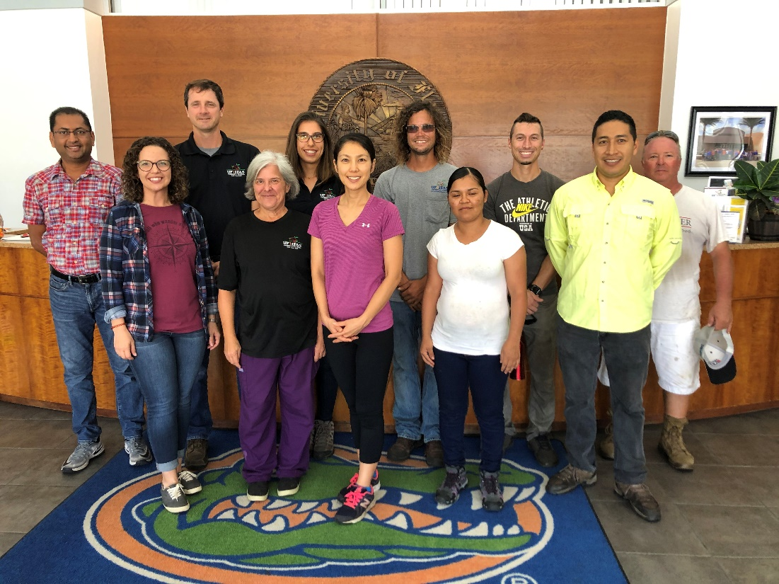
Tomato Lab staff Fall 2019

Daily Plan |  |  | Educator: | Dolly Cummings
Lesson Title: | 1- Orientation- First Things First
Unit/Program: | Hutton Onboarding Tutorial
Estimated Time: | 30 min +
Materials, Supplies, Equipment, References, and Other Resources:
Powerpoint, map handout
Links for mandatory UF/IFAS- GCREC trainings- Heat Stress, Hazardous Waste, etc.

Learning Outcomes
Essential Question: |  | Where did the tomato lab begin and what basic information should all staff know to work here?
Learning Objectives: |  | - Review the history of the Tomato Lab at Gulf Coast Research and Education Center (GCREC).  - Locate the various buildings and their purpose utilized by the Tomato Lab  - Know where to find and complete the required GCREC trainings.

Preflection/Introduction (Interest Approach) | Estimated Time: 2 minutes
It often helps to understand where one fits into an organization by learning how it got to where it is, what are the names of various commonly used locations on campus and the sundry tasks necessary for every new employee to complete. This is the start of your journey with the Hutton Tomato Lab at GCREC.

Learning Activity 1 |  | Estimated Time: 10 min.
Instructor Directions / Materials | Brief Content Outline
Powerpoint  Link to GCREC website | Modified presentation created by grad student Jessica Chitwood-Brown that provides overview of Tomato Lab. Includes brief history of tomato production in Florida, the start of GCREC in Bradenton, FL., its move to Balm Florida, and its continued growth. Details of tomato lab successes such as the Tasti-Lee tomato hybrid, as well as ongoing experiments and trials are described.  Additional information about GCREC at https://gcrec.ifas.ufl.edu/

Learning Activity 2 |  | Estimated Time: 10 min.
Instructor Directions / Materials | Brief Content Outline
Aerial photo- annotated | Aerial photo annotated with names of buildings. A handout provides a handy map of locations that are used by tomato lab staff and which tasks are completed at each location. It also includes labels that designate how each location is used.

Learning Activity 3 |  | Estimated Time: varies
Instructor Directions / Materials | Brief Content Outline
Links to required HR trainings | Links are provided to allow easy access to the HR required trainings at GCREC:  - Heat Stress  - Hazardous Waste  - Collaboration for Success!  - Entering & Adjusting Time: Hourly OPS (Non-Exempt) [Note: not a required training but important information]  - Other payroll related information https://learn-and-grow.hr.ufl.edu/toolkits-resource-center/human-resources-toolkits/time-and-labor/

Summary (Reflection) | Estimated Time: 2 min
Repeat Learning Objectives:
- Review the history of the Tomato Lab at Gulf Coast Research and Education Center (GCREC).
- Locate the various buildings and their purpose utilized by the Tomato Lab
- Know where to find and complete the required GCREC trainings.

Evaluation
Quiz- matching names to places on campus map.

Rubric Checklist- Verify completion of HR required trainings.

Survey for future revisions

Lesson 1 Orientation handout
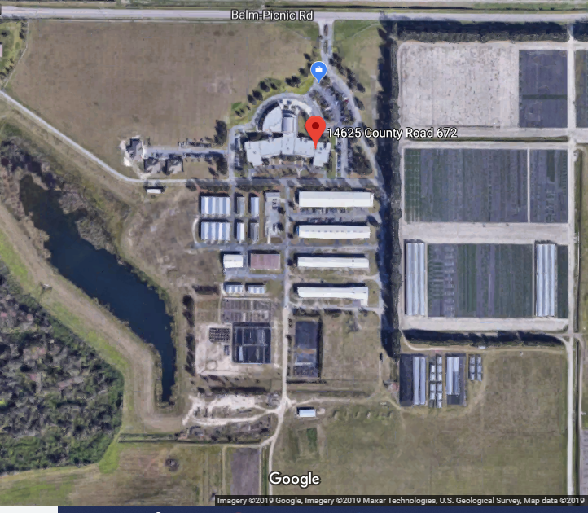
Tomato Lab- Field lab
Tomato Lab- Breeding Bench
Tomato Lab- Molecular Lab
Tomato Lab- Dr. S. Hutton office
Tomato Lab- Storage
Tomato Lab- Seed Extraction
Tomato Lab- Seed Cooler
Tomato Lab- Fruit Cooler
Speedling
(AKA Sawtooth
AKA Production)
Greenhouse
Main entranceGCREC
Map of GCREC noting areas used by Hutton Tomato Lab.
Work hours are 8am-4:30pm
Lunch time is 12:00- 12:30pm. There are no food service facilities within a reasonable distance to get you there and back in time so plan to bring your lunch each day. Refrigerator, microwave and other appliances are available for use in the break room. Fifteen-minute breaks start at 10am and 3pm.
If you are ill and can’t come to work or are running late, contact Dolly:
Text: 813-363-5438; Email: dollyc@ufl.edu
All requests for time off must be approved by Dolly and/or Dr. Sam Hutton.
Provide your contact information to Dolly for daily lab communication.
Tasks for each day are written on the whiteboard in the field lab. Check it for priorities. Be advised that any task is subject to change as conditions warrant.
Lesson 1 Orientation Quiz:
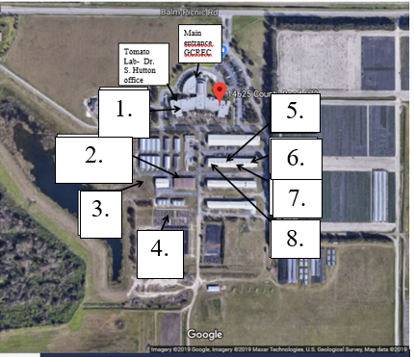
Match the numbered building above with the name and purpose of the area:
1. D A. Breeding Bench
2. E B. Field Lab
3. B C. Fruit Cooler
4. A D. Molecular Lab
5. H E. Production House
6. G F. Seed Cooler
7. F G. Seed Extraction
8. C H. Storage
Did you complete the following HR trainings?
yes no - Heat Stress
yes no - Hazardous Waste
yes no - Collaboration for Success!
yes no - Entering and Adjusting Time (OPS)

Daily Plan |  |  | Educator: | Dolly Cummings
Lesson Title: | 2- Seed Sowing
Unit/Program: | Hutton Onboarding Tutorial
Estimated Time: | 8 min
Materials, Supplies, Equipment, References, and Other Resources:
Power-point, Wooden stakes, prepared seed packets, planting trays, soil, sowing board, vermiculite, needles

Learning Outcomes
Essential Question: |  | What is the best way to sow seeds for most reliable germination and growth?
Learning Objectives:
- Know the best practices for sowing seeds in production greenhouse.
- Demonstrate how to fill (transplant) and thin (remove extra seedlings in well) for optimal growth.
- Know the significance of colored plastic stakes for growth maintenance tasks.

Preflection/Introduction (Interest Approach) | Estimated Time: <1 min
The success of any trial or experiment starts with the sowing of the seeds that will become the plants of interest to the researcher. Careful attention to detail at this stage will help prevent many problems later in the growth cycle.

Learning Activity 1 |  | Estimated Time: 6 min
Instructor Directions / Materials | Brief Content Outline
Powerpoint with instructions for best practices for seed sowing. | Powerpoint slides:  - Picture of planting trays, soil and water; explanation of multiple passes with water to ensure soil is thoroughly moistened.  - Picture of sowing board in use showing depth of hole for seed.  - Picture of seed packets with stakes ready for sowing; explanation of markings on stake denoting rows to sow, notes on packet regarding line number of seed and other information needed.  - Picture of sown tray with subsequent addition of soil, vermiculite and more water  - Picture of colored stakes and details of their significance for growth maintenance task.  - Picture of multi-plant wells in trays with empty wells (before) and trays after filling and thinning. Note special cases.

Summary (Reflection) | Estimated Time:<1
Review Learning Objectives
1. Know the best practices for sowing seeds in production greenhouse.
2. Demonstrate how to fill (transplant) and thin (remove extra seedlings in well) for optimal growth.
3. Know the significance of colored plastic stakes for growth maintenance tasks.

Evaluation
Skills evaluation:
Student will be given packets of prepared seed and instructed to sow them according to lesson protocols.

Rubric checklist:
__ Soil filled planting tray sufficiently moist throughout well.
__ Stakes are properly spaced according to instructions provided.
__ Seeds are sown in tray prepared using sowing board.
__ Seeds are placed 2 per well (may contain up to 4 without penalty) in wells without identifying stake.
__ In wells with identifying stake, up to a dozen seeds are sown as insurance against low germ.
__ Trays are covered with thin layer of soil.
__ Trays are next covered with thin layer of vermiculite.
__ Trays have been watered in to settled the soil around the seeds.
__ Colored stakes, as necessary, have been placed in each tray where specified.

Color stake quiz
1. If the trays have been designated for whitefly vectored disease experiments, what color plastic stake is used to alert spray crews not to use systemic insecticide?
- Orange
- Red
- White
- Blue
2. If the trays have plastic stakes within them that are white, what does this signify?
a. Do not use overhead spray
b. Handle with gloves only
c. Selections depend on genetic marker data
d. Water lightly.
3. As you are filling and thinning a group of seedlings in the E500 group, you notice that some stems are green and others are purple. What do you do?
a. Continue filling and thinning, this means nothing important at this stage.
b. Bring this to Dr. Hutton’s attention- this must be an error.
c. Fill wells with equal amounts of green and purple stemmed seedlings.
d. Note ‘seg’ on stake and fill all but last row with purple stems, last row with green stems.

Survey for future revisions

Daily Plan |  |  | Educator: | Dolly Cummings
Lesson Title: | 3- Field Planting
Unit/Program: | Hutton Onboarding Tutorial
Estimated Time: | 10 minutes
Materials, Supplies, Equipment, References, and Other Resources:
Field map, planting trays, field stakes, paint can, field tags
Learning Outcomes
Essential Question: |  | What is the procedure for preparing and planting in the field?
Learning Objectives:
- Know how to set up and pull plants into trays based on field map.
- Know how to transplant seedlings from trays to field
- Complete required steps for field identifications.

Preflection/Introduction (Interest Approach) | Estimated Time:<1 min
Proper field transplanting will continue the best management practices started during seed sowing to help prevent problems during the growing season. Efforts performed now will help set the course for a productive growing season and reduce any confusion as the season progresses.

Learning Activity 1 |  | Estimated Time: 8 min
Instructor Directions / Materials | Brief Content Outline
Powerpoint with instructions for best practices for field planting | Powerpoint slides:  - Picture: Field map showing locations for each plot.  - Picture: Trays prepared with field stakes in the process of pulling selected plants.  - Picture: Tray with white stakes that signify special selections needed based on genetic marker data. Second picture of wooden stake with selection numbers indicated below plot number.  - Picture: Blinds, odd growth, disease- all seedlings to avoid selecting.  - Picture: Last row in each tray saved for control plots to be added later. Choice of control based on pedigree of closest plots- note plot numbers so that controls can be determined from planting outline.  - Picture: Completed trays numbered, placed in vehicle efficiently.  - Picture: Depicts proper depth and procedure for transplanting.  - Picture: Post transplanting tasks- paint denoting walkways, painted lines at each stake denoting start of plot, later field tags on stakes after first tie.

Summary (Reflection) | Estimated Time: <1 min
Review learning objectives.
- Know how to set up and pull plants into trays based on field map.
- Know how to transplant seedlings from trays to field
- Complete required steps for field identifications.

Evaluation
Skills evaluation:
Student will be given prepared field stakes to set up in trays and pull required plants for field. Field work will include transplanting, paint markings and describing later step needed- field tags on stake after first tie.
Rubric checklist:
__ Stakes are placed correctly in trays according to number of plants noted at bottom of stake.
__ Last row in tray is left empty (to be filled later by control plants).
__ Plants are pulled that do not include blinds, odd growth or diseased plants.
__ Where white plastic stakes indicate marker data, plants have been pulled according to numbers on wooden stake.
__ A prominent stake in each tray indicates the order in which the trays will be planted.
__ Trays are loaded in transport vehicle in opposite order than they will be planted so the first one to be planted is last one on the vehicle, nearest tailgate.
__ Row plastic pulled back if necessary to prevent damage to seedling.
__ Seedlings are planted at the correct depth based on length of stem.
__ Surrounding soil pulled in to cover root ball.
__ Line painted on plastic row cover at each plot stake.
__ Walkway lines painted in designated locations.
__ Verbal indication of need for field tags after plant stakes in place and first tie completed.

Survey for future revisions

Daily Plan |  |  | Educator: | Dolly Cummings
Lesson Title: | 4- Pruning in the Breeding Bench
Unit/Program: | Hutton Onboarding Tutorial
Estimated Time: | 7 min
Materials, Supplies, Equipment, References, and Other Resources:
Tomato plants growing in Breeding Bench
Alcohol, 70% spray bottle
Pruning shears or scissors (optional)
Disposable gloves (optional)

Learning Outcomes
Essential Question: |  | How do you control for proper growth of tomato plants in the hybrid greenhouse?
Learning Objectives:
- Students will understand the need to use proper sanitary procedures to avoid introduction of pests and diseases in the hybrid greenhouse
- Students will learn the proper protocol for pruning tomato plants in the hybrid greenhouse.

Preflection/Introduction (Interest Approach) | Estimated Time: 1 min
Brief story about why this topic is critical by describing how greenhouse growth culture can go wrong. Mention overgrowth of indeterminate varieties that caused ‘jungle’ conditions, nutrient deficiencies that cause blossom end rot, infestations of whitefly, overspray from outside greenhouse of weed killers that entered via vents that stunted growth, etc.

Learning Activity 1 |  | Estimated Time: 5 min
Instructor Directions / Materials | Brief Content Outline
Powerpoint with instructions on sanitary procedures and pruning technique.  Handout of Points to Remember | - Picture: Entryway bleach tray and alcohol spray bottles.  - Picture: Plant Parts graphic from handout  - Picture: Tomato plant with sucker  - Picture: Sucker near terminal branch is retained for backup in case terminal branch is injured, stunted, or otherwise less than optimal.  - Picture: Growing tip trained up the string to keep branches off ground for easier access.  - Picture: Difference between compact growth tomatoes (CGH) and micro tomato plants vs. other tomato growth types in greenhouse. CGH tomatoes and micros do not get pruned except to remove dead or diseased leaves. CGH tomatoes are flagged with orange ribbon.  - Picture: Later in season, indeterminate types continue to grow so should be pruned to be no taller than 7 feet.

Summary (Reflection) | Estimated Time: <1 min
Review learning objectives
- Students will understand the need to use proper sanitary procedures to avoid introduction of pests and diseases in the hybrid greenhouse
- Students will learn the proper protocol for pruning tomato plants in the hybrid greenhouse.

Evaluation
Skills evaluation:
Student will be given equipment and asked to prune at least one row in Breeding Bench.

Rubric checklist:
__ Upon entering greenhouse, feet were dipped in bleach tray.
__ Used alcohol to sanitize hands or put on disposable gloves.
__ Used alcohol to sanitize equipment, if used.
__ Removed all suckers except for one closest to growing tip.
__ No unhealthy leaves remain on plant below the first flower cluster.
__ Lower leaves (below soil bag rim) removed.
__ No pruning done on orange flagged plants (CGH and micro)

Survey for future revisions

Tomato Plant ‘Anatomy’ Handout
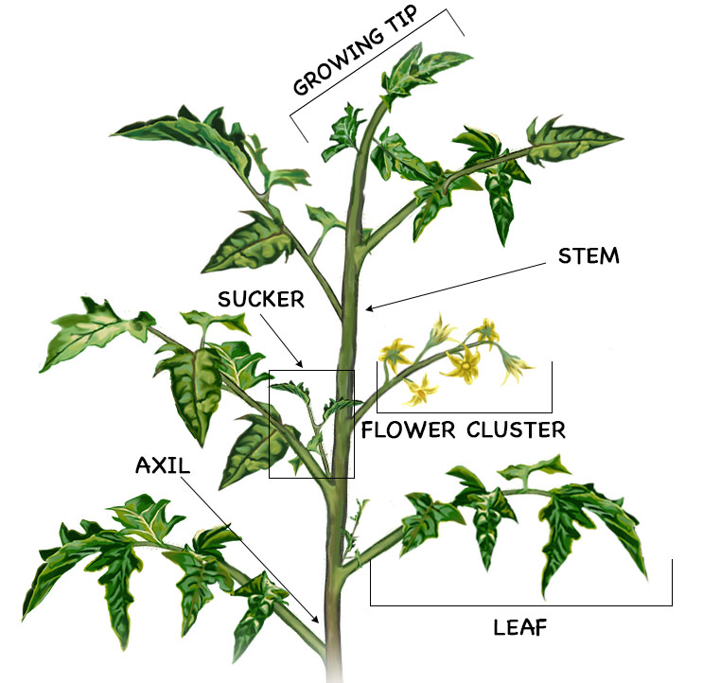
Points to remember
- Sanitize equipment and hands with 70% alcohol. Gloves are optional.
- Using pruners, scissors and/or snapping with hand, remove suckers as well as unhealthy-looking leaves below the first flower cluster.
- The sucker near terminal branch is retained for backup in case terminal branch is injured, stunted, or otherwise less than optimal.
- As the plant grows taller, the growing tip should be trained up the string to keep branches off ground for easier access and damage prevention.
- Note the difference between compact growth tomatoes (CGH) and micros vs. other tomato growth types in greenhouse. CGH and micros are not pruned except to remove dead leaves. These are flagged with orange ribbon.
Graphic credit: https://bonnieplants.com/gardening/how-to-prune-tomatoes/

Daily Plan |  |  | Educator: | Dolly Cummings
Lesson Title: | 5- Tomato Diseases in the Greenhouse
Unit/Program: | Hutton Onboarding Tutorial
Estimated Time: | 8 min
Materials, Supplies, Equipment, References, and Other Resources:
Powerpoint on Tomato diseases
Handout- ID of tomato diseases
Learning Outcomes
Essential Question: |  | How can we tell a healthy tomato plant from one that is not healthy?
Learning Objectives:
- Learn the symptoms of common tomato diseases in the greenhouse.
- Identify main modes of disease transmission- vector, contact and air-borne.

Preflection/Introduction (Interest Approach) | Estimated Time: 2 min
Reflect on last lesson where diseased tomato leaves were discussed in relation to pruning. Knowing how diseases are transmitted is our first line of defense to maintain a healthy greenhouse. Relate story of past issues with TMV (tobacco mosaic virus) and what was required to eliminate it.

Learning Activity 1 |  | Estimated Time: 5 minutes
Instructor Directions / Materials | Brief Content Outline
Powerpoint- modified from Dr. Vallad’s Tomato Diseases in the Field  Handout- ID of tomato diseases | Slides for common tomato diseases in the greenhouse are reviewed along with key symptoms to watch for while working in this environment.  - Bacterial (contact)  - Fungal (airborne)  - Virus (vector and contact)

Summary (Reflection) | Estimated Time: 1min
Review learning objectives:
- Learn the symptoms of common tomato diseases in the greenhouse.
- Identify main modes of disease transmission- vector, contact and air-borne.

Evaluation
Quiz- acceptable score is 100%. Repeat lesson if necessary.
- How do diseases spread in tomato plants?
- Insects
- Contact with foliage
- Air-borne
- All of the above

- What is the vector that transmits the viral disease, TYLCV?
- Whitefly
- Spores
- Water
- Contact

- In what instance should you never enter the greenhouse?
- After eating
- Without gloves
- Right after working in the field
- Wet from the rain

- Which disease is often spread by people who smoke cigarettes?
- TYLCV
- TMV
- Bacterial spot
- Powdery mildew

- T F You can eliminate all disease spread in the greenhouse by wearing gloves.
- T F All virus diseases are spread by vectors.
- T F Bacterial diseases spread most rapidly in wet conditions.
- T F Disease scouting is critical to the health of the greenhouse.

Survey for future revisions

Tomato Diseases in the Greenhouse Handout
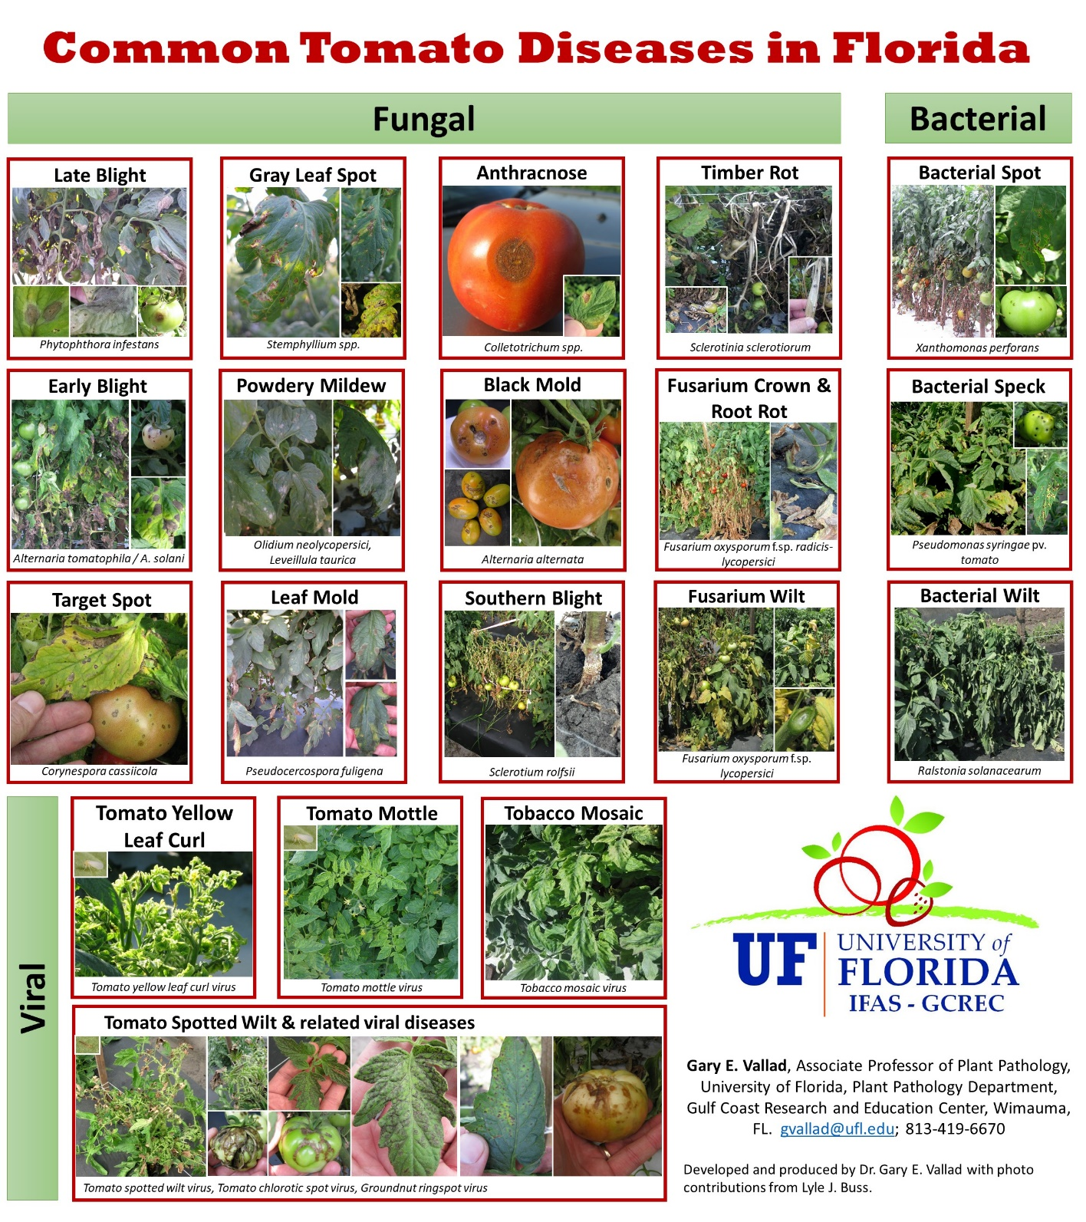
Notes:
Remember to dip your feet into the bleach tray at the door to the breeding bench greenhouse before entering.
Wearing gloves is optional but spray alcohol on your bare hands before working with plants. Repeat periodically. Note: if you smoke, do not enter greenhouse!
Do not enter greenhouse if you have been in the field earlier in the day.
Daily Plan |  |  | Educator: | Dolly Cummings
Lesson Title: | 6- Emasculating tomato flowers
Unit/Program: | Hutton Onboarding Tutorial
Estimated Time: | 10 min
Materials, Supplies, Equipment, References, and Other Resources:
Alcohol, forceps, colored string segments

Learning Outcomes
Essential Question: |  | How can we ensure that tomato flowers do not self-pollinate when creating hybrids?
Learning Objectives:
- Demonstrate skill at tomato flower emasculation
- Know the meaning for color codes.

Preflection/Introduction (Interest Approach) | Estimated Time: <1 min
In order to properly prepare tomato flowers to accept the specific pollen needed to create unique and distinct crosses, the flower’s original male parts must be removed to prevent self- pollination. This simple but effective procedure provides the reliability needed to ensure correct crosses for desired hybrids.

Learning Activity 1 |  | Estimated Time: 8 min
Instructor Directions / Materials | Brief Content Outline
Powerpoint with instructions on best practices for flower emasculation | Picture: Specific color ribbons- do not emasculate and why  Picture: Pink color ribbons should be emasculated- donor pollen in field.  Picture: If no ribbons on plant – emasculate; hang tag specifies cross.  Picture: Selection of flowers noting which are correct stage to work with.  Picture: Identify names of flower part using graphic  Picture: 1st step- remove sepals, signifies manual cross.  Picture: 2nd step- remove petals  Picture: 3rd step remove stamens.  Picture: 4th step- ensure style is intact, place color string across pedicel.  Picture: many prepped flowers-emasculate as many flowers at the correct stage as possible.

Summary (Reflection) | Estimated Time: < 1min
Review Learning Objectives:
- Demonstrate skill at tomato flower emasculation
- Know the meaning for color codes.

Evaluation
Quiz: Match the numbered flower part in the picture to its correct label in the right hand column.
9.  8.  7.  6.  5.  4.  3.  2.  1. | Flower parts:  - Ovary  - Ovule  - Pedicel  - Petal  - Pistil  - Seed  - Sepal  - Stamen  - Stigma  - Style
Key: | Flower parts:  - Ovary  - Ovule  - Pedicel  - Petal  - Pistil  - Seed  - Sepal  - Stamen  - Stigma  - Style

Tomato graphic from: http://tomatosphere.letstalkscience.ca/Resources/library/ArticleId/4767/the-life-cycle-of-a-tomato-plant.aspx

Multiple Choice (Answer key: correct terms are highlighted):
10. The name of the flower part that receives the pollen to complete fertilization is:
- Pedicel
- Petal
- Sepal
- Stamen
- Stigma

11. The name of the flower part that sheds the pollen to be used for fertilization is:
- Pedicel
- Petal
- Sepal
- Stamen
- Stigma

12. The name of the flower part that, when removed, shows the flower is a manual cross:
- Pedicel
- Petal
- Sepal
- Stamen
- Stigma

Skills Evaluation:
Student will be instructed to go to breeding bench to emasculate as many flowers at the appropriate stage as possible within 10 minutes.

Rubric Checklist:
__ Student dips shoes in bleach tray before entering greenhouse?
__ Student sprays hands with alcohol or put on gloves?
__ The flower was at the appropriate stage when emasculated?
__ ALL the sepals on the flower have been removed?
__ ALL the petals on the flower have been removed?
__ ALL the stamens on the flower have been removed?
__ The style is still intact?
__ There a colored string across the pedicel of every emasculated flower?

Survey for future revisions

Daily Plan |  |  | Educator: | Dolly Cummings
Lesson Title: | 7- Pollinating in the Breeding Bench
Unit/Program: | Hutton Onboarding Tutorial
Estimated Time: | 10 min
Materials, Supplies, Equipment, References, and Other Resources:
70 % Alcohol, pollinating spoons, pollen shaker, gel caps, cap tray, forceps, scalpel, pollen tubes (prepared with cotton/ dri-rite), labeling tape

Learning Outcomes
Essential Question: |  | How are tomato flowers manually pollinated?
Learning Objectives:
- Demonstrate skill extracting pollen using pollen spoon and shaker.
- Demonstrate skill extracting pollen from detached flowers from field into gelcaps.
- Demonstrate ability to pollinate prepared (emasculated) flowers using either pollen source.

Preflection/Introduction (Interest Approach) | Estimated Time: < 1 min
The hybrids produced in the Breeding Bench are the result of known parents. In the field, you would never be sure that there was no contamination from different nearby plants since domestic tomatoes are wind pollinated. In the controlled setting of the greenhouse, the pollen we choose to use is more reliably certain, as long as best practices are followed.

Learning Activity 1 |  | Estimated Time: 6 min
Instructor Directions / Materials | Brief Content Outline
Powerpoint part 1 | Picture: Suitable stage of flower to obtain pollen.  Picture: Placement of pollen spoon and pollen shaker.  Picture/video: pollen drop  Picture: using pollen filled spoon to touch previously exposed stigmas.  Picture: using pollen filled gelcap to touch previously exposed stigmas.  Picture/video: using pollen shaker to promote self-pollination (purple flag).  Picture: colored strings removed after pollination.

Learning Activity 2 |  | Estimated Time: 5 min
Instructor Directions / Materials | Brief Content Outline
Powerpoint part 2 | Picture: Layout of equipment and flowers for pollen extraction.  Picture: slice end of flowers to allow free flow of pollen.  Picture: write plant ID on gel cap, insert one end into holding tray.  Picture/video: flower held above gel cap, tap to release pollen.  Picture: close gel cap and place in labeled pollen tube.

Summary (Reflection) | Estimated Time: <1 min
Review Learning Objectives:
- Demonstrate skill extracting pollen using pollen spoon and shaker.
- Demonstrate skill extracting pollen from detached flowers from field into gel caps.
- Demonstrate ability to pollinate prepared (emasculated) flowers using either pollen source.

Evaluation
Skills evaluations:
Student is asked to pollinate one row of plants, previously prepared in breeding bench.
Rubric checklist:
__ Pollen was taken on pollen spoon from red-polka dot flagged plants where appropriate.
__ Stigma on appropriate emasculated flowers shows pollen coverage using pollen spoon.
__ Pollen was used from gel caps on pink flagged plants- stigma shows pollen coverage.
__ Pollen shaker properly used on purple flagged plant flowers.

Student is presented with 10 flowers from the field to extract pollen for gel cap storage.
Rubric checklist:
__ Flower tips are sliced to allow pollen flow.
__ ID of pollen source written on gel cap.
__ ID of pollen source written on label on pollen tube
__ Pollen extracted into gel cap.
__ Gel cap placed in correct pollen tube and stored in refrigerator.

Survey for future revisions

Daily Plan |  |  | Educator: | Dolly Cummings
Lesson Title: | 8- Fruit Harvest from Breeding Bench
Unit/Program: | Hutton Onboarding Tutorial
Estimated Time: | 9 min
Materials, Supplies, Equipment, References, and Other Resources:
Plastic harvest bags, harvest tags, industrial permanent marker

Learning Outcomes
Essential Question: |  | What concerns need to be addressed to harvest hybrid fruit from Breeding Bench?
Learning Objectives:
- Know the stages of tomato fruit ripening.
- Confirm fruit has correctly labeled harvest tag based on hang tag information.

Preflection/Introduction (Interest Approach) | Estimated Time: <1 min
There are many different crosses in the breeding bench. This could lead to errors if a system of checks is not in place. Fruit not only have to be ripe enough to have mature seeds, they must be labeled so there is no confusion or possibility of error. Care must be taken at all times.

Learning Activity 1 |  | Estimated Time: 7 min
Instructor Directions / Materials | Brief Content Outline
Powerpoint- with instructions on what to look for in breeding bench. | Picture: Equipment needed- harvest tags, plastic bags.  Picture: Parent plant with ripe fruit, ready for harvest.  Picture: Remove pedicel to prevent damage to fruit.  Picture: Tag in bag with fruit harvested next to harvested plant.  Picture: Multiple tied bags in crate.  Picture: Moving bags to fruit cooler.  Picture: Sorting by breeding bench number into numbered crates to await seed extraction.

Summary (Reflection) | Estimated Time:<1 min
Review Learning Objectives:
- Know the stages of tomato fruit ripening.
- Confirm fruit has correctly labeled harvest tag based on hang tag information.

Evaluation
Quiz:
1. The name of the flower part that must be removed at harvest to prevent damage is:
- Pedicel
- Petal
- Sepal
- Stamen
- Stigma

2. Unacceptable fruit to harvest for seed are:
a. Greens
b. Star breakers
c. Red ripe
d. none of the above

3. T F It doesn’t matter which Sharpie is used as long as it’s legible.
4. T F Fruit harvested must always be red ripe.
5. T F All bagged fruit should be moved to fruit cooler by the end of the day.

Skills evaluation:
Student is instructed to harvest fruit in one row of the breeding bench.

Rubric checklist:
__ Student writes the correct number on the plastic harvest tag that corresponds to the cross number noted on the card above the plant to be harvested.
__Student uses the approved type of marker to prevent ink fading.
__ Student writes legibly- no ambiguous numbers or letters.
__ Student puts label and all ripe fruit with no sepals from the corresponding plant into a harvest bag. (Note: no sepals indicates it was manually crossed, not a naturally occurring self-pollinated fruit)
__ Student has removed all pedicels from fruit before putting in bag (pedicels may puncture fruit or bag in handling process)
__ Student ties bag and brings to fruit cooler (to store for later seed processing) before the end of the day.

Survey for future revisions

Daily Plan |  |  | Educator: | Dolly Cummings
Lesson Title: | 9- Fruit Harvest from Field
Unit/Program: | Hutton Onboarding Tutorial
Estimated Time: | 7 min
Materials, Supplies, Equipment, References, and Other Resources:
Yellow crates, colored flagging ribbons, scale, clipboard, yield sheets, pencils, fruit grader

Learning Outcomes
Essential Question: |  | What concerns need to be addressed to harvest fruit from field?
Learning Objectives:
- Know the right stage to pick fruit for optimal seed volume and germination.
- Know the color codes for flagged plants to ensure correct plants are harvested.

Preflection/Introduction (Interest Approach) | Estimated Time: <1 min
After a season of observations, certain tomato plants show promise for future trials or experiments. These are selected by Dr. Hutton, who uses different flagging ribbons to indicate his preference of plants and harvest tags that will follow the fruit from field to seed extraction to the next season’s seed packets.

Learning Activity 1 |  | Estimated Time: 5 min
Instructor Directions / Materials | Brief Content Outline
Powerpoint- with instructions on what to look for in field | Picture: equipment needed- yellow crates, plastic bags.  Picture: Flagged plant with ripe fruit, ready for harvest.  Picture: Tag in bag with fruit harvested next to harvested plant.  Picture: Multiple tied bags in crate on vehicle.  Picture: Moving bags to fruit cooler to await seed extraction.

Summary (Reflection) | Estimated Time: <1 min
Review Learning Objectives:
- Know the right stage to pick fruit for optimal seed volume and germination.
- Know the color codes for flagged plants to ensure correct plants are harvested.

Evaluation
Skills evaluation:
Student is instructed to harvest fruit from one row in field.

Rubric checklist:
__ Student writes the correct number on the plastic harvest tag that corresponds to the field tag.
__ Student correctly identifies type of selection from color of flagging ribbon: white- single select; orange- SBK; blue- BK.
__Student uses the approved type of marker to prevent ink fading.
__ Student writes legibly- no ambiguous numbers or letters- on harvest tag in harvest bag.
__ Student has removed all pedicels from fruit before putting in bag (pedicels may puncture fruit or bag in handling process)
__ Student ties bag and brings to fruit cooler (to store for later seed processing) before the end of the day.

Survey for future revisions

Daily Plan |  |  | Educator: | Dolly Cummings
Lesson Title: | 10- Harvest for Yield
Unit/Program: | Hutton Onboarding Tutorial
Estimated Time: | 10 min
Materials, Supplies, Equipment, References, and Other Resources:
Yellow crates, flagging ribbon, grading belt, clipboard, tally sheets, pencils, scale

Learning Outcomes
Essential Question: |  | What protocols are necessary to harvest fruit for yield studies?
Learning Objectives:
- Know proper method of harvesting for yield
- Identify fruit disorders that require culling at grading belt.

Preflection/Introduction (Interest Approach) | Estimated Time: <1 min
Some trials require plots to be harvested, counted and weighed to allow analysis of productivity. Attention to detail is imperative to ensure that plots are tallied correctly to ensure reliable and valid results.

Learning Activity 1 |  | Estimated Time: 4 min
Instructor Directions / Materials | Brief Content Outline
Powerpoint- Instruction on harvest in field | Picture: Crate with flagging tape showing plot and rep number.  Picture: Fruit harvested- breaker and riper- filling crate  Picture: Exception is CGH hybrids that take all fruit- green through ripe.  Picture: Trailer loaded with crates ready for grading

Learning Activity 2 |  | Estimated Time: 5 min
Instructor Directions / Materials | Brief Content Outline
Powerpoint- Instruction on grading harvest from field | Picture: Crate with flagging tape showing plot and rep number.  Picture: Fruit emptied on grader  Picture: Labeled examples of culled fruit with disease or disorder.  Picture: All others sorted by size, counted and weighed.  Picture: Data is entered on tally sheets for later analysis.

Summary (Reflection) | Estimated Time: < 1 min
Review learning objectives:
- Know proper method of harvesting for yield
- Identify fruit disorders that require culling at grading belt.

Evaluation
Student will assist with harvest for yield.
Rubric checklist:
__ Picked only mature fruit- breakers and riper (unless it was CGH hybrids, then all picked).
__ Picked from correct plants in plot.
__ Placed fruit in correct crate.
__ Tied flagging ribbon so plot number and rep are still legible.
__ Kept double crates together to avoid confusion later.
__ Help cull unmarketable fruit at grader.
__ Keeps accurate count of sorted fruit
__ Calls out number of fruit while bringing crate to be weighed for tally sheet.

Survey for future revisions

Program Evaluation Model
Stufflebeam’s CIPP Evaluation Model is appropriate for this evaluation plan.
Context, Input, Process, and Product evaluations lend themselves to the following logic model:
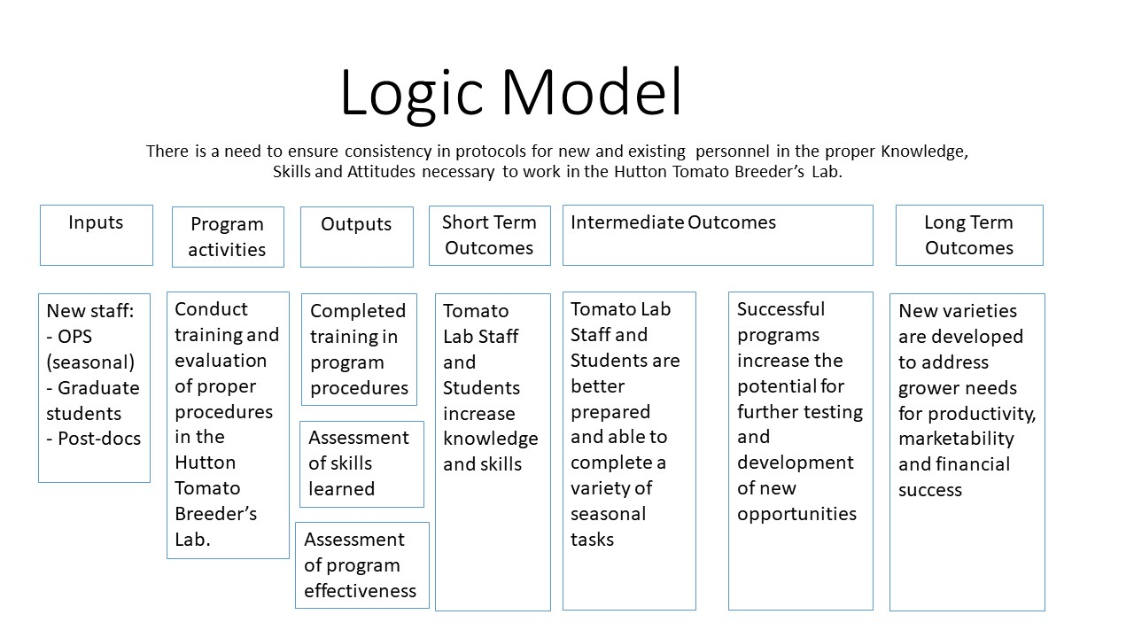
Rationale
The CIPP model is a decision/accountability model that will help evaluate the program to achieve the desired outcomes as illustrated in the following flow chart which includes intangible ROI. It is useful for both formative and summative evaluations.
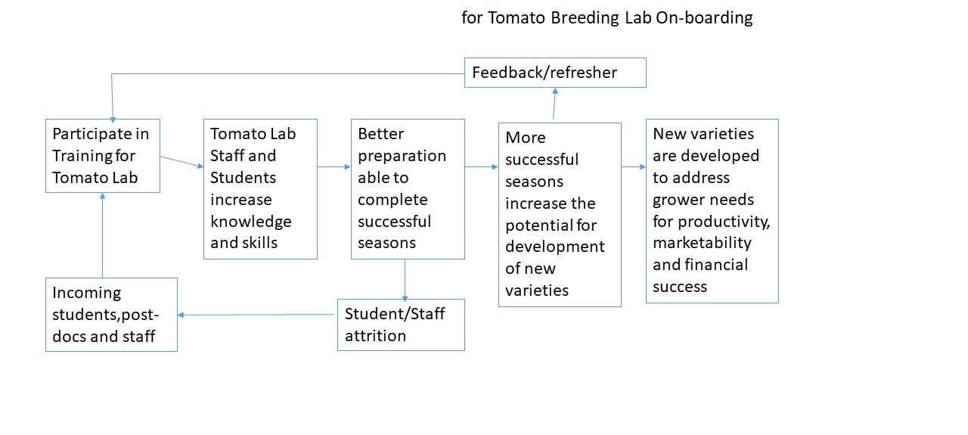
Data/evidence to be collected

Assessment data will be collected upon completion of the learning module utilizing the instruments created that include multiple choice, matching and skills rubric checklist.
From whom data/evidence will be collected

The data will be collected from each new member of the tomato lab team- grad students, post-docs and OPS (seasonal employees).

Data/evidence collection timeline

Data will be collected at the initial completion of the learning module. The data for these evaluations will also be collected at least once each season to properly monitor the program module’s effectiveness.

Program evaluation reporting plan

This plan provides for the evaluation of the Gulf Coast Research and Education Center’s Tomato Breeding Lab On-boarding Program. This plan determines the means to acknowledge the adequate training of new staff and students in Dr. Sam Hutton’s Tomato Breeders Lab utilizing the proper Knowledge, Skills and Attitudes necessary to work in the breeding program’s hybrid greenhouse. The key stakeholder is Dr. Sam Hutton. The module is offered when new staff or students join the Tomato Breeder Lab as well as a refresher when warranted by employee performance decline. A survey attached to each lesson module will obtain feedback from participants regarding the suitability of the program lessons toward learning achievement. This will help provide a summative evaluation of the program objectives.

Key questions addressed in the evaluation:
Is the project module adequate for teaching the skills required?
Is it meeting the objectives of this project module?
Should it be continued? Modified? Re-designed?

It is recommended that at least one full season of performance is appropriate to make valid and reliable evaluation recommendations.

Results of the analysis of evaluation data would be made available to the primary stakeholder, Dr. Sam Hutton, along with suggestions to improve or correct the outcome of the evaluation.

Survey- Lesson Evaluation

Created on Qualtrics at https://ufl.qualtrics.com/jfe/form/SV_2hlNkK33fAooZdX

Date of hire? ___________

Please select the modules accessed. (dropdown menu with lesson names)

How useful were these modules in helping you better understand your work in the Hutton Tomato Lab?
- Extremely useful
- Moderately useful
- Slightly useful
- Neither useful nor useless
- Slightly useless
- Moderately useless
- Extremely useless

How useful were these modules in helping you increase your knowledge?
- Extremely useful
- Moderately useful
- Slightly useful
- Neither useful nor useless
- Slightly useless
- Moderately useless
- Extremely useless

How useful were these modules in helping you improve your skills?
- Extremely useful
- Moderately useful
- Slightly useful
- Neither useful nor useless
- Slightly useless
- Moderately useless
- Extremely useless

Did you use any of the reference materials to seek further information?
- Yes
- No
If yes, were there any problems or broken links to any of the referenced materials?
- Yes
- N/A

What was missing from the modules that you would like to see added?

Which specific areas would you recommend for improvement?

What other modules do you feel need to be added to help you in your work?

Please feel free to add any other comments here:

References:

Angima, W. and Carroll, J.B. (2019). Recruitment and onboarding resources for extension in the west. Journal of Extension 57(2) 1-5. Retrieved from: https://joe.org/joe/2019april/tt2.php

Ary, D., Jacobs, L.C. and Sorensen, C. (2010). Introduction to research in education. Belmont, CA: Wadsworth, Cengage Learning.

Bandura, A. 1991. Social cognitive theory of self-regulation. Organizational Behavior and Human Decision Processes 50(2) 248-287. doi: 10.1016/0749-5978(91)90022-L

Brame, C.J. (2016). Effective educational videos: Principles and guidelines for maximizing student learning from video content. CBE- Life Science Education 15(6) 1-6.
DOI:10.1187/cbe.16-03-0125

Cummings, D. (2018). AEC6543 Teaching and learning theory: Applications in agricultural education and communication. Discussion post. Retrieved from https://ufl.instructure.com/courses/346163/discussion_topics/1594528

Dick, W., Carey, L. and Carey, J.O. (2015). The systematic design of instruction. Upper Saddle River, NJ: Pearson Education, Inc.

Duke, B., Harper, G. and Johnston, M. (2013). Connectivism as a digital age learning theory. The International HETL Review, Special Issue. p. 4-13. Retrieved from https://www.hetl.org/wp-content/uploads/2013/09/HETLReview2013SpecialIssue.pdf

Fernando, S. and Marikar, F. (2017). Constructivist teaching/learning theory and participatory teaching methods. Journal of Curriculum and Teaching. 6(1) 110-122.

Fung, F.M. (2015). Using first-person perspective filming techniques for a chemistry laboratory demonstration to facilitate a flipped pre-lab. Journal of Chemical Education. 92(9), 1518-1521.

Isaac, E.P., (2011). Assessing adult learning and learning styles. In Victor X. Wang (Ed.), Assessing and Evaluating Adult Learning in Career and Technical Education. 143-153. Hershey, PA: IGI Global. doi:10.4018/978-1-61520-745-9

Jaeger, D. (2016). The impact of the use of video recording eyewear on skill acquisition. Doctoral Dissertation. Retrieved from https://search.proquest.com/openview/012288683f07b161c5a0ddfe4f62181b/1

Miller, G. (1997). Studying agriculture through videotape: Learner strategies and cognitive styles. Journal of Agricultural Education. 38(1), 21-28. doi: 10.5032/jae.1997.01021

Nilson, Linda B. (2010). Teaching at its best: A research- based resource for college instructors 3rd ED. Hoboken, NJ: John Wiley & Sons, Inc.

Ravid, R. (2015). Practical statistics for educators. Lanham, MD: Rowman & Littlefield Publishing Group, Inc.

Schunk, D.H. (2012). Learning theories: An educational perspective. Boston, MA: Pearson Education, Inc.

Slavich, G. and Zimbardo, P. (2012). Transformational teaching: Theoretical underpinnings, basic principles and core methods. Educational psychology review. 24(4) 569-608. doi: 10.1007/s10648-012-9199-6.

