Zoonotic Diseases – Wanted Poster

Competency: FL DOE 14.04 – Define zoonosis and investigate selected zoonotic diseases.

Directions: Using the definition provided, define zoonosis in your own words.

According to Merriam-Webster, the definition of zoonosis is “an infection or disease that is transmissible from animals to humans under natural conditions.”

Your Definition:

Directions: Select ONE of the zoonotic diseases provided below. Using reliable websites, please research the selected zoonotic disease. With the information collected, you’ll be responsible for creating a wanted poster for that particular disease. If additional assistance is needed, please reference the example poster!

Zoonotic Disease Options:
- Rabies
- Lyme Disease
- Malaria
- Salmonella
- E. Coli
- Parrot Fever
- Brucellosis
- Swine Influenza

Wanted Poster Requirements:
- Disease Name
- Description of Appearance
- Symptoms of Disease
- Picture of Disease – On an Animal, Under a Microscope, Etc.
- Treatment Options
- Country of Origin
- Impact of Disease
Wanted Poster Example

WANTED

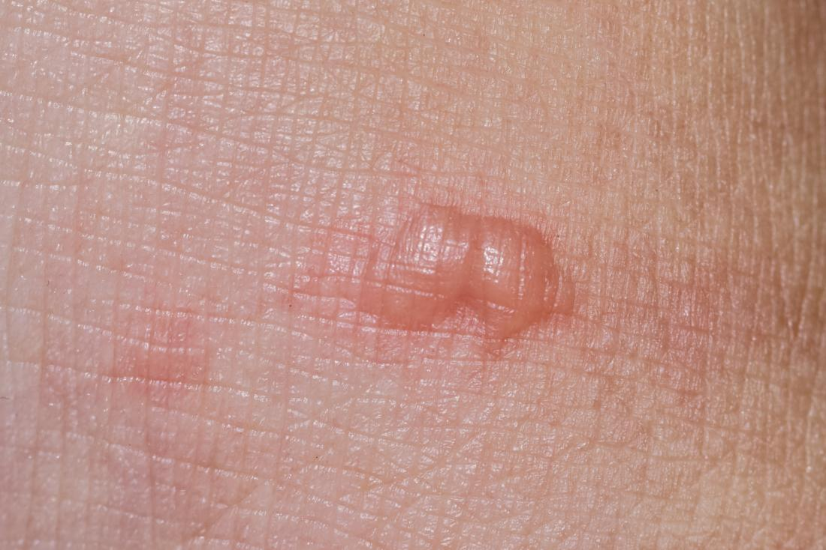

Suspect #1
Cat Scratch Disease

Description of Appearance: A skin lesion that is red and enlarged with the possibility of being pus filled.
Symptoms: Indicators of this disease include fevers, headaches, decreased appetites, and tiredness.
Treatment Options: Patients are only treated in severe cases, which rely on antibiotics.
Impact of Disease: This is a mild disease, however, complications can arise in younger individuals and those with preexisting conditions.
Country of Origin: France
Reference: https://www.cdc.gov/healthypets/disease/cat-scratch.html

