Weed Collection & Identification Lab Student Worksheet
Weeds negatively impact agriculture and food production. Each year farmers, ranchers, city and county governments, and private landowners spend billions of dollars on the elimination and control of weeds. The most aggressive weeds are classified as noxious and require landowners to actively control them when they are found on your property. As climates change, the ability of weeds to infest properties changes as well. In addition, seasonal weather patterns can play a crucial role in the timing of treatments, and seed distribution. Monitoring weeds, and eliminating or controlling the spread of noxious weeds saves everyone money.

Use the internet or class readings to:
List five ways weeds can negatively impact crop yield.

What are some methods available to farmers to control weed pests?
Mechanical:

Chemical:

Describe the impacts of Noxious Weeds on farm income.

Lab Objectives:
In this lab you will:
- Collect Weeds
- Preserve Weeds for identification
- Identify common Weeds

Materials:

- Plant Press
- Weed ID book
- Contact Paper
- Card-stock

Pre lab Question:
  - What are the noxious weeds in our area? (List them)

Procedure:

- Collect Weeds for identification.
  - Collect 30 different weeds from your community.
  - Photograph the plant prior to collecting
  - Record the GPS coordinates for the plant (Create Gaia or other GPS waypoint if available)
  - If collecting the entire plant, remove as much dirt from the roots as possible
  - Dry large fruits separately, they will create a mess in the press when drying
  - See additional information for more detail on different collection recommendations.
- Press Weeds
  - Make sure specimens are clean and dry
  - Lay out leaves so both sides are viewable at different locations on the plant
  - Gently fold tall specimens to fit the press
  - Cut thick roots but leave representative pieces
- Identify Weeds
  - Use ID books to accurately identify the plants
  - If in doubt, consult your teacher, a county extension agent, or the county weed director.
  - Clearly write or type a name card for each plant and attach in lower right corner of the mounting page, or in the mounting box.
Common Name: Scientific Name: Collection Date: Collector Name: Location:

- Preserve your samples (any of the following methods)
  - Laminate your sample
    - Hot lamination in a press laminator, not roller laminator
    - Cold lamination with clear contact paper
  - Vacuum Seal in a page protector with a heavy paper backing (will not work well for thorny plants)
  - Mount in Riker Mount box
- Use your GPS coordinates to create a Custom Google Earth Map (instruction sheet in GPS Unit)

Analysis:

- Which noxious weeds were you able to find?

- What pressing techniques require the most care?

- How can you make one side of the plat show all the identifiable characteristics?

- How much of the plant did you need to collect?

Research Questions:
Select one of the following topics and write a one-page paper answering your chosen question:
- How do weeds get transported in our area?
- How have changes in climate impacted weed distribution?
- What impact could change in weed life cycles impact agricultural production?

Alternate Specimen Collection Ideas:
- Create a leaf margin poster display.
  - Collect only the leaves and label their margins.
- Create a leaf arrangement display
- Create a bulletin board display for the best pressed and displayed samples.

Additional Information for Teachers:
Tips for building your own plant press
- Use a sturdy material for the top and bottom. Plywood makes a durable yet affordable solution.
  - Peg board is also frequently used, as are lattice of 1’x ¼ to ½” hardwood slats riveted or stapled in a 1½” grid.
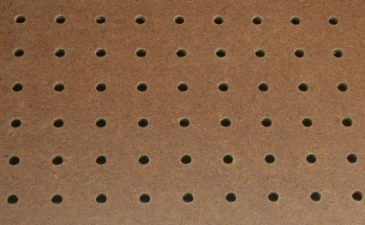
  - Some people cut 1” holes in a grid pattern to help speed the drying process when using plywood.

  - Professionally prepared kits are also available (this one is from Bioquip.com for $43) in a variety of configurations.
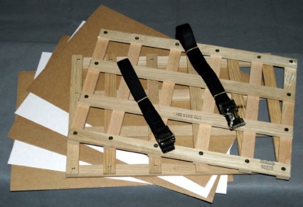

- Dryers cut to the size of your top and bottom pieces.
  - This is just cardboard. Look for pieces without tape and with limited printing.
    - Table saws provide a fast and accurate way to cut large quantities of cardboard quickly.
    - Craft stores get large sheets (10-12’ square) of cardboard weekly and recycle them.
- Blotting paper
  - Newsprint is a good alternative
  - Sized to the size of your press
    - Dollar Savers, Thrifty Nickels, etc. are a great size that won’t need cut down.
- Straps
  - Many options are available. Look for sturdy buckles and ¾”-1” wide straps.
    - Metal buckles are a good long term investment
    - UV treated straps will last longer
    - Straps need to be a minimum of 6’ for 12”x18” presses

Tips for pressing and preserving plants
- Choose good specimens to start with
  - Find specimens which easily show the identification characteristics
  - Avoid plants with excessive damage or wilt
  - Avoid wet plants, they slow the drying process and lead to moldy specimens
  - Thin the specimen to only the parts you need, overlapping parts dry poorly and do not show identifying characteristics well
- Cutting rather than pulling will result in less damage to the plant
  - Digging is also preferred to pulling if you need to have the roots displayed
- Arrange the plant carefully in the press
  - Remember only one side will show
  - Place leaves and flowers in the position that shows identification characteristics the best
  - Carefully bend flower stems so the flowers is visible in the pressed sample
  - Carefully fold tall specimens so they will fit into your press and on the final display paper or box
  - Make your press a bit larger than your intended display size. This allows you to adjust the dried sample and still have a full sample.
  - Place blotting paper of newsprint on both sides of the plant. For succulent plants, you may need to change these every few days to speed the drying process.
- Allow time to completely dry
  - Some plants will take a couple of weeks to dry, change paper every couple of days to speed drying, or place in front of a fan. Pickup beds in dry climates often provide a good location for a plant press to dry specimens quickly.
  - Flowers may stick to drying paper, so be careful when opening the drying paper
  - Check the specimens after a day or two, they will still be pliable and you can make further adjustments to improve appearances in this near preserved state
    - This is a good time to remove parts of the plant you don’t want including dead, deformed, or insect damaged portions
- Pressure helps the plants dry faster
  - Secure the plant press with straps or with heavy objects
  - Even pressure will ensure all parts of the plant dry the same and have the same appearance
  - Bulky plant parts may need cut down (cutting half of the taproot so it is not as thick) to achieve even pressure
  - Freezing will kill any insects on your specimens
- Develop an identification system
  - Take a geo-tagged photo of the plant and some of the surrounding area
  - Number the photo and the plant so they match up later
  - If using an application that allows record additional data with the picture (like Gaia GPS, or a similar app)

