USDA Agency Research

Directions: Using the list below, choose an agency of the USDA. Explore their website.

Please make a poster, brochure, page, or ad for the agency. This should include

- The agency name.
- What the agency does.
- Regulations and what those do.
- How they support agriculture/farmers.
- Their contact information.
- 2 pictures.
If you need to see the agencies, use the USDA.gov website. If you need any assistance, please let me know. Submit the file via Canvas or email.

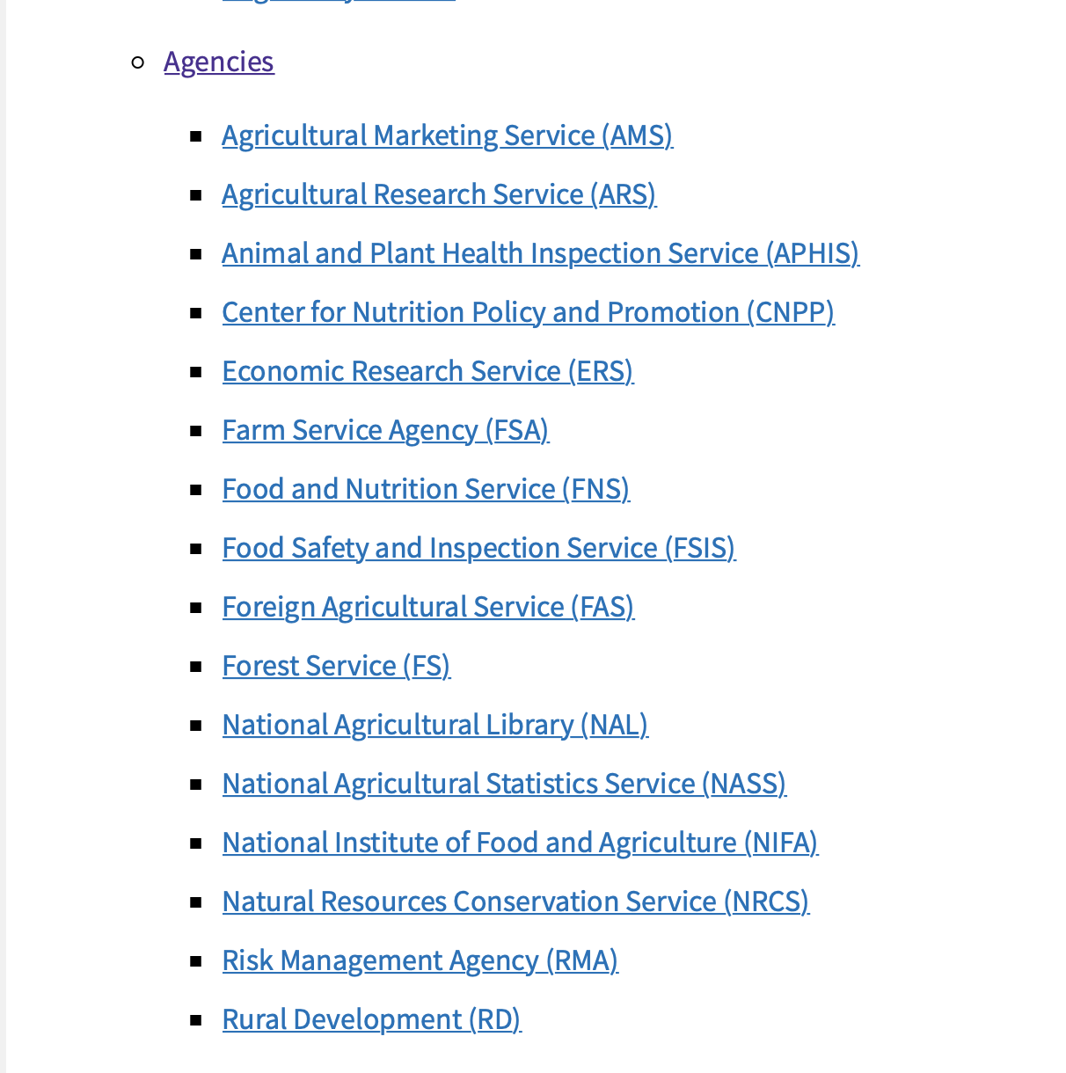
The agencies are here:

