Swine Breeding Worksheet

Read the following information about the Wildwood Middle High School Swine Breeding Program and answer the questions below that follow.

We have three sows at the Wildwood Ag Department that we will breed this spring. Each sow will be artificial inseminated with semen from one of the boars at Shaffer's Goldrush in Albany, Indiana.

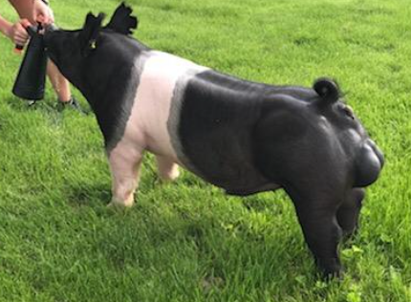

Sow #1 (Gypsy): We plan to breed Gypsy to Thunder Roar (Shown above)

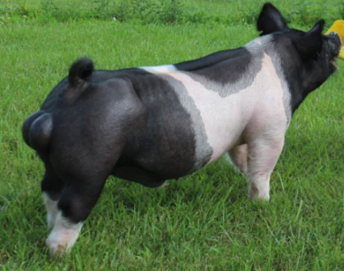

Sow #2 (Dory): We plan to breed Dory to Rubble (Shown above)

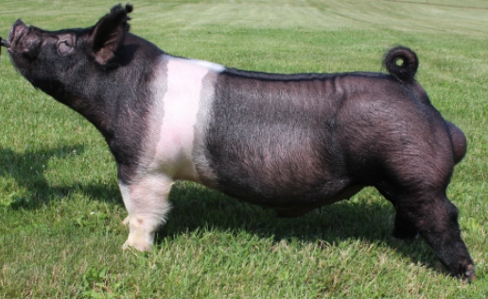

Sow #3 (Lick): We plan to breed Lick to Electrify (shown above)

Question #1:

Look at the chart and circle a breeding date we need if we plan to have litters around August 3, 2020.
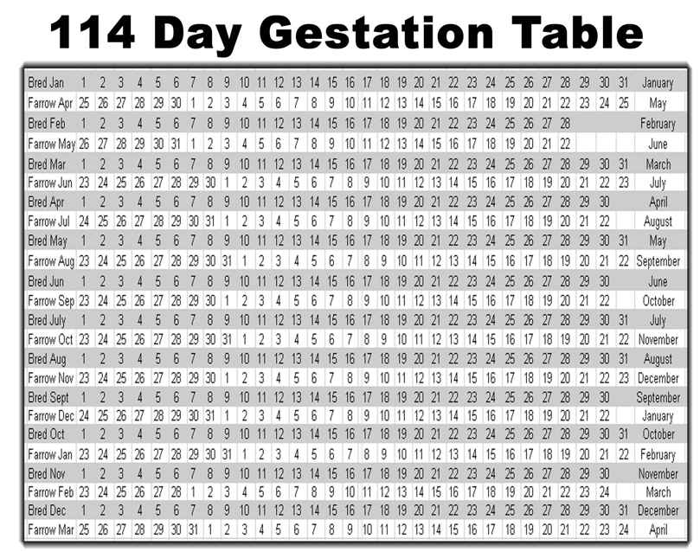

The Following Chart is the Vaccination Record for our Sows at the Ag Department. Read the information below and answer the question that follows.

Question #2:

Breeding Vaccination Record | Farrowsure-R1 | Fostera-R1 | Farrowsure-R2 | Fostera-R2 | PG-600
Dory | 2/18 | 2/18 | 3/18 | 3/18 | ?
Lick | 2/18 | 2/18 | 3/18 | 3/18 | ?
Gypsy | 2/18 | 2/18 | 3/18 | 3/18 | ?

Farrowsure and Fostera are vaccines to prevent complications and increase litter sizes.

PG-600 is an Estrus Synchronization.

Estrous synchronization is the process of targeting female animals to come to heat within a short time frame (36 to 96 hours). This is achieved with one or more hormones.

PG-600 will cause the sow to form the follicle and ovulate within 4-6 days.

Knowing our target breed date: When will we need to administer the PG-600?

Answer: ____________

Answer the Following Questions in 1 to 2 complete sentences

Question #3:

Why do you think it is important that the sows’ estrus cycles be synced?

Answer:_____________________________________________________________________________________________________________________________________________________________________________________________________________________________________________________________________

Question #4:
What do you think are the advantages of artificially inseminating an animal rather than natural sexual reproduction?

Answer:_____________________________________________________________________________________________________________________________________________________________________________________________________________________________________________________________________

