Introduction to Soil
Exploration of Agriscience – 02.07 Describe the major components of soil.
Background
Soil is a vital substance to life on earth. It is more than just “dirt”; soil is the complex mixture of minerals, water, air, organic matter, and countless organisms that are the decaying remains of once-living things.
Directions
Watch the short clip on soil texture at the following link then answer the questions below.
Soil Texture – Environmental Science https://www.youtube.com/watch?v=knrmCbctGEA&safety_mode=true&persist_safety_mode=1

Soil Questions
- What are the 3 components that makes up soil?

- What is porosity?

- What is permeability?

- Does water flow through clay or sand soil more easily? Explain why.

- What is the soil that is best for growing most crops called?

- What is the proportion of clay, silt, and sand, respectively, in loam soil?

Soil Lab
I challenge you to find at least 2 different soils at your home. Some places to look – the natural soil in your yard, bags of soil in a shed or garage, home gardens, plant pots, sand boxes, etc. Complete the steps below and take pictures of your lab.
- First, read through the entire lab sheet.
- Collect the following supplies:
- 2 small containers
- 2 sheets of white paper (write soil A and soil B on the sheets)
- A small cup of water
- A notebook and pencil
- Without disturbing any plants, take small samples of 2 different soils and put them in separate containers, determine one as soil A and one as soil B.
- On a flat table, or a sidewalk or driveway, carefully pour each dry soil sample onto it’s own sheet of paper.
- Observe each sample. Feel it in your fingers, move it around the paper. Observe the contents, particle sizes, color, texture, etc.
- Take note of your observations in your notebook.
- Now, pour the soil samples back into their own containers.
- One soil sample at a time, complete the tests below. Take notes on your observations/findings.
- Use the grid on the last page and see if you can figure out what kind of soils you collected!
- Report your observations, pictures, and conclusions in any way you choose (word doc, PowerPoint, video, Prezi, pamphlet, etc.)

Stage One - The Ball Test
Take a handful of soil and wet it little by little until it is kind of like moist putty. Adjust this by adding either dry soil or water. Form the soil into a ball.
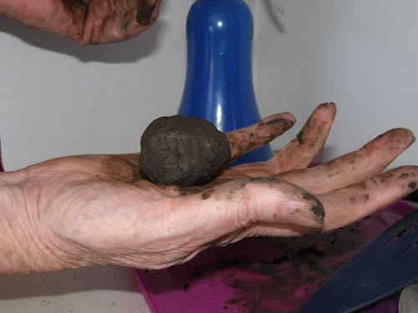
Some soil will not form into a ball. You can adjust the moisture back and forth forever and it still is not a ball. This means you have Sandy soil.
For those that did get a ball, move on to Stage two.

Stage Two - The Ribbon Test
For this test take the ball of soil and gently push it into a ribbon between your thumb and forefinger. Here is a picture of me doing that.
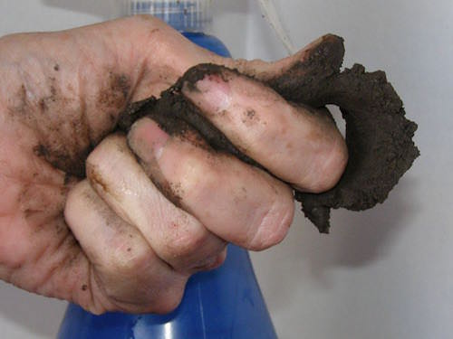
If, as you try to form a ribbon, the soil just kind of crumbles you have Loamy Sand.
If the soil does form a ribbon you just keep pushing the soil out until the ribbon breaks from its own weight.
• Weak Ribbon - an inch or less before breaking
• Medium Ribbon - between 1 and 2 inches long before breaking
• Strong Ribbon - longer than 2 inches
The ribbon makers move on to Stage three.

Stage Three - Gritty, Smooth or Sticky
In this stage you take a small amount of the soil from your sample and put it in the palm of your hand. Add quite a bit of water and then using your finger rub the soil against your palm.
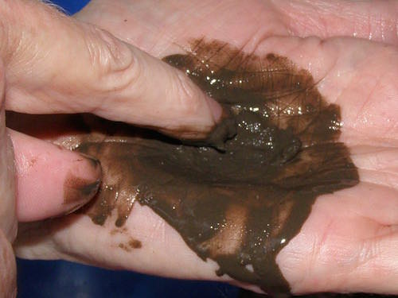
What you are looking for is whether the soil feels
• Mostly Gritty - like there are bits of sand
• Very Smooth - like you are touching flour
• Neither gritty nor smooth predominates - might feel sticky
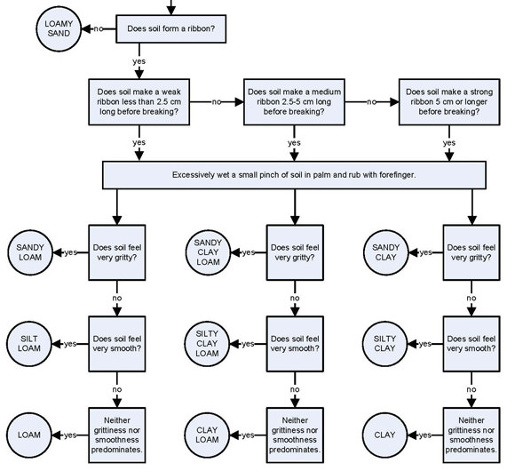

Resources
https://www.youtube.com/watch?v=knrmCbctGEA&safety_mode=true&persist_safety_mode=1
https://www.the-compost-gardener.com/soil-texture-testing.html

