How to Read a Food Label
Reading a food label is an important part of being healthy. You need to know what you are putting in your body to know if you are going to have a healthy diet.
What is a calorie? ________________________________________________
______________________________________________________________
How many calories should the average adult consume in a day?
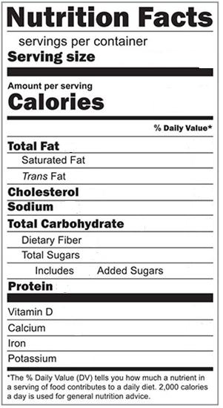
Directions: Go to your pantry or refrigerator. Grab your 2 favorite foods. Fill out the food labels below to match the ones you chose.
Food Name: Food Name:
Directions: Use the food labels you filled out to answer the following questions.
Which food has the most servings per package?

Which food has the most protein?

Which food has the least amount of sodium?

Which food has less sugar?

Based on the calories an average person should consume, how many calories would you have left if you ate one serving of your favorite food?

Which food has more fat?

Which food has more carbohydrates?

After looking at the food labels, which food would you rather eat? Why?

