Flower Dissection Lab Activity

Background Information:
Every flower consists of a set of adaptations that help to ensure successful reproduction. For example, flowers often have bright colors, attractive shapes, and pleasing aromas. These traits help them attract insects and other animals that will carry pollen grains from flower to flower. Pollination also occurs by means other than animals carrying the pollen. For some flowering plants, the wind plays an important role in transferring pollen from plant to plant.
The seed-bearing plants that produce flowers are angiosperms. The flower produces the seeds, each of which contains a new plant embryo. The parts of the flower are usually found in whorls, or rings. Petals are one of the sets of whorls. They attract pollinators. Sepals lie outside the petals. They protect the bud.
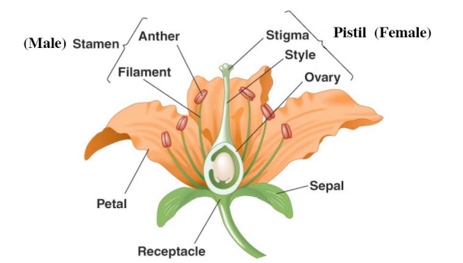
The reproductive organs, the stamens and pistils, lie inside the petals. A stamen is a male reproductive part. It consists of an anther that is held up by a filament. The anther produces pollen grains. A pistil is a female reproductive part. Its top is called the stigma. It is sticky to ensure that when pollen grains land on it, they stick to it. The middle supporting structure is the style, and the large base is the ovary, where the eggs are produced.

Materials:
Flower, Forceps, Magnifying Glass, Glue/Tape)

Procedure:
1. Locate the outermost layer of flower parts. These are the sepals. Carefully remove the sepals.
a. In your data table, record the number of sepals, attach one, and describe the function.
2. Identify the petals. These form the next layer of flower parts. Carefully remove each petal.
a. Fill in the data table on the next page.
b. What advantage to the flower are colorful petals? ____________________________________________________________________
3. Now locate the stamen. These male flower parts should now be exposed.
a. Record the number of stamen, attach one, and describe the function in your data table.
b. What do anthers produce? ________________________________________
c. Name the flower part that elevates the anther. ___________________________________
d. Why do you think it is important that the anthers are elevated? ________________________
__________________________________________________________________________
e. Describe two different ways that a pollen grain can get to the stigma of a pistil. ___________________________________________________________________________ ___________________________________________________________________________
f. Flowers usually contain more stamen than pistils. Why do you think this is? ______________________________________________________________________________________________________________________________________________________
4. The female flower part remains.
a. Record the number of pistils, attach one, and describe the function in your data table.
b. Name the flower part that elevates the stigma. __________________________________
c. Why is it important to elevate the stigma? ________________________________________
___________________________________________________________________________
d. How does the structure of the stigma aid in pollination? ______________________________________________________________________________________________________________________________________________________
e. Which parts of the flower develop into the seeds? _________________________________
f. When fertilized, what will the ovary grow into? ___________________________________
6. Using the textbook, research the difference between monocots and dicots. Using what you’ve learned, support the specimen we’ve dissected is a monocot or dicot? Defend your findings by listing multiple reasons to explain how you know this.
___________________________________________________________________________
___________________________________________________________________________
___________________________________________________________________________
___________________________________________________________________________

DATA TABLE
Flower Part | Quantity | Attach one of each part below: | Description of function:
Sepal

Petal

Stamen (filament, anther, pollen) |  | Filament | Filament
 |  | Anther | Anther
 |  | Pollen | Pollen
Pistil (stigma, style, ovary, ovules) |  | Stigma | Stigma
 |  | Style | Style
 |  | Ovary | Ovary
 |  | Ovules | Ovules

