Nutrition – Reading Feed Tags

Competency: FL DOE 22.10 – Analyze different feed labels and apply feed label regulations.

Directions: There are two feed tags provided, please thoroughly read the information on each label. Then, answer the questions below.

Feed Tag #1
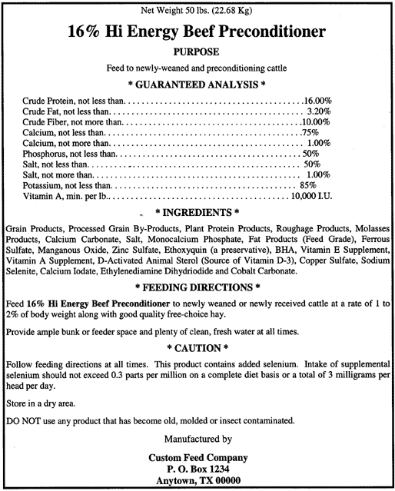

Feed Tag #2
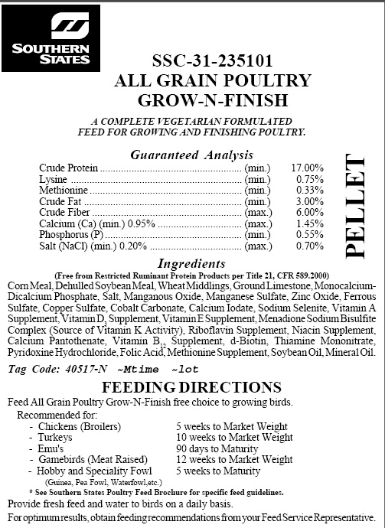

Feed Tag Questions

- What are the first 5 ingredients listed on the feed tags?

Feed Tag #1:

Feed Tag #2:

- What is the percentage of crude protein on the guaranteed analysis?

Feed Tag #1:

Feed Tag #2:

- What is the percentage of crude fiber on the guaranteed analysis?

Feed Tag #1:

Feed Tag #2:

- What feeding directions are provided on the feed tags?

Feed Tag #1:

Feed Tag #2:

- Who is responsible for manufacturing these feeds?

Feed Tag #1:

Feed Tag #2:

- What livestock species are these feeds intended for?

Feed Tag #1:

Feed Tag #2:

- If available, what cautions are posted on the feed tags?

Feed Tag #1:

Feed Tag #2:

Feed Tag Regulations

Feed Tags MUST Include:
- Brand Name
- Product Name
- Description of Purpose
- Guaranteed Analysis
- Ingredient List
- Directions of Use
- Warnings or Cautions
- Manufacturer Information
- Quantity Information

Direction: Answer the questions below using the two feed tags provided, in addition the feed tag regulations.

- Does the feed tag include all 9 feed tag regulations? If not, which regulations are missing?

Feed Tag #1:

Feed Tag #2:

- What is the importance of including the guaranteed analysis on the feed tag?

- Why do you think feed tags need all 9 requirements?

Bonus – Extra Credit Opportunity

Directions: Create your own feed tag that includes all 9 feed tag requirements. Please use the two feed tags provided above as a reference. Be creative, yet reasonable!

