Using the internet complete the following chart for each of the commercially important livestock breeds listed.
This is an excellent web site: http://www.ansi.okstate.edu/breeds/
To enter the picture, drag and drop from the web site. If necessary resize your pictures to be no larger than 1.5 inches (click on the picture and choose format picture.
Breed | Species | Physical Description (color, size, horned, etc) | Picture
Appaloosa | Equine
Arabian
Paint
Quarter Horse
Thoroughbred
Angus
Brahman | Bovine
Charolais
Limousin
Polled Hereford
Duroc
Hampshire | Porcine
Yorkshire
Boer | Caprine
Nubian
Pygmy
Spanish | Caprine |  | 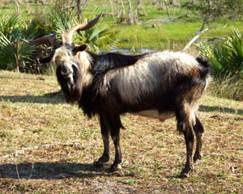
Florida Native | Ovine
Hampshire | Ovine
Suffolk

