Plant Selection

Lesson: Read the following material below and complete the activity that follows

Selecting the right plant is an essential part of creating a beautiful landscape. Therefore, there are some important things to keep in mind[= while you are at the nursery.

When installing a landscape Do Not purchase trees or plants……..

*…….. with yellow or discolored leaves

*……..with weak, poorly formed, scarred, or cracked trunks or branches.

*….. with main double leaders or with branches clustered together on the trunk. Poorly distributed branches on the main stem may result in weak plants.

*……that are root bound. With plants that are container grown, the roots should be distributed throughout the container medium and not protruding outside the container or penetrating into the ground (root bound) see figure 1 below.

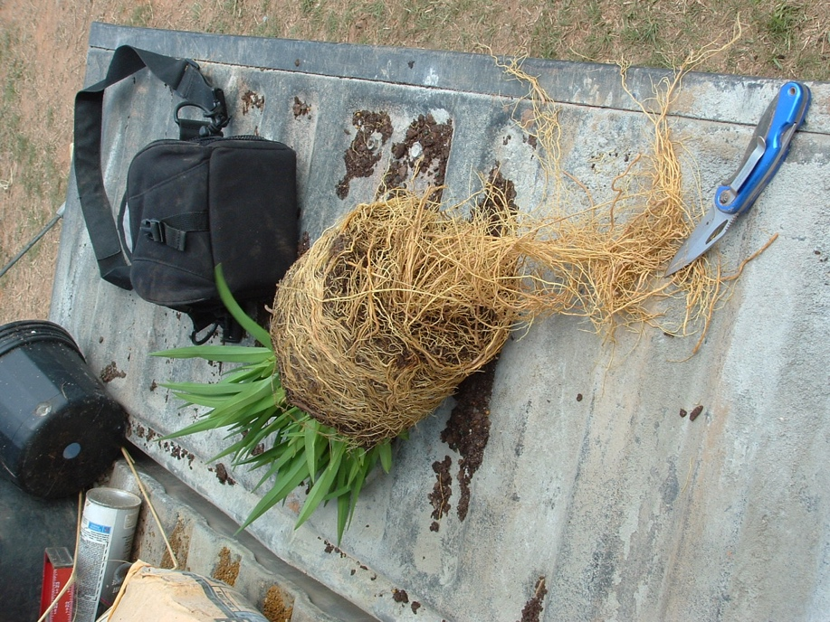
Figure 1. A Root Bound Plant

Other Considerations:

*Balled and Burlapped ( B&B) plant root balls should be moist with the soil held firmly above the roots

*A broken or cracked root ball means that the tree was handled poorly and may result in poor establishment and growth of the plant in the landscape.

*Avoid buying plants that are placed in areas with no shade as it can lead to heat stress on the plant, and more importantly the roots. Plants should be held in areas with 30% - 50% shade to reduce or eliminate heat stress to plants.

*Stems and roots can also be damaged by cold weather. However, the damage may not be noticeable until warmer weather hits. You should examine the plant for root injury or bark splitting.

Activity: Using the information posted above and your personal judgement decide whether or not the plants/trees in the pictures below should or should not be bought. There is no wrong answer but you should be able to justify your answer in a complete sentence or more.

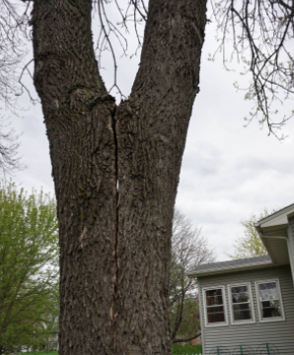

Should this plant be bought? Why or Why Not?

Answer:

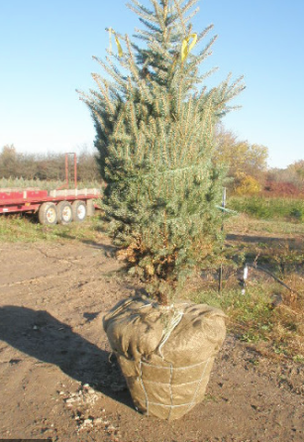

Should this tree be bought? Why or Why Not?

Answer:

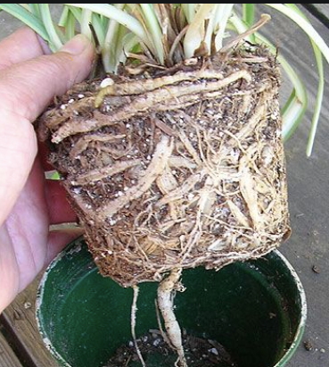

Should this plant be bought? Why or Why Not?

Answer:

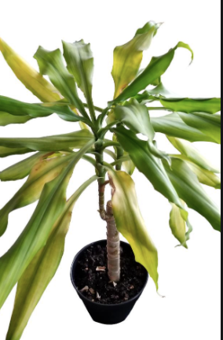

Should this plant be bought? Why or Why Not?

Answer:

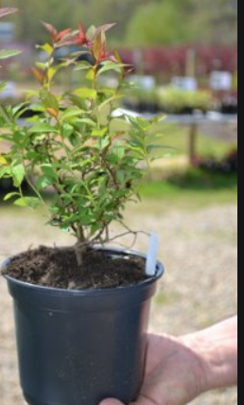

Should this plant be bought? Why or Why Not?

Answer:

