Breeds 101
A breed is an animal that has a common origin and characteristics.
A Golden Retriever is a breed of dog. A miniature pony is a breed of pony.
You can identify a breed by its looks and its personality traits.
People choose animals based on their breed because of the characteristics that can be found in the breed.
Directions:
- Choose a type of animal. (horse, cow, dog, cat, monkey, etc.)
- Research 5 breeds of the animal you chose.
- Create a booklet that talks about the basics of each breed that you chose.
- Include all the requirements listed below:
Horse Breeds 101
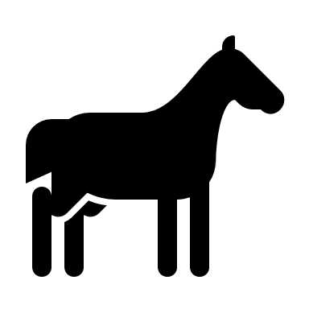

Requirements
- Title Page:
- Write the type of animal you researched
- Include a picture
- Include your name
- Breed Pages:
- You should have 5 pages. Each page has its own breed.
- Each page should have the name of the breed, 3 physical characteristics, its origin, an interesting fact and how it is beneficial to humans.
- Include a picture
- Reference Page
- List all your resources on this page.
- General
- Your booklet should be neat
- You should have color on every page
- Your spelling and grammar should be correct
 | Points Possible | Points Earned
Title Page | 10
Breed Pages | 15
Reference Page | 10
General | 15
Total Points | 50

