Swine Unit Test
Competency: FL DOE 06.02- Analyze commercially important livestock breeds in Florida.
Directions: Answer the questions below based on our learning of the swine industry. You may not look up answers and should complete this to the best of your ability. You can use the highlighter function to indicate answers for the multiple choice and true false sections

Multiple choice- please choose/highlight the correct answer for each question (1pt. each).
- Which breed of pig has erect ears?
- Duroc
- Berkshire
- Landrace
- Chester White
- Which breed of pig has a white belt around their midsection?
- Berkshire
- Landrace
- Poland China
- Hampshire
- What is the act of giving birth in pigs?
- Farrowing
- Pigletting
- Delivering
- Birthing
- Which of the following is not a wholesale pork cut?
- Bacon
- Rump
- Picnic
- Ham
- What wholesale pork cut is located on the head of the pig?
- Loin
- Clear plate
- Jowl
- Picnic

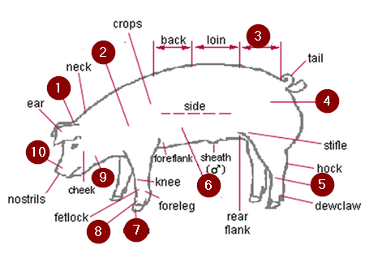
- What body part is represented by 5 on the diagram above?
- Pastern
- Poll
- Cannon
- Femur
- Which of the following does not have a monogastric digestive system?
- Goats
- Pig
- Human
- Horses
- Where does the physical breakdown of food occur?
- Rumen
- Esophagus
- Cecum
- Mouth
- Which of the following is not a common method for pig identification?
- Ear Notching
- Microchipping
- Ear Tags
- Tattooing

True/False- Identify the following statements as either true or false (1 pt. each).
- TRUE/FALSE Pigs have a monogastric digestive system.
- TRUE/FALSE Ear tags are commonly used in piglet identification.
- TRUE/FALSE When reading a pig’s ear notches, the left ear shows the litter number.
- TRUE/FALSE Pigs have a cecum.

Written response- Answer each question in complete sentences (3 pts. each).
- What is the difference between artificial insemination and natural breeding?

- Give a pro and con for both breeding methods.

- Give an example of a byproduct from pork.

- List 3 of the 4 management practices/ procedures given to piglets after birth.

- List and explain 3 skills you would gain from raising a market hog as an SAE project.

Extra Credit (5 pts)
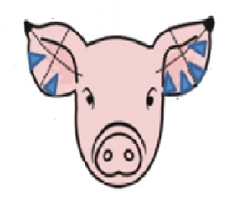
- Based off the image above, please give the piglets litter number and individual identification number.

Answer Key
- B
- D
- A
- B
- C
- C
- A
- D
- B
- T
- F
- F
- T

