Anatomy of a Pig
Competency: FL DOE 06.02- Analyze commercially important livestock breeds in Florida.
Directions: Complete the following diagrams by including the correct terminology for each missing piece. Since pork is a meat widely consumed in America, we will be labeling wholesale cuts of pork, as well as the external anatomy of a pig. There are 3 vocabulary words and 5 research questions that should be answered in complete sentences. You may use online resources such as pork.org for assistance.

Vocabulary to define before beginning (give an example of each)
Byproduct:

Wholesale cut:

Resale cut:

Research questions- Please answer in complete sentences.
- How do cuts of pork visually differ from cuts of beef?

- Do you believe the external anatomy of a pig will be similar to that of a cow? Why or why not?

- What are some common methods of cooking pork?

- Why is pork often seen as a healthier meat?

- What is the difference between a muscle of support and a muscle of locomotion?

Wholesale Pork Cuts
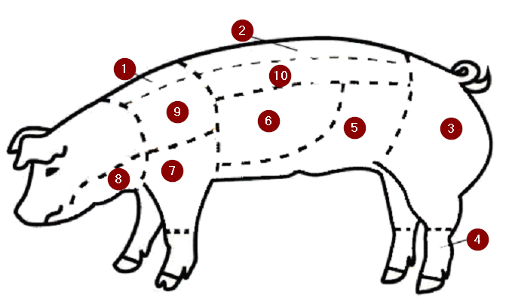
Using the word bank below, please fill out the diagram. Not all words will be used.
Bacon | Back Fat | Boston Butt | Clear Plate | Chop
Ham | Hind Feet | Jowl | Loin | Picnic
Pot Roast | Rump | Spear Ribs | Sideline | Underbelly

External Anatomy of Swine
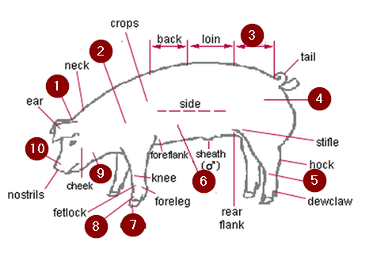
Without a word bank, please label the remaining parts of swine external anatomy.

Bonus question: What were two shocking byproducts of pork you found while conducting your research?

