Professional Life Phases: Identifying Professional Development Needs Relating to Instructional Practices and Teacher Development for Florida Agriscience Teachers
Thornton, K. M.
University of Florida

Author Note
Thornton, K. M., Department of Agricultural Education and Communication, University of Florida
Abstract
For learners to be better prepared to solve current and future complex problems, teachers must continue to strengthen and refine their teaching and learning practices throughout their career. One known modality to assist teachers in refining their pedagogical skills is teacher participation in professional development opportunities. The purpose of this study was to identify the self-perceived professional development needs of agriscience teachers in Florida based on their professional life phase. All three career phases shared modifying instruction for students with special needs as one of their top four identified ranked instructional practice needs. Regarding teacher development, all three career phases shared managing stress as one of their top two identified ranked teacher development needs. It is recommended that agricultural education professional development organizers consider years of experience when planning workshops and opportunities. The “cookie cutter” method or “one size fits all” themes for professional development may not be the most effective way to continue offering these workshops since the findings of this study and others indicate differing needs of agriscience teachers based on professional life phase and years of experience.
Introduction
For learners to be better prepared to solve current and future complex problems, teachers must continue to strengthen and refine their teaching and learning practices throughout their career (Darling-Hammond & Bransford, 2005; Darling-Hammond, Hyler, & Gardner, 2017; Mizell, 2010; Wash, Lovedahl, & Page, 2000). One known modality to assist teachers in refining their pedagogical skills is teacher participation in professional development opportunities. Quality professional development focused on educational programming allows educators to build on their knowledge and skills to apply the best educational practices to impact learners’ knowledge and skill acquisition (Darling-Hammond & Richardson, 2009; Mizell, 2010; Wenglinsky & Silverstein, 2006). However, identifying which professional development opportunities to offer teachers can often be difficult (Washburn, King, Garton, & Harbstreit, 2001). Teachers from every career phase, beginning to end, are met by professional challenges that can influence their retainment in the profession (Sutcher, Darling-Hammond, & Carver-Thomas, 2016). Cannon, Kitchel, and Duncan (2012) found teachers’ needs can change over time due to their diverse backgrounds and experiences. Thus, conducting periodic teacher needs assessments can be beneficial to identifying teacher needs (Borich, 1980; Darling-Hammond et al., 2017).
Literature Review/Conceptual Framework
Day and Gu (2014) outlined six professional life phases centered around years of experience in teaching: zero to three, four to seven, eight to 15, 16 to 23, 24 to 30, and 31 years or more. During the professional life phase one (zero to three years), teachers are said to have a high level of commitment. Within this phase two subgroups of teachers exist, those with a developing sense of efficacy and those with a reduced sense of efficacy. The level of support, recognition of their work, and school culture are key factors that play a role in the professional life trajectories for teachers during this phase (Day & Gu, 2014).
For the second professional life phase (four to seven years), promotion and additional responsibilities begun to play a significant role in the identities, motivation and sense of effectiveness for teachers. Day and Gu (2014) indicated the second phase has three sub-groups. The first sub-group of teachers maintain a strong sense of identity, the second sub-group is observed as merely coping and managing their identity, efficacy and effectiveness, and the third sub-group is shown to be declining or vulnerable with their identity, efficacy, and effectiveness as teachers are at risk of leaving the profession.
The third professional life phase (eight to 15 years) focuses on managing changes in role and identity including tensions and transitions in the workplace. Two sub-groups were observed in this phase, teachers whom sustained engagement and those who were affected by detachment or a loss of motivation. Day and Gu (2014) also said that this professional life phase is described by some (Hargreaves & Fullan, 2012) as being the most overlooked group in the entire teaching profession. Even though the teachers in this professional phase are most likely to be confident and well established, they are starting to face difficulties managing both their professional and personal lives.
Day and Gu (2014) define the professional life phase (16 to 23 years) as work-life tensions, challenges to motivation and commitment. Teachers were observed and categorized into three sub-groups based on their level of work challenge management and life/home experiences. Teachers are reported to have seen their motivation and commitment increase as a result of career advancement and/or good pupil relationships in sub-group one. Sub-group two teachers simply maintained their motivation, commitment, and effectiveness and would likely continue to cope with work life tensions in their next professional phase. Teachers included in the third sub-group were observed having their workload, management of competing tensions and career stagnation lead to a decrease in career motivation and commitment.
Based on challenges to sustaining motivation, two sub-groups were also identified for the fifth professional life phase (24 to 30 years of teaching experience). They were made up of those who had continued to maintain a strong sense of motivation and commitment and those who were losing motivation which likely leads to an early retirement. Classroom knowledge updates and more general professional/personal development needs were observed to be important to teachers in this professional life phase (Day & Gu, 2014).
The sixth and final professional life phase includes teachers with 31 or more years of teaching experience and described by Day and Gu (2014) as having sustaining/declining motivation, the ability to cope with change, or looking to retire. Teachers in this phase were categorized either as teachers whose motivation and commitment remained high despite of or because of changing personal, professional, and organization contexts and teachers whose motivation had declined and whose expected trajectories were increased fatigue, disillusionment, and exit. Supportive school cultures not only played a crucial role in teachers’ continued engagement in the profession during this professional life phase, but in the teachers’ sense of effectives across all six professional life phases (Day & Gu, 2014).
Figland, Blackburn, Smith, and Stair (2017) reported findings for classroom-based professional development needs of agriculture teachers based on years of teaching experience. According to the responses for perceived instructional needs, teachers with one to five years of experience identified need in teaching in a laboratory and managing instruction facilities. Teachers with six to 10 years of experience reported perceived instructional need in motivating student learning and developing online teacher resources. Those with 11 to 15 years of teaching experience had identified need in developing online teaching resources and using instructional technologies. Teachers with 21 or more years of teaching experience identified their highest need as using instructional technologies.
Sorensen, Lambert, and McKim (2014) examined agriscience teachers’ professional development needs by career phase and identified the top five-ranked in-service needs among teachers in the induction phase (one to five years), as being (a) writing grant proposals for external funding, (b) utilizing a local advisory committee, (c) utilizing the AET record book system, (d) training CDE teams, and (e) balancing priorities to make time for career and family/personal life. In a qualitative study conducted by Smalley and Smith (2017), 35 participants, representing all regions of the National Association of Agricultural Educators (NAAE), responded to the question, “What are the biggest obstacles that prevent mid-career agriculture educators from becoming the teachers they wish to be?” Nineteen participants identified time management as their biggest obstacle. Another five participants acknowledged work/life balance concerns, which the researchers related back to the issue of time management. The second most identified theme was course planning, particularly regarding (a) content knowledge, (b) locating curriculum, (c) classroom resources, and (d) developing lesson plans (Smalley & Smith, 2017).
This particular study sought to identify the needs of Florida agriscience teachers based on professional life phase. The professional life phases used in this study were (a) early-career (zero to seven years), (b) mid-career (eight to twenty-three years), and (c) late-career (twenty-four years and up). There is a considerable need for new data that can assist in guiding the professional development of Florida agriscience teachers since the last assessment was administered over ten years ago (Blinded authors, Date). Additionally, identifying the professional development needs of agricultural educators directly aligns with Research Priority 5: Efficient and Effective Agricultural Education Programs of the American Association for Agricultural Education National Research Agenda (Thoron, Myers, & Barrick, 2016).

Purpose and Objectives
The purpose of this study was to identify the self-perceived professional development needs of agriscience teachers in Florida based on their professional life phase. For this purpose, instructional practices are competencies related to teaching methodologies, planning lessons and units, and student assessment. Teacher development includes competencies related to balancing work and personal life, managing time and stress, and financial planning. Four objectives guided this study.
- Identify the self-perceived instructional practice and teacher development needs for agriscience teachers in the early-career phase.
- Identify the self-perceived instructional practice and teacher development needs for agriscience teachers in the mid-career phase.
- Identify the self-perceived instructional practice and teacher development needs for agriscience teachers in the late-career phase.
- Determine the similarities in the self-perceived instructional practice and teacher development needs between the three professional life phases of agriscience teachers based on ranked mean weighted discrepancy scores (MWDS).

Methods
Population and Sampling

The target population for this study was all Florida agriscience teachers who registered for FFA Chapter Officer Leadership Training (COLT) Conferences (N = 366). Each of the six areas in Florida hosted a COLT conference and data were collected at each location and point in time through a hardcopy questionnaire administered during the teacher professional development sessions. Ultimately, 269 teachers completed and submitted the instrument for a 73% response rate. Collection of data from non-respondents or agriscience teachers who did not attend the conference was not attempted by the researchers. Non-response data was not collected because 64% of the total Florida teacher agriscience population (N = 465) completed the instrument and the researchers considered the sample representative of the population. For the purposes of this study, the professional life phase timeline purposed by Day and Gu (2014) was combined with the teacher life cycle model created by NAAE (2015) to describe professional life phases of Florida agriscience teachers. Early-career teachers were those who have taught zero to seven years in the classroom. Mid-career teachers have been teaching for eight to twenty-three years. The late-career life phase includes those who have been teaching for twenty-four years or more. The teacher respondents in this study were majority female (f = 177; 65.8%), white (f = 243; 90.3%), and held a bachelor’s degree (f = 198; 73.6%). A slight majority indicated that they were traditionally certified in agriculture (f = 102; 37.9%), taught in a single teacher program (f = 149; 55.4%) and at the high school level (f = 147; 54.6%). Regarding teacher professional life phases, 163 (60.6%) were early-career, 82 (30.5%) were mid-career, and 24 (8.9%) were late-career, with the majority of participants having taught an average of 8.8 years (SD = 9.0; Min. = 1.0; Max. 42.0).
Instrumentation
The study utilized an instrument that was originally created by Roberts and Dyer (2004) and later revised by Saucier, Tummons, Terry, and Schumacher (2010), and Figland, Blackburn, Smith, and Stair (2017). It was modified further in order to fit the needs of this study. The questionnaire instrument aimed to identify the professional development needs of agriscience teachers in their corresponding states. A panel of experts comprising of five agricultural education faculty members and six doctoral students, five of which were former agriscience teachers, established face and content validity. Three items were deleted, and numerous items were rephrased to make items relevant for Florida agriscience teachers as a result of the instrument review. Seven sections comprised the instrument that measured agriscience teacher needs. For the purpose of this study, sections (a) instructional practices, (e) teacher development, and (g) teacher demographics, were analyzed. Two Likert-type scales (1 = Low; 5 = High) intended to measure teacher perceived current knowledge and perceived job relevance were used in sections (a) and (e).
Data Analysis
The data were examined for the distribution of missingness (Schafer & Graham, 2002) in order to address missing data. It was determined that data were missing at random, and single imputation was used (Schafer & Graham, 2002). The data were analyzed using SPSS version 26 for PC. Descriptive statistics, including means, standard deviations, frequencies, and percentages were used to describe the population of agriscience teachers who attended the COLT conferences. For the purpose of objectives one through four, mean weighted discrepancy scores (MWDS) were used. Discrepancy scores are well-suited for ranking prioritizing competencies of needs assessments (Borich, 1980). In accordance with Borich’s (1980) model. The MWDS was determined by subtracting the perceived content knowledge score from the perceived job relevance score to find the difference. That difference was then multiplied by the mean job relevance score which equaled the individual discrepancy score. Individual discrepancy score means were then calculated to obtain the MWDS for each competency. These calculations were conducted using a Microsoft Excel template.
Study Limitations
Data was collected only from the agriscience teachers that were able to attend the COLT conference. A non-response follow-up was not conducted since a majority (64%) off all agriscience teachers in Florida were in attendance and responded to the questionnaire. An argument could be made that the professional development needs of those teachers who did not attend the conference could differ from those who did.
Findings
Objective 1: Identify the instructional practice and teacher development needs for Florida agriscience teachers in the early-career phase.
Based on MWDS, the five competencies identified in the area of instructional practice with the greatest need by teachers in the early-career phase included determining content to be taught in specific courses (MWDS = 4.68), sequencing lessons and units of instruction (MWDS = 4.37), assessing student learning in the classroom and lab (MWDS = 4.12), modifying instruction for students with special needs (MWDS = 4.09), and identifying resources for curricula (MWDS = 3.88). The three competencies identified with the least need in the area of instructional practice were using instructional technology (e.g., interactive whiteboards, tablets, smartphones, etc.) (MWDS = 1.46), highlighting science in agriculture courses (MWDS = 1.40), and planning for teaching in a block schedule (MWDS = -0.61).
Table 1
Instructional Practice Needs of Florida Early-Career Phase Agriscience Teachers (n = 163)
Rank | Competency | MWDS | Mean  Knowledge Level | SD | Mean  Relevance  Level | SD
1 | Determining content to be taught in specific courses | 4.68 | 3.61 | 1.03 | 4.63 | 0.70
2 | Sequencing lessons and units of instruction | 4.37 | 3.50 | 0.98 | 4.48 | 0.74
3 | Assessing student learning in the classroom and lab | 4.12 | 3.63 | 0.85 | 4.54 | 0.68
4 | Modifying instruction for students with special needs | 4.09 | 3.25 | 1.07 | 4.22 | 0.96
5 | Identifying resources for curricula | 3.88 | 3.30 | 0.98 | 4.22 | 0.90
6 | Developing lesson plans | 3.79 | 3.58 | 1.01 | 4.44 | 0.92
7 | Using experiments in teaching | 3.64 | 3.34 | 0.99 | 4.21 | 0.84
8 | Managing student behavior | 3.54 | 3.93 | 0.85 | 4.69 | 0.64
9 | Teaching for different learning styles | 3.50 | 3.56 | 0.88 | 4.36 | 0.77
10 | Motivating students | 3.25 | 3.90 | 0.83 | 4.60 | 0.65
11 | Teaching problem solving skills | 3.12 | 3.34 | 0.99 | 4.21 | 0.84
12 | Evaluating teaching resources | 3.02 | 3.33 | 1.03 | 4.07 | 1.01
13 | Teaching critical thinking skills | 2.98 | 3.56 | 0.89 | 4.26 | 0.90
14 | Teaching decision making skills | 2.54 | 3.72 | 0.86 | 4.31 | 0.84
15 | Highlighting reading strategies in agriculture courses | 2.25 | 3.52 | 0.93 | 4.07 | 0.82
16 | Highlighting math in agriculture courses | 2.23 | 3.15 | 1.00 | 3.75 | 1.03
17 | Using instructional technology (e.g., interactive whiteboards, tablets, smartphones, etc.) | 1.46 | 3.73 | 1.02 | 4.09 | 1.11
18 | Highlighting science in agriculture courses | 1.40 | 4.17 | 0.84 | 4.48 | 0.68
19 | Planning for teaching in a block schedule | -0.61 | 2.75 | 1.37 | 2.50 | 1.61

In the area of teacher development, the three competencies identified with the greatest need included managing stress (MWDS = 8.12), balancing work and personal life (MWDS = 7.26) and managing time (MWDS = 7.04). The two competencies identified with the least need were managing paperwork (MWDS = 6.38) and financial planning (investing, retirement planning) (MWDS = 6.33).
Table 2
Teacher Development Needs of Florida Early-Career Phase Agriscience Teachers (n = 163)
Rank | Competency | MWDS | Mean  Knowledge Level | SD | Mean  Relevance  Level | SD
1 | Managing stress | 8.12 | 2.98 | 1.28 | 4.71 | 0.66
2 | Balancing work and personal life | 7.26 | 3.07 | 1.26 | 4.64 | 0.76
3 | Managing time | 7.04 | 3.20 | 1.16 | 4.70 | 0.62
4 | Managing paperwork | 6.38 | 3.24 | 1.15 | 4.62 | 0.67
5 | Financial planning (investing, retirement planning) | 6.33 | 3.06 | 1.22 | 4.47 | 0.89

Objective 2: Identify the instructional practice and teacher development needs for Florida agriscience teachers in the mid-career phase.
Based on MWDS, the five competencies identified in the area of instructional practice with the greatest need by teachers in the mid-career phase included modifying instruction for students with special needs (MWDS = 3.82), using experiments in teaching (MWDS = 3.16), assessing student learning in the classroom and lab (MWDS = 3.15), identifying resources for curricula (MWDS 2.83), and motivating students (MWDS = 2.77). The three competencies identified with the least need in the area of instructional practice were highlighting science in agriculture courses (MWDS = 1.70), developing lesson plans (MWDS = 1.44) and planning for teaching in a block schedule (MWDS = -1.56).
Table 3
Instructional Practice Needs of Florida Mid-Career Phase Agriscience Teachers (n = 82)
Rank | Competency | MWDS | Mean  Knowledge Level | SD | Mean  Relevance  Level | SD
1 | Modifying instruction for students with special needs | 3.82 | 3.48 | 1.00 | 4.35 | 0.79
2 | Using experiments in teaching | 3.16 | 3.43 | 0.92 | 4.18 | 0.80
3 | Assessing student learning in the classroom and lab | 3.15 | 3.93 | 0.89 | 4.61 | 0.64
4 | Identifying resources for curricula | 2.83 | 3.63 | 0.95 | 4.29 | 0.82
5 | Motivating students | 2.77 | 3.93 | 0.90 | 4.54 | 0.72
6 | Teaching critical thinking skills | 2.75 | 3.71 | 0.91 | 4.34 | 0.71
7 | Teaching for different learning styles | 2.75 | 3.71 | 0.90 | 4.34 | 0.77
8 | Determining content to be taught in specific courses | 2.72 | 4.06 | 0.84 | 4.65 | 0.57
9 | Teaching problem solving skills | 2.72 | 3.85 | 0.86 | 4.46 | 0.65
10 | Using instructional technology (e.g., interactive whiteboards, tablets, smartphones, etc.) | 2.41 | 3.73 | 1.13 | 4.29 | 0.82
11 | Teaching decision making skills | 2.34 | 3.94 | 0.91 | 4.46 | 0.60
12 | Evaluating teaching resources | 2.01 | 3.65 | 0.91 | 4.13 | 0.87
13 | Highlighting math in agriculture courses | 1.94 | 3.60 | 0.91 | 4.07 | 0.80
14 | Managing student behavior | 1.93 | 4.24 | 0.87 | 4.66 | 0.63
15 | Sequencing lessons and units of instruction | 1.88 | 3.98 | 0.94 | 4.40 | 0.83
16 | Highlighting reading strategies in agriculture courses | 1.79 | 3.63 | 1.00 | 4.07 | 0.91
17 | Highlighting science in agriculture courses | 1.70 | 4.12 | 0.87 | 4.50 | 0.71
18 | Developing lesson plans | 1.44 | 3.88 | 0.93 | 4.22 | 1.11
19 | Planning for teaching in a block schedule | -1.56 | 3.29 | 1.47 | 2.72 | 1.74

In the area of teacher development, the three competencies identified with the greatest need included financial planning (investing, retirement planning) (MWDS = 5.54), managing stress (MWDS = 5.44) and managing time (MWDS = 5.23). The two competencies identified with the least need were balancing work and personal life (MWDS = 5.16) and managing paperwork (MWDS = 4.99)
Table 4
Teacher Development Needs of Florida Mid-Career Phase Agriscience Teachers (n = 82)
Rank | Competency | MWDS | Mean  Knowledge Level | SD | Mean  Relevance  Level | SD
1 | Financial planning (investing, retirement planning) | 5.54 | 3.21 | 1.13 | 4.45 | 1.03
2 | Managing stress | 5.44 | 3.41 | 1.22 | 4.60 | 0.89
3 | Managing time | 5.23 | 3.48 | 1.10 | 4.61 | 0.81
4 | Balancing work and personal life | 5.16 | 3.41 | 1.20 | 4.55 | 0.96
5 | Managing paperwork | 4.99 | 3.45 | 1.09 | 4.55 | 0.83

Objective 3: Identify the instructional practice and teacher development needs for Florida agriscience teachers in the late-career phase.
Based on MWDS, the five competencies identified in the area of instructional practice with the greatest need by teachers in the mid-career phase included modifying instruction for students with special needs (MWDS = 2.71), using instructional technology (e.g., interactive whiteboards, tablets, smartphones, etc.) (MWDS = 2.30), motivating students (MWDS = 2.08), highlighting reading strategies in agriculture courses (MWDS = 1.93), teaching for different learning styles (MWDS = 1.75). The three competencies identified with the least need in the area of instructional practice were assessing student learning in the classroom and lab (MWDS = -0.18), identifying resources for curricula (MWDS = -1.03), and planning for teaching in a block schedule (MWDS = -2.36).
Table 5
Instructional Practice Needs of Florida Late-Career Phase Agriscience Teachers (n = 24)
Rank | Competency | MWDS | Mean  Knowledge Level | SD | Mean  Relevance  Level | SD
1 | Modifying instruction for students with special needs | 2.71 | 3.71 | 0.78 | 4.67 | 0.64
2 | Using instructional technology (e.g., interactive whiteboards, tablets, smartphones, etc.) | 2.30 | 3.71 | 1.00 | 4.25 | 1.07
3 | Motivating students | 2.08 | 4.08 | 0.88 | 4.54 | 0.72
4 | Highlighting reading strategies in agriculture courses | 1.93 | 3.75 | 1.22 | 4.21 | 0.83
5 | Teaching for different learning styles | 1.75 | 3.79 | 0.83 | 4.21 | 0.93
6 | Teaching decision making skills | 1.12 | 4.21 | 0.78 | 4.46 | 0.66
7 | Determining content to be taught in specific courses | 1.01 | 4.63 | 0.65 | 4.83 | 0.38
8 | Using experiments in teaching | 0.97 | 3.63 | 0.97 | 3.88 | 1.03
9 | Teaching problem solving skills | 0.94 | 4.29 | 0.75 | 4.50 | 0.66
10 | Managing student behavior | 0.78 | 4.50 | 0.78 | 4.67 | 0.64
11 | Highlighting science in agriculture courses | 0.74 | 4.29 | 0.86 | 4.46 | 0.66
12 | Teaching critical thinking skills | 0.70 | 4.04 | 0.62 | 4.21 | 0.88
13 | Highlighting math in agriculture courses | 0.65 | 3.75 | 1.03 | 3.92 | 0.93
14 | Evaluating teaching resources | 0.18 | 4.17 | 0.82 | 4.21 | 0.83
15 | Sequencing lessons and units of instruction | 0.00 | 4.42 | 0.83 | 4.42 | 0.72
16 | Developing lesson plans | -0.17 | 4.21 | 1.02 | 4.17 | 0.96
17 | Assessing student learning in the classroom and lab | -0.18 | 4.46 | 0.66 | 4.42 | 0.72
18 | Identifying resources for curricula | -1.03 | 4.38 | 0.65 | 4.13 | 0.95
19 | Planning for teaching in a block schedule | -2.36 | 4.21 | 1.28 | 3.54 | 1.53

In the area of teacher development, the three competencies identified with the greatest need included managing paperwork (MWDS = 3.86), managing stress (MWDS = 3.24), and financial planning (investing, retirement planning) (MWDS = 3.14). The two competencies identified with the least need were managing time (MWDS = 2.89) and balancing work and personal life (MWDS = 1.75).
Table 6
Teacher Development Needs of Florida Late-Career Phase Agriscience Teachers (n = 24)
Rank | Competency | MWDS | Mean  Knowledge Level | SD | Mean  Relevance  Level | SD
1 | Managing paperwork | 3.86 | 3.79 | 1.25 | 4.63 | 0.65
2 | Managing stress | 3.24 | 3.88 | 1.03 | 4.58 | 0.65
3 | Financial planning (investing, retirement planning) | 3.14 | 4.04 | 0.81 | 4.71 | 0.62
4 | Managing time | 2.89 | 4.00 | 0.93 | 4.63 | 0.65
5 | Balancing work and personal life | 1.75 | 4.29 | 0.86 | 4.67 | 0.64

Objective 4: Determine the similarities in the self-perceived instructional practice and teacher development needs between the three professional life phases of agriscience teachers based on ranked mean weighted discrepancy scores (MWDS).

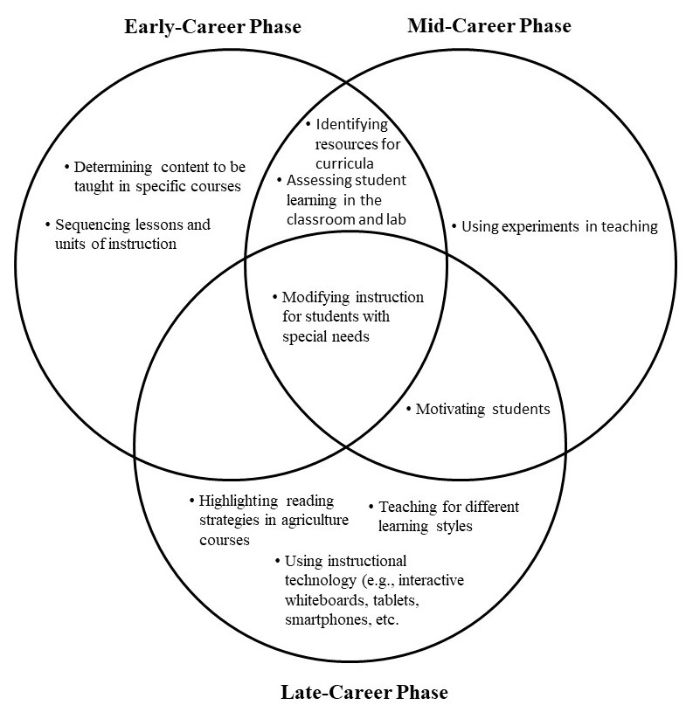
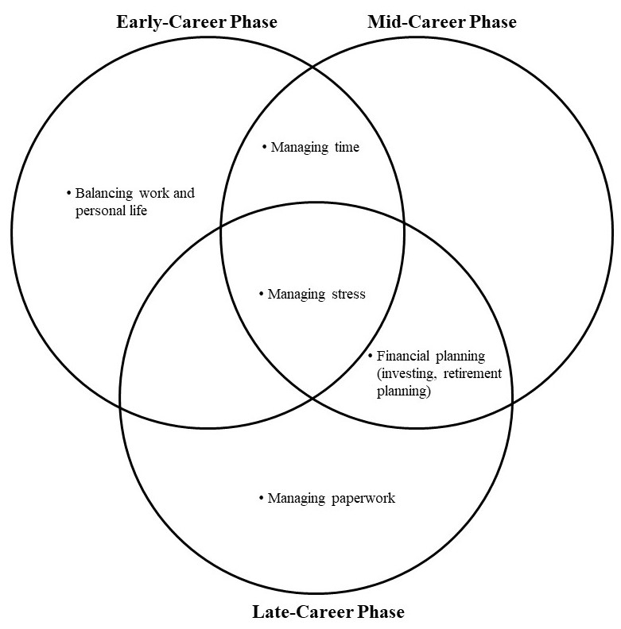
When comparing the ranked needs of the three groups of agriscience teachers, they collectively shared one of their highest five self-perceived instructional practice needs (see Figure 1). Early-career phase agriscience teachers and mid-career phase agriscience teachers shared an additional two of their highest five self-perceived instructional practice needs (see Figure 1). Mid-career phase agriscience teachers and late-career agriscience teachers shared an additional self-perceived instructional practice need (see Figure 1). When comparing the three groups self-perceived teacher development needs, they collectively shared one of their highest three needs (see Figure 2). Early-career phase teachers and mid-career phase teachers share an additional top three teacher development need, as well as mid-career and late-career teachers (see Figure 2).

Figure 1. Comparison of the top five Figure 2. Comparison of the top three
instructional practice needs by career phase teacher development needs by career phase

Conclusions
The purpose of this study was to identify the instructional practices and teacher development need of Florida agriscience teachers. After examination of the data, 60.6% of the respondents were classified as early-career phase teachers with zero to seven years of teaching experience in agriculture. Early-career phase teachers reported their top five self-perceived needs as being determining content to be taught in specific courses, sequencing lessons and units of instruction, assessing student learning in the classroom and lab, modifying instruction for students with special needs, and identifying resources for curricula. In the area of teacher development, the top three self-perceived needs were reported as being managing stress, balancing work and personal life, and managing time. This conclusion is consistent with Sorensen, Lambert, and McKim (2014) who reported that balancing priorities to make time for career and family/personal life as ranking among the top in-service needs of teachers in the induction phase of their study (one to five years of teaching). This conclusion also supports Day and Gu’s (2014) inference that teachers in this stage are beginning to struggle with additional responsibilities and this will begin to affect their identities.
The mid-career phase teachers represented 30.5% of the respondents. Teachers ranked financial planning (investing, retirement, planning), managing stress, and managing time as their top three self-perceived teacher development needs. Day and Gu (2014) categorized the teacher in this career-phase based on their level of management of work challenges and life and home experiences. The sub-groups are the outcome of teachers that are facing needs of managing stress and managing time as presented above. This conclusion also aligns with Smalley and Smith’s (2017) who reported that time management followed by work/life balance concerns as being major concerns for mid-career agriculture educators. Additionally, Florida mid-career agriscience teachers ranked modifying instruction for students with special needs, using experiments in teachings, assessing student learning in the classroom and lab, identifying resources for curricula, and motivating students among their top five self-perceived instructional practice needs. Three out of five of these needs can be categorized in the course planning theme reported by Smalley and Smith (2017).
Only 8.9% of the study’s Florida agriscience teacher respondents represented the late-career phase. Modifying instruction for students with special needs, using instructional technology (e.g., interactive whiteboards, tablets, smartphones, etc.), motivating students, highlighting reading strategies in agriculture courses, and teaching for different learning styles were the top five reported self-perceived instructional practice needs. Late-career phase teachers reported much need for managing paperwork, managing stress, and financial planning (investing, retirement planning) in the area of teacher development. Day and Gu (2014) purported classroom knowledge updates and struggling motivation as needs among the teachers in the late-career phase as well. This conclusion also aligns with Figland, Blackburn, Smith, and Stair (2017) who stated that using instructional technologies was the highest need among agriculture teachers with 21 years or more of teaching experience.
All three career phases shared modifying instruction for students with special needs as their number one identified ranked instructional practice need. Early and mid-career phase teachers shared identifying resources for curricula and assessing student learning in the classroom and lab, while the mid and late-career phase teachers had motivating students as a shared ranked need regarding instructional practice. Regarding the area of teacher development, all three career phases shared managing stress as their number one identified ranked teacher development need. Early and mid-career phase teachers shared managing time, while the mid and late-career phase teachers shared financial planning (investing, retirement planning) as a common ranked need regarding teacher development.
Recommendations
Recommendations for Practice
The results of this study should be shared with state agricultural education staff, university faculty, the Florida Association of Agricultural Educators, and anyone else who provides professional development experiences for agriscience teachers. These groups should work together in the vested interest of agriscience teachers to offer relevant professional development based on professional life phase. It is recommended that agricultural education professional development organizers consider years of experience when planning workshops and opportunities. The “cookie cutter” method or “one size fits all” themes for professional development may not be the most effective way to continue offering these workshops since the findings of this study and others indicate differing needs of agriscience teachers based on professional life phase and years of experience. Specifically, for teachers in the early-career phase (zero to seven years), professional development opportunities could be offered on determining content to be taught in specific courses and balancing work and personal life. For mid-career phase teachers (eight to twenty-three years), the areas of using experiments in teachings or financial planning (investing, retirement planning) would make beneficial professional development topics. Additionally, late-career phase teachers (twenty-four or more years) should receive professional development opportunities related to using instructional-technology or managing paperwork. However, when it is not possible to offer a workshop geared toward teachers in a specific professional life phase, it is recommended that an audience consisting of members from each career-phase be offered professional development in the area of modifying instruction for students with special needs or managing stress since all three phases identified these areas as a shared ranked need to be addressed.
Recommendations for Future Research
This study only identified the instructional practice and teacher development needs of the agriscience teachers based on professional life phases. Further research should look at the self-perceived needs included in the additional areas of the questionnaire. There is much knowledge to be gained about future professional opportunities from these areas that include data on agriscience teacher needs concerning (a) industry certifications, (b) technical agriculture, (c) laboratory settings, and (d) program management.
An additional question emerged from the findings of this study. Why is modifying instruction for students with special needs a priority area of need among agriscience teachers in every career phase? A study which explores the curricula currently being taught in teacher preparation programs to identify if the content in the courses are effectively preparing teachers to work with students with special needs would be informative. Future needs assessments should be administered periodically to collect the most current agriscience teacher’s needs data. Finally, analysis of need changes overtime should be conducted to monitor professional development progress in the top priority areas.

References
Borich, G. D. (1980). A needs assessment model for conducting follow-up studies. Journal of Teacher Education, 31(3), 39. Retrieved from http://search.ebscohost.com/login.aspx?direct=true&AuthType=ip,uid&db=edb&AN=19681902&site=eds-live

Cannon, J. G., Kitchel, A., & Duncan, D. W. (2012). Perceived teaching and learning professional development needs of Idaho secondary career and technical teaching education teachers. The Researcher, 24(1), 43-54
Darling–Hammond, L., & Bransford, J. (Eds.). (2005). Preparing teachers for a changing world: What teachers should learn and be able to do. San Francisco: Jossey–Bass.

Darling-Hammond, L., Hyler, M. E., & Gardner, M. (2017). Effective teacher professional development. Palo Alto, CA: Learning Policy Institute.

Darling-Hammond, L., & Richardson, N. (2009). Teacher learning: What matters? Educational Leadership, 66(5), 46-53
Day, C., & Gu, Q. (2014). Teacher development, retention and renewal. In A. Lieberman et al. (Eds.), Resilient Teachers, Resilient Schools Building and sustaining quality in testing times (pp. 66-85). New York, NY: Routledge.
Figland, W., Blackburn, J., Smith, E., & Stair, K. (2017). What do they need to know? Determining differences in the classroom-based professional development needs of Louisiana agriculture teacher by years of teaching experience. Proceedings of the 2017 American Association for Agricultural Education Southern Region Research Conference, Jacksonville, Fl.
Hargreaves, A. & Fullen, M. (2012). Professional capital: Transforming teaching in every school. New York, NY: Teachers College Press.
National Association of Agriculture Educators (2015). Ag teacher’s life cycle. Retrieved from http://www.naae.org/lifecycle/index.cfm
Roberts, T.G., & Dyer, J. E. (2004). Inservice needs of traditionally and alternatively certified agriculture teachers. Journal of Agricultural Education, 45(4), 57-70. doi:10.5032/jae.2004.04057
Saucier, P. R., Tummons, J. D., Terry R., & Schumacher, L. G. (2010). Professional development inservice needs of Missouri agricultural educators. Proceedings of the 2010 American Association for Agricultural Education Research Conference, Omaha, NE.
Schafer, J. L., & Graham, J. W. (2002). Missing data: Our view of the state of the art. Psychological Methods, 7(2), 147-177. doi:10.5032/jae.2017.04283
Smalley, S. W., & Smith, A. R. (2017). Professional development needs of mid-career agriculture teachers. Journal of Agricultural Education, 58(4), 282-290. doi:10.5032/jae.2017.04283
Sorensen, T. J., Lambert, M. D., & Mckim, A. J. (2014). Examining Oregon agriculture teachers’ professional development needs by career phase. Journal of Agricultural Education, 55(5), 140-154. doi:10.5032/jae.2014.05140
Sutcher, L., Darling-Hammond, L., & Carver-Thomas, D. (2016) A coming crisis in teaching? Teacher supply, demand, and shortages in the U.S. Palo Alto, CA: Learning Policy Institute.
Thoron, A. C., Myers, B. E., & Barrick, R. K. Research priority 5: Efficient and effective agriculture education programs. In T. G. Roberts, A. Harder, & M. T. Brashears (Eds.), American Association for Agricultural Education national research agenda: 2016-2020 (pp. 41-48). Gainesville, FL: Department of Agricultural Education and Communication.
Wash, S., Lovedahl, B., & Paige, W. (2000). A comparison of traditionally and alternatively certified technology education teachers’ professional development and receptivity to change. Journal of Industrial Teacher Education, 37(2), 31-46
Washburn, S. G., King, B. O., Garton, B. L., & Harbstreit, S. R. (2001). A comparison of the professional development needs of Kansas and Missouri teachers of agriculture. In Proceedings of the 28th National Agricultural Education Research Conference, 28, 396-408).
Wenglinsky, H., & Silverstein, S. (2006). The science training teachers need. Educational Leadership, 64(4), 24-29.

