UNITED STATES SUGAR CORPORATION’S FACEBOOK POSTS AND RESPONSES DURING THE 2018 ALGAL BLOOM CRISIS: A CASE STUDY

By
KATIE ANN MORRIS

SUPERVISORY COMMITTEE:
DR. JAMIE LOIZZO, CHAIR
DR. CECILIA SUAREZ, MEMBER

A PROJECT IN LIEU OF THESIS PRESENTED TO IFAS/AEC
OF THE UNIVERSITY OF FLORIDA IN PARTIAL FULFILLMENT
OF THE REQUIREMENTS FOR THE DEGREE OF
MASTER OF AGRICULTURAL COMMUNICATION AND EDUCATION
UNIVERSITY OF FLORIDA
2019

Abstract
Floridians faced both a severe outbreak of blue-green algae and red tide in the summer months of 2018. The environmental crisis caused the public and the media to have emotional reactions and seek out information to determine and debate the causes for the outbreaks. The agricultural industry, particularly sugarcane growers in the Everglades Agricultural Area, faced accusations and widespread distrust of environmental practices. While no scientific information was presented that directly linked the outbreak to agriculturalists, some members of the public and environmental activist groups blamed local farmers. A content analysis of the United States Sugar Corporation Facebook page was conducted to evaluate the organization’s public posts and responses to public reactions to their posts during the crisis. The analysis followed the ten crisis response postures defined by Coombs (2019) for crisis communication. All data was coded and evaluated according to the response postures and as new codes emerged, they were noted. Results indicated the U.S. Sugar Corporation primarily communicated through messages that shared factual information, links to outside media articles, and statements about their industry’s previous sustainability efforts and successes. Additionally, results indicated the U.S. Sugar Corporation only responded to public comments that were defensive or shared further information regarding the topic. Research recommendations from this study include: 1) public relations practitioners who represent agricultural organizations should have continuing communication with stakeholders at all times and utilize scientific information as a part of a crisis communication strategy and 2) organizations that find themselves at the center of public mistrust during an environmental crisis should focus on publishing messages with themes of transparency, gratitude towards stakeholders, and scientific information.

Introduction
Throughout much of 2018, Florida residents voiced concerns about fish kills, economic impacts and environmental damage caused by an outbreak of blue-green algae blooms and red tide through various online discussion forums and on the Facebook social media platform. Roughly two-thirds of U.S. adults (68%) report they are Facebook users, and roughly three-quarters of those users access Facebook on a daily basis (Pew Research Center, 2018). Technological advances and the adoption of Facebook as a news source are transforming how crisis management professionals and researchers view, interact with, and disseminate information to affected communities in a crisis situation. Coombs (2015) defines a crisis as the perception of an unpredictable event that threatens important expectancies of stakeholders related to health, safety, environmental, and economic issues, and can seriously impact an organization’s performance and generate negative outcomes.
In May of 2018 the state of Florida received record rainfall which delivered extra nutrients from the local watershed into Lake Okeechobee, adding to the ingredients that already had been built up from the rainfall and runoff during Hurricane Irma in 2017 (Krimsky, 2018). This heavy rainfall created perfect conditions for an intense algal bloom. There are several different kinds of blue-green algae that can cause algal blooms including Microcystis. Water samples suggest that the dominant species affecting the 2018 Lake Okeechobee bloom was Microcystis. Lake Okeechobee is most prone to having large cyanobacteria blooms when the weather is warm and sunny (spring through early fall). Periods of high rainfall and tropical storms can increase the potential for blooms by stirring up nutrients in the lake bed and increasing the flow of nutrient-rich water into the lake from upstream watersheds (Stump, 2018). Harmful algal blooms can produce extremely dangerous toxins that can sicken or kill people and animals, create dead zones in the water, raise treatment costs for drinking water, and hurt industries that depend on clean water (EPA, 2019.
Red tides are caused by an accumulation of a type of microscopic organism called a dinoflagellate, which is found in lakes, rivers, estuaries and the oceans. The particular dinoflagellate that causes Florida’s red tide blooms is Karenia brevis (Krimski, 2018). Red tide, or harmful algal blooms (HAB) produce toxins that have harmful effects on people, fish, marine mammals, and birds. HAB can result in varying levels of eye and respiratory irritation for people, which may be more severe for those with preexisting respiratory conditions (such as asthma). The blooms can also cause large fish kills and discolored water along the coast (NOAA, 2018). Red tides are estimated to cause more than $20 million in tourism-related losses in Florida each year (Adams, 2017.)
The Everglades Agricultural Area (EAA) is an area in Florida extending south from Lake Okeechobee and incorporates almost 1,158 square miles of highly productive agricultural land (FDEP, 2019 Approximately 400,000 acres of the 700,000 acres of the EAA is farmed by sugar companies, United States Sugar Corporation (USSC) and Florida Crystals (Hardev, 2017). In accordance with the Everglades Forever Act in 1994, EAA farmers are required by law to reduce excessive levels of phosphorus leaving their farms, and have done so for the past 25 years (FDEP, 2019). During the described environmental crisis in 2018, the red tide and blue-green algae outbreak led USSC to develop and share content and communicate about the crisis with stakeholders on their Facebook page. Often referred to as “big sugar” by its adversaries, USSC is often publicly named and attacked for their land ownership, use of fertilizer, and their role in restoration of the Everglades. One environmental activist organization, Bullsugar, established in 2014, promotes a mission to “stop the destructive discharges and restore clean fresh water flows to Florida Bay and to acquire land in the EAA to reconnect Lake Okeechobee and the Everglades” (Bullsugar, 2019). Meanwhile, Lapointe, a scientist at Harbor Branch Oceanographic Institute at Florida Atlantic University, published a paper in 2017 in which he concluded septic systems contribute to nutrient pollution and harmful algal blooms in the St. Lucie Estuary (Sherman, 2018). In addition to conflicting scientific research reports about the connection between blue-green algae, red tide, and nutrient pollution, the emergence of various and conflicting media sources of information further confused stakeholders (Krimski, 2018). The participants of a 2007 study conducted in Louisiana (age 11–70) had heard of algae (100%), but very few had heard of a harmful algal bloom (40%) and when the participants were pressed on the subject, few could define algae (Smith, Blanchard, and Bargu, 2014).
Crisis communication is a sub-specialty of the public relations profession that is designed to protect and defend an individual, company, or organization facing a public challenge to its reputation (Barrera, 2014). Social media is at its core human communication, possessing characteristics of participation, openness, conversation, community, and connectedness (Mayfield, 2006). It has become vital for crisis communication practitioners to utilize social media, specifically Facebook, when at the center of a crisis.
The lead researcher of this study examined information shared and the crisis communication response postures used by (USSC) on their Facebook page during the 2018 algae crisis in Florida to explore the communication postures an agricultural organization uses on social media during a crisis communication event. This study is significant to the researcher because of the geographical proximity to the researcher’s home and place of employment. The EAA is an hour’s drive from the researcher’s home, plus sugar is a major commodity to the state, and sugarcane crops contribute over $3.2 billion dollars to Florida’s economy every year (USSC, 2019). In addition, sugar is a major supermarket item in the U.S. and abroad. The average American consumes more than 152 pounds of sugar in one year (USDA, 2018) making this crisis and threat to sugar production one of great national concern for both consumers and the agricultural industry.
Literature Review
Mixed messages from a variety of scientific and media sources about the red tide and blue-green algae outbreaks made a difficult situation even more confusing (Krimsky, 2018). Social media, particularly USSC’s Facebook page, became a place that many Floridians and stakeholders shared their opinions and asked questions about the blue-green algae and red tide crisis. Facebook also became a primary source of information sharing for USSC communications practitioners during the crisis. In order to examine USSC’s social media crisis communication strategy, literature from crisis communication, science literacy, and social media engagement informed this study.
Crisis Communication
Coombs (2019) stated that “A crisis is not a purely objective situation because it has a strong subjective component. People can disagree on whether a situation is a crisis. Some crises, particularly those involving conflicts with outside groups, are hard to see (p. 149).” Crisis communication is a sub-specialty of the public relations profession that is designed to protect and defend an individual, company, or organization facing a public challenge to its reputation (Barrera, 2014) Coombs (2015) defined a crisis as the perception of an unpredictable event that threatens important expectancies of stakeholders related to health, safety, environmental, and economic issues, and can seriously impact an organization’s performance and generate negative outcomes. According to Seeger, Sellnow, and Ulmer (1998), “organizational crises are specific, unexpected, and non-routine events or series of events that create high levels of uncertainty and threat or perceived threat to an organization’s high priority goals.” When a crisis occurs, it creates a need for information, and through effective crisis communications, information and knowledge are refined and shared with key stakeholders (Coombs, 2010). Coombs (2019) also stated that crisis communication is the lifeblood of crisis management.
Van Woerkum and Van Lieshout (2007) described that to maintain a positive reputation during a crisis situation, an organization first has to be transparent during normal operations. Additional review of the literature found that transparency before and during a crisis situation may significantly help organizations maintain brand reputation among its stakeholders throughout the crisis (Opat, Magness, and Irlbeck, 2018). Transparency means openness. Openness is a multifaceted idea that includes availability to media contacts, willingness to share information and being honest (Coombs, p. 135). Transparency in crisis communication can give stakeholders a sense of security, understanding and trust in the organization (Opat, Magness, and Irlbeck, 2018). To establish transparency on social media, one approach is to share direct information about the science of an issue for increasing public science awareness, literacy, and trust (Coombs, p. 137).
The Media, Crises, and Science Literacy
Science literacy in America is very low compared to other developed countries. The public has a poor understanding of basic scientific principles (28% are considered scientifically literate) and outreach efforts to address this problem are limited (Smith, Blanchard, and Bargu, 2014). ‘‘Progress in science depends to a considerable extent on public understanding and support of a sustained program of science education and research’’ (Waterman, 1960200)
Science communication is frequently defined as communication directly from researchers about science to non-science audiences (Bennett and Iyengar, 2008). Though there is no definitive definition of science literacy, one that is widely accepted is Shen’s. The researcher differentiated three types of science literacy (1975, p. 46-47):
- Practical: “the kind of knowledge which can be used to solve practical problems . . . such as health and survival.”
- Civic: “to enable the citizen to become more aware of science and science related issues so that he and his [sic] representatives would bring common sense to bear upon such issues and thus participate more fully in the democratic process of an increasingly technological society.”
- Cultural: A motivation or “desire to know something about science as a major human achievement.”

As it relates to media coverage, the civic definition of science literacy is most relevant to this study. Previous studies on public understanding of science indicate that science literacy levels are generally low (Paisley, 1998). Reasons for this science illiteracy include the news media's lack of science expertise, news-gathering norms, editorial pressures on journalists, the failure of scientists to communicate with the public, and the public's lack of interest in science (Treise and Weigold, 2002). Because the public has the ability to choose their news and their preferred sources, they typically select information that matches their current values, attitudes, and beliefs, and ignore other sources that contradict them (Prior, 2007). Agricultural organizations and companies should be proactive and develop crisis communication materials to tell their industry’s side of the story found because many reporters want agricultural information, but they are not familiar with the industry and do not know where to find accurate information (Irlbeck, 2011).
Whether communicating to share information or motivate members to contact elected officials, organizational leaders should utilize the sources of information members perceived as most trustworthy to deliver effectively communicate the relevant information (Randolph, L., Warwick, C., Rampold, S., Telg, R. 2019). Stephens and Malone (2010) conducted research that indicates uncertainty can be reduced during a time of crisis by communicating scientific information to stakeholders. Their research suggests that technical translation messages can be effective in explaining the scientific information to a nonscientific audience.
Social Media in Crisis Communication
When social network sites emerged, people were given a new structure for connecting to those around them (Boyd, 2015). Web and social media users affected by or interested in a crisis situation have become stakeholders. Users actively search for content relevant to their own interests on social media channels (Goldgruber, Sackl-Sharif, Ausserhofer, and Gutounig, 2018). People have to choose to become followers in order to access certain information on social media platforms, which makes the channels audience-driven. As a result of the increase in social media use for news consumption in recent years (Newman, Fletcher, Kalogeropoulos, Levy, and Nielsen, 2017), there are currently more possibilities than ever before to inform the public about events related to crises. Coombs (2019) argued that some social media platforms are more relevant than others depending on the crisis situation, the audience, and the crisis response messages.
During a crisis, the amount of information and thoughts exchanged through social media can be so high that it becomes impossible to have a clear picture of what is happening (Goldgruber,Sackl-Sharif, Ausserhofer, and Gutounig, 2018). Bloggers or Facebook users can also publish false information (Goldgruber, Sackl-Sharif, Ausserhofer, and Gutounig, 2018). Their perception of the reality might be biased during a crisis, which can lead to a situation where it is difficult for the emergency manager to get the right picture of the situation (Wendling, Radisch, and Jacobzone, 2013). Social media also greatly increases the possibility of many voices communicating about the crisis and can therefore make it difficult to monitor (Coombs, 2019).
Coombs (2015, 2019) defines a crisis as an unpredictable event that can have far reaching impacts on an organization and further defines crisis communication as a crucial aspect of crisis management where information and knowledge is refined and shared with key stakeholders. The public has the ability to choose their news and their preferred sources, they typically select information that matches their current values, attitudes, and beliefs, and ignore other sources that contradict them (Prior, 2007). Social networking sites, such as Facebook, have recently emerged and provided a new platform for the public to share information and seek news (Boyd, 2015). The concept of echo chambers emerged in recent years to explain how information is shared on the internet and social media (Jasny, Wagle, and Fisher, 2015). The development of these echo chambers reinforces the perspectives and opinions that a person has already established and limits exposure to a diversity of opinions (Colleoni, Rozza, and Arvidson, 2014). The concept involves two parts: the echo and the chamber. The echo is the repeated message or messages that support and reinforce the views of participants in the conversations. The chambers are the mechanism through which the echo travels and consists of a speaker, a receiver, and a mediating actor (Jasny et al., 2015). The highlighted literature supports the following problem statement.
Problem Statement
Population growth and mother-nature will continue to contribute to the various water crises involving both fresh and salt water sources in Florida for years to come (IFAS, 2018). Given the understanding that the water and algal crises will continue, there is a need for agricultural organizations to be responsive and provide scientific information to stakeholders. Therefore, it is important to examine how agricultural groups in the EAA have utilized social media to date to communicate about blue-green algae and red tide outbreaks. However, there is a gap in current research and the agricultural industry’s social media response to the outbreak has gone unexamined. Therefore, the following study examines crisis communication and response postures to blue-green algae and red tide from a major agricultural organization with significant holdings in the EAA.
Purpose and Research Questions
The purpose of this study was to analyze USSC Facebook posts, responses, and public responses during the 2018 Florida blue-green algae and red tide crisis in order to understand how Florida agricultural organizations can better respond in future environmental crisis. The following research questions (RQ) guided the study:
- RQ 1: What were USSC’s typical Facebook posts during the height of the 2018 blue-green algae and red tide outbreak (August 1, 2018 – September 15th, 2018)?
- RQ 2: What were the key messages of USSC Facebook posts specifically addressing the 2018 blue-green algae and red tied outbreak?
- RQ 3: What crisis response postures did USSC use when it responded to public comments during the 2018 blue-green algae and red tide outbreak?
Theoretical Framework
Situational Crisis Communication Theory
In order to understand USSC messaging and responses to their stakeholders on Facebook it was important to first understand Situational Crisis Communication Theory (SCCT). SCCT builds on Benoit’s (1997) Image Repair Theory (IRT) by identifying a set of primary crisis communication response strategies:
- Denial (attacking the accuser, denial of the story, scapegoating);
- Diminishment (offering excuses, justification of what happened);
- Rebuilding (compensation of victims, offering apologies, taking full responsibility).
Because IRT offered limited crisis response postures SCCT was developed by researchers and is a secondary, supporting crisis communication response strategy that reinforces the primary message by reminding stakeholders about the good works of the organization and/or how the organization may be a victim as well. Neither Benoit nor Coombs considered silence as a strategy. Coombs stated that “silence is too passive and allows others to control the crisis (Coombs and Holladay, 2012). SCCT provides an evidence-based framework for understanding how to maximize the reputational protection afforded by post-crisis communication. SCCT suggests that crisis communicators should match their responses based upon the level of their organizations level of responsibility for the crisis. (Coombs, 2007). SCCT informed the researcher’s examination of USSC’s Facebook posts and guided the logic that shaped the study. USSC is an organization that could be considered as one that promotes the sustainability efforts of the Florida sugar industry, yet also a victim of debate about the environmental impacts of the industry’s practices.
Methods
This study used a case-based design. A case study investigates a bounded system, selected because it is intrinsically interesting (Smith, 1978). In this study, the case was bound by a social media platform, Facebook, and the content shared and posted by a large agricultural organization during the 2018 HAB bloom in Florida. The lead researcher conducted a content analysis of the Facebook posts made by USSC to answer the three research questions. Content analysis is defined as “research technique for making replicable and valid inferences from texts (or other meaningful matter) to the contexts of their use” (Krippendorff, 2013, p.24.) Content analysis has also been defined as “an approach of empirical, methodological controlled analysis of texts within their context of communication, following content analytic rules and step by step models, without rash quantification” (Mayring, 2000, p.2). Because this study aimed to examine communication content in a specific time frame from a specific medium, a qualitative content analysis was deemed most appropriate.
All posts made between August 1, 2018 and September 15th, 2018 that USSC made on its public U.S. Sugar Facebook page, as well as the comments these posts received on the page, were included in the content analysis. These dates were selected because they occurred during the height of both the red tide and blue-green algae outbreaks in South Florida. The chosen social media platform for content analysis was Facebook because it has the most users (Pew Research Center, 2018.) Another reason Facebook was chosen is because USSC has more followers on Facebook than on its other social media channels, with a total of 62,609 people or pages following the organization (USSC Facebook, 2019).
The researcher currently lives in Florida and works in the agricultural industry. The researcher was aware of the 2018 algal crises and followed along daily as it was happening. The lead researcher used the crisis response postures as proposed by Coombs (2015) to guide the analysis. The researchers examined the response strategies of USSC posts and responses to followers using the same crisis response postures as a guide. Only the comments made by USSC of each post were used in the study because many posts had several hundred comments. This methodology resulted in only the content and responses from USSC being analyzed. Posts and comments were coded by the researcher according to which crisis response strategy (Table 1) they best reflected. Coombs (2015) discussed ten crisis response postures that are frequently used by organizations in their crisis communication (Table 1). In addition to the ten postures outlined by Coombs, two new themes emerged from the data and were added when appropriate. Original posts and any comments were labeled as more than one category where appropriate.
Table 1. Crisis Response Postures as proposed by Coombs (2015).
Attacking the Accuser | The crisis manager confronts the person or group that claims that a crisis exists. The response may include a threat to use force  (e.g., a lawsuit) against the accuser.
Denial | The crisis manager states that no crisis exists. The response may include explaining why there is no crisis.
Excusing | The crisis manager tries to minimize the organization’s responsibility for the crisis. The response can include denying any intention to do harm or claiming that the organization had no control of the events that led to the crisis
Scapegoating | Some other person or group outside of the organization is blamed for the crisis.
Justification | The crisis manager tries to minimize the perceived damage associated with the crisis. The response can include stating that there were no serious damages or injuries or claiming that the victims deserved what they received.
Compensation | The organization provides money or other gifts to the victims.
Apology | The crisis manager publicly states that the organization takes full responsibility for the crisis and asks forgiveness.
Reminding | The organization tells stakeholders about its past good works.
Ingratiation | The organization praises stakeholders.
Victimage | The organization explains how it too is a victim of the crisis.

The Opat, Magness, and Irlbeck (2018) study of Blue Bell Ice Cream’s Facebook crisis communication response postures informed this study. The researchers coded Blue Bell’s initial posts and stakeholders’ reactions. However, this study is somewhat different in that USSC’s initial posts and responses to public comments were examined. Public comments were not coded. The particular focus was on initial content and how USSC responded to stakeholder comments to their posts. Opat, Magness, and Irlbeck (2018) focused solely the initial content posted by the organization and on how stakeholders reacted.
Credibility of the study was ensured through peer debriefing and by utilizing Coombs well established guidelines for analyzing the data. Dependability was established by providing an adequate description of all data and maintaining a clear and accurate database. Dependability was further established using thick description. Thick description is described by Lincoln and Guba (1985) as a way of achieving external validity. By describing a phenomenon in detail researchers can begin to evaluate the extent to which the conclusions drawn are transferable to other times, settings, situations, and people. Thick description refers to the detailed account of field experiences in which the researcher makes explicit the patterns of cultural and social relationships and puts them in context (Holloway, 1997).
The researcher accessed USSC the public Facebook page and took screenshots of each post and all response made by USSC within the timeframe established for the study. Each post and response were saved as an image and were coded utilizing the crisis response postures. An excel spreadsheet was developed for each of the research questions. The content from each screenshot was input into the appropriate excel sheet and coded based on the themes of the postures found present in the content.
In his crisis response postures Coombs (2015) defines scapegoating as “some other person or group outside of the organization is blamed for the crisis.” An example of USSC Facebook response text that was coded with the theme of scapegoating was “Read the article. It’s not our water causing this crisis. Most posts were coded with multiple postures because the researcher determined that they contained themes of more than just one response posture. The Institutional Review Board (IRB) at the University of Florida provided human subjects research approval for this study.
Results
Research Question 1: What were USSC’s typical Facebook posts during the height of the 2018 blue-green algae and red tide outbreak (August 1, 2018 – September 15th, 2018)?
During the 46 days examined in this study there were a total of 16 original content posts and 45 comments to user posts made by USSC to their public Facebook page. Of the 16 total posts, 6 of them directly addressed the HAB crises. The majority of posts made during this time frame did not address the ongoing HAB crises. The 10 posts that did not address the crisis focused on topics such as football ticket giveaways and community service events and national holidays as seen in the example shown in Figures 1 and 2.

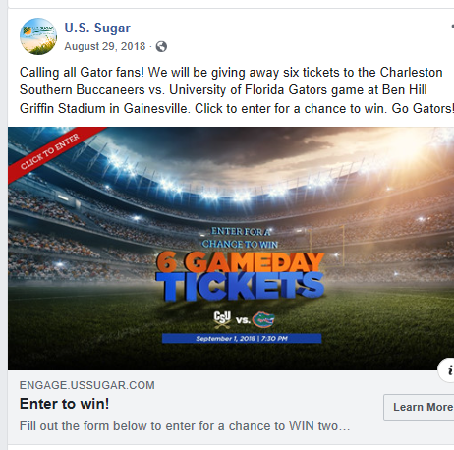
Figure 1. USSC Non-crisis related post
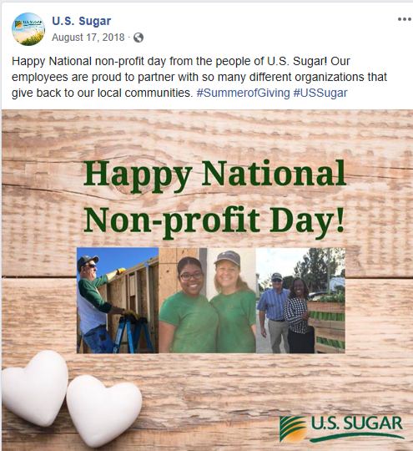
Figure 2. USSC Non-crisis related post
The only time throughout this study that the researcher identified the theme of gratitude was in one of the non-crisis related posts. The post had themes of reminding but also stated the pride that USSC has in partnering with and supporting local organizations to serve the community (Figure 3). The theme of compensation was identified in three initial posts in the form of football tickets, while this was not related to the crisis it involved the organization providing gifts to the stakeholders.
The crisis related posts were not posted in any chronological order that was significant. On two occasions, opinion sharing and factual posts were shared on the same day as other non-crisis related posts. Of the 6 USSC posts that were related to water or crisis issues, the average number of comments made was 186, compared to an average of 18 comments made on non-crisis related posts. This data indicated that the stakeholders and USSC took a much more active role in communicating about science and crisis related issues than other content.
Research Question 2: What were the key messages of USSC Facebook posts specifically addressing the 2018 blue-green algae and red tied outbreak?
The researcher found that the following themes were present in USSC Facebook posts during the crisis: excusing, reminding, victimage, scapegoating, factual and opinion sharing (Table 2). The researcher labeled posts as “factual” that contained straightforward facts about USSC or scientific studies. The researcher labeled posts “opinion sharing” that contained news stories from various media outlets or links to advertisements or websites developed by USSC. This included multiple links to press releases and local newspaper stories, and to a site developed by USSC. Although factual and opinion sharing were not listed as response themes proposed by Coombs (2015), the researcher noted that many of USSC Facebook posts during the timeline had themes of opinion sharing and factual content such as the example shown in figures 3 and 4. The media stories shared had factual information and were coded both as information sharing and factual. Many of the posts that USSC submitted in response to user comments could fit into multiple categories of Coombs’ crisis response themes, but did have a central message and were coded appropriately.
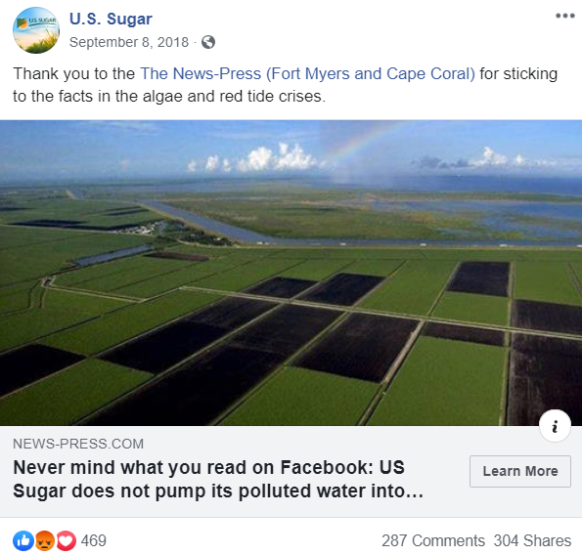
Figure 3. USSC Opinion sharing post
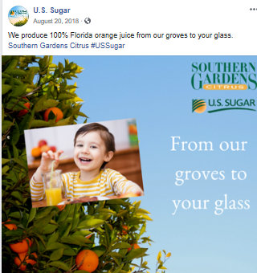
Figure 4. USSC Factual post
Research question 3: What crisis response postures did USSC use when it responded to public comments during the 2018 blue-green algae and red tide outbreak?
Most of the USSC response posts fit into multiple categories within Coombs proposed response postures. The six most frequently observed categories were reminding, scapegoating, factual, victimage, opinion sharing, and denial. All six of the most frequently observed postures in USSC responses are listed in Table 3 with examples. One of the strongest trends found in the comments during this time period was denial. The statement that “no back pumping occurs” was made multiple times. While this is not a direct denial of involvement with the crisis, this is a central issue that was mentioned multiple times.
Table 2. Postures used in USSC crisis posts
Crisis Response Posture | Explanation of Posture | Response from USSC
Reminding | The organization tells stakeholders about its past good works. | 26 years ago today, Hurricane Andrew made landfall in Florida. The days following that storm were marked by leadership, service, resilience, and helping our neighbors recover. #USSugar
Victimage | The organization explains how it too is a victim of the crisis. | It is time to take a hard look at South Florida’s water run-off — so we’ll start with ours. We are committed to being open and honest about our water, our farming practices and our heartfelt desire to work with our neighbors to use sound science and factual information to solve all of our shared water issues.
Scapegoating | Some other person or group outside of the organization is blamed for the crisis. | Red tide, blue-green algae and Lake Okeechobee discharges are all extremely serious and deserve serious attention. It’s time to take a hard look at the truth about Florida’s water issues. Click to see our latest ad running in Florida newspapers this week.
Factual | Straightforward statements that provide facts to the public | We produce 100% Florida orange juice from our groves to your glass. Southern Gardens Citrus #USSugar
Opinion Sharing | Articles from other sources are shared | According to the Florida Fish and Wildlife Conservation Commission, "In contrast to the many red tide species that are fueled by nutrient pollution associated with urban or agricultural runoff, there is no direct link between nutrient pollution and the frequency or severity of red tides caused by K. brevis."  More info at the link below...

Throughout the USSC responses to user comments, there was also a general theme of scapegoating. While this theme was often accompanied by factual or opinion sharing information, the general sentiment that others were responsible for the crisis. Multiple responses included specific information on possible alternative sources of pollution and contribution to the crisis. USSC maintained the posture that their organization was not to blame for any of the crisis and provided feedback and additional information to support their statements. Another frequently observed theme was reminding. Most comments made by USSC to their users made mention of the sacrifices made by EAA farmers in an effort to contribute to Everglades Restoration and water issues. USSC often referred to historical good deeds and adherence to regulations.
In regards to the 10 posts that were made that did not address the crisis, USSC only responded once to Facebook user comments throughout the timeframe examined (Figure 5. On multiple posts, users left USSC comments or questions, but the organization did not ever respond to those comments. (Figure 6). Throughout the crisis examined in this study USSC only responded to comments that were negative or attacking in nature. Of the 16 posts made that were examined, USSC only responded to comments on eight of the posts. The concentration of responses from USSC was centered around the posts that had the most user comments.
In multiple responses, USSC offered users the opportunity to tour their facilities (Figure 7), in an effort to be transparent. Despite efforts to be transparent, USSC still utilized response postures that did not share the same overall theme. In comments where USSC offered transparency other themes were also detected, such as scapegoating and victimage. The themes of denial and scapegoating were almost always present in USSC responses to user comments.
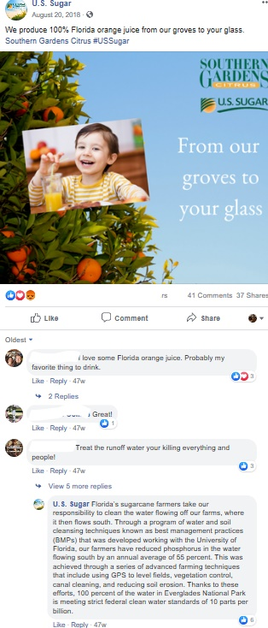
Figure 5. USSC sole response to non-crisis post feedback
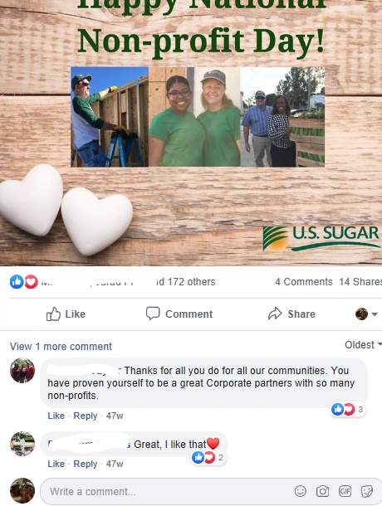
Figure 6. Example post with no USSC response
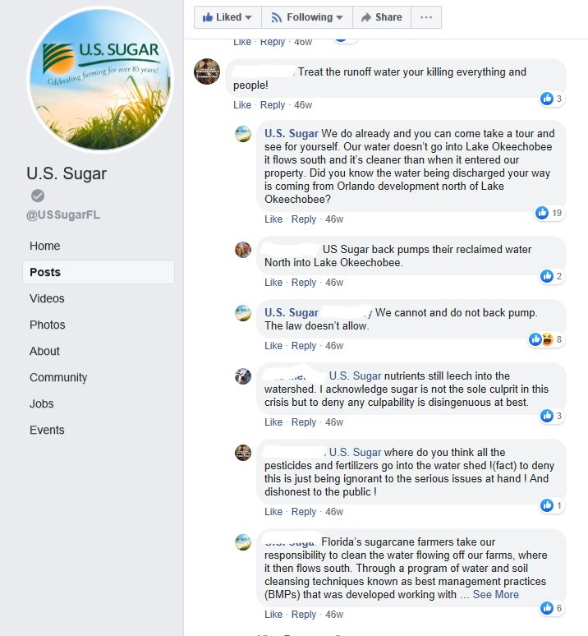
In this response USSC says “...you can come take a tour and see for yourself”
Figure 7. Example post with USSC invitation to visit

Table 3
Postures found in USSC responses to public comments
Crisis Response Theme | Explanation of theme | Response from USSC
Reminding | The organization tells stakeholders about its past The organization tells stakeholders about its past good works. good works. | In addition to the land given up, farmers have already invested more than $450 million into research, restoration, and on-farm water and soil cleaning efforts – more than any private entity has spent to date. We pay a $25/acre agricultural privilege tax and have over the last two decades. And we ARE cleaning water and do it every day.
Victimage | The organization explains how it too is a victim of the crisis. | Farmers have given up more than 120k acres of productive farmland for the purpose of restoration, including the land the EAA Reservoir will be built on.
Denial | The crisis manager states that no crisis exists. The response may include explaining why there is no crisis. | Although “back pumping” of water off farmland and sugarcane fields from south of Lake Okeechobee is often blamed for the algae blooms, the practice largely ended in the 1980s and occurs now only in emergency situations when communities around the lake are threatened with flooding.  There has been no measurable back pumping this year, according to the South Florida Water Management District. In 2016 and 2017, a total of 32 days of back pumping occurred after record rain events and during Hurricane Irma.  In the 12 years previous to 2016, a total of 70 days of back pumping occurred.
Scapegoating | Some other person or group outside of the organization is blamed for the crisis. | Read the article. It’s not our water causing this crisis.
Factual | Straightforward statements that provide facts to the public | 95 percent of the water and nutrients in Lake O comes from the northern. Lake O holds almost all of the runoff that comes from the Kissimmee River basin.
Opinion Sharing | Articles from other sources are shared | There is evidence that septic tanks are making the algae blooms worse. Our Glades communities converted from septic to sewer years ago. http://www.fau.edu/newsdesk/articles/septic-system-study.p
Many comments made by USSC addressed regulatory issues facing the agricultural industry in the EAA. The researcher identified this theme as “defending.” The related comments were solely in response to comments made on crisis posts, and were not found at all in comments on posts not related to the crisis. Various responses utilized the posture of factual or opinion sharing accompanied by a link to a site developed by USSC with in depth information and scientific details. In an effort to communicate science, USSC sought to establish themselves as a source of information and guided users to that site.
Throughout this study, the researcher did not find any responses that exhibited themes of apology, ingratiation, or responsibility. All of the comments made by USSC either offered factual information, outside opinion sharing, and took a defensive posture. In comparison with the quantity of user comments left on posts, USSC did not respond to all user comments, and their responses were infrequent.
Limitations
The first limitation of this research was the possibility that some comments made by private users or USSC may have been deleted before the researcher reviewed and captured them. It is also possible that USSC posted crisis response messaging during this time to private Facebook profile pages in response to other posts that are not visible to the researcher. Because of the various security features of Facebook, it is likely that not all posts and comments to posts made by USSC during this time period were captured. The researcher also noted that the links to some of the articles shared by USSC were no longer active. These news articles were not part of the study, but could have affected some of the responses and comments to the original posts. This study set out only to understand the crisis response postures used by USSC and not responses or comments made by public Facebook users. Because this study did not take into account the content posted by Facebook users, there were multiple responses made by USSC could be difficult to gauge. Another limitation includes the researcher’s close proximity, interest, and stake in the topic. However, to ensure transparency in procedures, the researcher followed qualitative procedures for establishing validity of results through third-party checking and thorough presentation of methods and results.
Discussion
Although they may not have known it, USSC was utilizing many of Coomb’s crisis response postures in their posts on Facebook during the 2018 HAB crises. USSC posted and responded using mostly crisis response themes that included scapegoating, victimage, denial, and reminding. Many posts the USSC made contained more than one theme, but the four listed here were the most dominant among all content shared by USSC. The researcher was surprised to find that USSC did not daily communicate with users on their public Facebook page during the crisis.
Many Floridians and stakeholders had emotional reactions to the HAB outbreaks and threats to their way of life and water sources. While research would state that this kind of reaction is expected from the public during an environmental crisis, it was surprising to the researcher that such a defensive stance was deemed necessary by USSC as a part of their crisis communication responses. As previously stated in the article, this environmental crisis was complex and according to University of Florida Institute of Food and Agricultural Sciences (IFAS) researchers, the causes were an accumulation of natural events and long buildups of nutrient saturation (IFAS, 2018). There is no indication that USSC was directly responsible for the outbreak, yet they took a very defensive posture on their Facebook page messaging. Becoming too defensive may lead to poor decisions and ineffective crisis communication postures (James and Wooten, 2010). It appears that the reputation of USSC had already been damaged prior to the crisis, and these defensive postures may not have aided in reputation rebuilding as intended.
No themes of apology, ingratiation or gratitude were found in any of the posts or comments made by USSC throughout the study. Coombs (2015) suggested organizations adopt those themes when at a center of a crisis, and USSC did not. In multiple responses USSC claimed no involvement at all in the contribution to the issues that contributed to the causes of the HAB outbreak, and assumed no responsibility at all. Contrastingly, Irlbeck., et al. (2018) found that Blue Bell Ice Cream was able to successfully retain a positive reputation by communicating about maintaining transparency in their practices, improvements, and corrective actions during a crisis.
Previous research discussed that engaging with the audience and framing conversations to seem more personal and genuine would help establish an entity as a leader during a crisis (Wagler and Cannon, 2015). USSC engaged with the public Facebook audience but did not engage in explanation or sharing of science. The seemingly random and defensive responses may not have come across as genuine to users and could have actually been detrimental to the reputation of USSC during the crisis.
Coombs stated that crisis managers should not focus too much on the threat of the crisis, and should avoid a siege mentality (Coombs, 2019). USSC did not solely focus on the crisis in their Facebook posts, which may have created opportunity for positive reputation building in the midst of the crisis. The posts that were not related to the crises did not acknowledge the crisis at all, and received much less attention from users than those that did address the crisis.
Recommendations for Practitioners
Learning to read, write and participate on the web, especially on social media platforms such as Facebook, is essential for reaching out to and connecting with different actors and online communities (Goldgruber et al., 2018). Palmer (2010) warned all agricultural organizations to be prepared and realize a crisis can occur. The researcher recommends that public relations and communication practitioners who work with or represent agribusinesses prepare for future crisis by developing an understanding of the best crisis response postures and a crisis communication plan. Training would also include how to monitor and appropriately respond to social media posts. This social media training could be part of a social media crisis communication literacy training for agribusinesses in the EAA, which takes into account the speciﬁc needs and requirements of crisis management for environmental crises.
Coombs, (2019) stated the importance of not only communicating, but explaining science to the public. This study indicates that explaining industry specific and scientific terms could be a useful tool in crisis communication plans. The researcher also recommends that in times of crisis agribusinesses in the EAA make an effort to not over-utilize postures with themes of defensiveness. When communicating with stakeholders through Facebook and other social media platforms, crisis communication practitioners should utilize response postures such as improvement, ingratiation, and informational, that may illicit more positive feedback and interaction with the public.
Many public relations and communications practitioners utilize scheduling software or even paid external agencies that create evergreen or sales focused content as a part of their marketing and social media plans. The researcher recommends that any organization who plans to utilize social media as an aspect of their crisis communication plan be mindful of any previously scheduled posts, and schedule any crisis related posts with other content in mind.
Expansion of this study could include examination of public response postures during a crisis time. In this study, only the posts and comments made by USSC were examined, but further examination of public comments may help gain an understanding of the mindset and knowledge base of USSC Facebook followers, the organization may be able to formulate a more effective crisis communications plan in the future. Future research could also be done by interviewing Facebook users about their scientific knowledge of algal issues.

References
Adams, C., “Red Tide Causes Economic Losses to Southwest Florida Industry”. UF/IFAS Florida Shellfish Aquaculture Featured News. January 13, 2017. http://shellfish.ifas.ufl.edu/news/red-tide-causes-economic-losses-sw-florida-industry/
Barrera, A. "When Public Scrutiny Requires Crisis Communications". Gutenberg Communications. Retrieved 28 February 2014.
Baucum, L., Rice, R., “An Overview of Florida Sugar Cane”. July, 1, 2017. https://ufdc.ufl.edu/IR00003414/00001
Bennett, W. L., & Iyengar, S. (2008). A new era of minimal effects? The changing foundations of political communication. Journal of Communication, 58(4), 707-731. doi:10.1111/j.1460 -2466.2008.00410.
Benoit, W., (1997). Accounts, Excuses, and Apologies: A Theory of Image Restoration Strategies. New York: State University of New York Press.
Bullsugar, 2019, www.bullsugar.org
Boyd, D. (2015). Social media: A phenomenon to be analyzed. Social Media + Society, 1(1), 1–2. doi:10.1177/2056305115580148
Colleoni, E., Rozza, A., & Arvidsson, A. (2014). Echo chamber or public sphere? Predicting political orientation and measuring political homophily in twitter using big data. Journal of Communication, 64(2), 317-332. doi:10.1111/jcom.12084
Colwell, R., Machlis, G. Science During Crisis: Best Practices, Research Needs, and Policy Priorities. Accessed March 28, 2019. https://www.amacad.org/publication/science-during-crisis/section/4
Coombs, W. Timothy; Holladay, Sherry J. (2010). The Handbook of Crisis Communication. Hoboken, NJ: Wiley-Blackwell.
Coombs, W. T. (2015). Ongoing Crisis Communication: Planning, Managing, and Responding (4th ed.). Los Angeles, CA: Sage.
Coombs, W. (2016). Image repair theory. In C. Carroll (Ed.), The SAGE encyclopedia of corporate reputation (pp. 344-346). Thousand Oaks,, CA: SAGE Publications, Inc. doi: 10.4135/9781483376493.n139
Environmental Protection Agency. https://www.epa.gov/nutrientpollution/harmful-algal-blooms
Florida Department of Agriculture and Consumer Services. Accessed July 1, 2019 https://www.freshfromflorida.com/
Florida Department of Environmental Protection, "Glossary of Terms". Everglades Forever.
Goldgruber, E., Sackl-Sharif, S., Ausserhofer J.,and Gutounig, R. (2018). '‘When the Levee Breaks’: Recommendations for Social Media Use During Environmental Disasters', in Harald Hornmoen Klas Backholm (ed.) Social Media Use in Crisis and Risk Communication. Emerald Publishing Limited, pp. 229-253
Holloway, I. (1997). Basic Concepts for Qualitative Research. London: Blackwell Science.
Irlbeck, E.G., Akers, C.L., & Palmer, A. (2011). A nutty study: A framing analysis of the 2009 Salmonella outbreak in peanut products. Journal of Applied Communications, 95(2). 48-59.
James, E.H., & Wooten, L.P., (2010) Leading under pressure: From surviving to thriving before, during and after a crisis. New York, NY: Routledge.
Krimski, L. “Understanding the Florida Red Tide”. UF/IFAS Florida Extension. December 4, 2018. http://blogs.ifas.ufl.edu/extension/2018/12/04/understanding-the-florida-red-tide/
Krimski, L. “Algal Blooms FAQ”. UF/IFAS Florida Extension. July 10, 2018. http://blogs.ifas.ufl.edu/extension/2018/07/10/algal-blooms-faq/
Jasny, L., Waggle, J., & Fisher, D. R. (2015). An empirical examination of echo chambers in US climate policy networks. Nature Climate Change, 5(8), 782-786. doi:10.1038/nclimate2666
Levy, R., Warwick, C., Rampold, C., Telg, R. (2019) Examining Communication Between Florida Agricultural Organizational Leaders and Members to Encourage Member Engagement in Agricultural Policy. Unpublished document.
Lincoln, YS. & Guba, EG. (1985). Naturalistic Inquiry. Newbury Park, CA: Sage Publications.
Mayfield, A. (2006), ‘What is Social Media?’Spannerworks, http://www.spannerworks.com/fileadmin/uploads/eBooks/What_is_Social_Media.pdf (accessed July 18, 2019).
Mayring, P. (2000). Qualitative content analysis. Forum: Qualitative Social Research, 1(2). Retrieved July 18, 2019, from http://217.160.35.246/fqs-texte/2-00/200mayring-e.pdf
National Oceanic and Atmospheric Administration. https://oceanservice.noaa.gov/news/redtide-florida/
Newman, N., Fletcher, R., Kalogeropoulos, A., Levy, D. A. L., & Kleis Nielsen, R. (2017). Reuters institute digital news report 2017. Retrieved from http://www.digitalnewsreport.org
Opat, Kelsi; Magness, Haley; and Irlbeck, Erica (2018) "Blue Bell's Facebook Posts and Responses During the 2015 Listeria Crisis: A Case Study," Journal of Applied Communications: Vol. 102: Iss. 4. https://doi.org/10.4148/1051-0834.2232
Paisley, W. J. (1998). Public communication campaigns: The American experience. In R. Rice and C. Atkin (Eds.), Public communication campaigns (pp. 3-21). Thousand Oaks, CA: Sage Publications, Inc.
Palmer, A. (2010). A case study of the risk and crisis communications used in the 2008 Salmonella outbreak. (Thesis.) Texas Tech University, Lubbock, TX
Pew Research Center (2018). Social Media Fact Sheet. Retrieved from pew research center social media fact sheet 2018
Prior, M. (2007). Post-broadcast democracy: How media choice increases inequality in political involvement and polarizes elections. New York, NY: Cambridge University Press.
Ruth, Taylor K.; Rumble, Joy N.; Galindo-Gonzalez, Sebastian; Lundy, Lisa K.; Carter, Hannah S.; and Folta, Kevin M. (2019) "Can Anyone Hear Us? An Exploration of Echo Chambers at a Land-Grant University," Journal of Applied Communications: Vol. 103: Iss. 2.
Sandhu, H., “Performance of CP Sugarcane Cultivars Grown in Different Locations in Florida” Accessed July 18, 2019. https://edis.ifas.ufl.edu/sc086
Seeger, M. W., Sellnow, T. L., & Ulmer, R. R. (1998). Communication, organization, and crisis. Annals of the International Communication Association, 21(1), 231-276.
Shen, B.S.P. (1975). Scientific literacy and the public understanding of science. In S.B. Day (Ed.), Communication of Scientific Information (pp. 44-52). Basel, Switzerland: Karger.
Sherman, A. What role do septic tanks play in the algae bloom crisis in Florida? August 20, 2018. https://www.politifact.com/florida/article/2018/aug/20/what-role-do-septic-tanks-play-algae-bloom-crisis-/
Smith, E., Blanchard, P. & Bargu, S. (2014). Education and public outreach concerning freshwater harmful algal blooms in Southern Louisiana. Harmful Algae, (35), 38-45.
Stump, K. “Harmful Algal Blooms” UF/IFAS Florida Extension. August 8, 2018. http://blogs.ifas.ufl.edu/osceolaco/2018/08/08/harmful-algal-blooms/
Treise, D., & Weigold, M. F. (2002, March). Advancing science communication: A survey of science communicators. Science Communication, 23(3), 310-322.
United States Sugar Corporation. www.ussugar.com
United States Department of Agriculture. November 29, 2018. https://www.ers.usda.gov/data-products/ag-and-food-statistics-charting-the-essentials/food-availability-and-consumption/
van Woerkum, C. M. J., & van Lieshout, I. M. (2007). Reputation management in agro-food
industries: Safety first. British Food Journal, 109(5), 355-366. doi:
10.1108/00070700710746777

Waterman, A., (1960). National science foundation: a ten-year resume´. Science (131), 1341–1354.

Wendling, C., J. Radisch and S. Jacobzone (2013), "The Use of Social Media in Risk and Crisis Communication", OECD Working Papers on Public Governance, No. 24, OECD Publishing, Paris, https://doi.org/10.1787/5k3v01fskp9s-en.

